

MINISTRY OF EDUCATION AND TRAINING  
**FPT UNIVERSITY**

CAPSTONE PROJECT DOCUMENT

Building an Incident Management System with Wazuh and pfSense in an Enterprise Network Environment

|  |  |
| --- | --- |
| GSP25IA12 | |
| Group members | Nguyễn Xuân Yến – Leader – SE171363 Nguyễn Thanh Hợp – Member - SE171294 Trần Minh Quang – Member - SE172867  Đặng Hoàng Việt – Member - SE172096 |
| Supervisor | Trần Văn Ninh |
| Ext Supervisor |  |
| Capstone Project code | SP25IA12 |

- Ho Chi Minh, 01/2025 -

Contents

CHAPTER 1: INTRODUCTION 10

1.1. Project Information 10

1.2. Participation 10

1.2.1. Supervisor 10

1.2.2. Group Members 10

1.3. The problem 10

1.3.1. Dynamics of Modern Cybersecurity 10

1.3.2. Current Limitations in Cybersecurity 11

1.3.2.1. Significant Cybersecurity Incidents of 2024 13

a. CrowdStrike Incident – Global IT Disruption Catastrophe 13

b. Ransomware Attack on Change Healthcare 13

c. Microsoft Breach by Midnight Blizzard 13

d. Customer Data Breaches at AT&T and Dell 13

1.3.2.2. Common Attachments in Malicious Emails 13

1.3.2.3. Attack Trends and Enterprise Security Vulnerabilities 15

1.3.2.4. Rising DDoS Attacks in 2024 16

1.3.3. Current Detection and Prevention Limitations 17

1.3.4. The Need for an Integrated Security Approach 17

CHAPTER 2: PROJECT MANAGEMENT PLAN 19

2.1. Problem setting 19

2.1.1. Name of Capstone Project 19

2.1.2. Problem Abstraction 19

2.1.3. Project Overview 19

2.2. Project Organization 19

2.2.1. Solution Process Model 19

2.2.2. Roles and Responsibilities 19

2.2.3. Tools and Techniques 21

2.3. Project Management Plan 22

2.3.1. Tasks 22

2.3.1.1. Planning 22

2.3.1.2. Research 22

2.3.1.3. Developing Solutions 22

2.3.1.4. Writing Document 23

2.3.2. Task Sheet: Assignments and Timetable 23

2.3.3. All Meeting Minutes 25

CHAPTER 3: RISK ASSESSMENT 26

3.1. The Essential of Assessment 26

3.2. Identify Critical Information Assets 26

3.3. Risk Identification 26

3.3.1. Threat Identification 26

3.3.2. Vulnerability Identification 27

3.4. Risk Analysis 27

3.4.1. Impact Assessment 27

3.4.2. Likelihood Assessment 27

3.4.3. Risk Level Description 28

3.5. Control Identification and Assessment 28

3.5.1. Control Methods 28

3.5.1.1. Technical (Safeguard, Tools) 28

3.5.1.2. Non-Technical 29

3.5.2. Control Types 29

3.5.3. Risk Monitoring and Controlling 30

CHAPTER 4: RISK MANAGEMENT PLAN (RMP) 31

4.1. Objectives of RMP 31

4.1.1. Lists of Threats/Vulnerabilities 31

4.1.2. Cost associated with risks 32

4.1.3. List of Recommendations to Reduce the Risks 32

4.1.4. Costs Associated with Recommendations 33

4.2. Assigning Responsibilities 33

4.3. Describing Procedures and Schedules for Accomplishment 33

4.4. Reporting Requirements 34

4.4.1. Present Recommendation 34

4.4.2. Document Management Response to Recommendations 34

4.5. Plan of Action and Milestones 35

4.6. Charting the Progress of a RMP 36

4.6.1. Milestone Plan Chart 36

4.6.2. Gantt Chart 36

4.7. Tools and Practices 37

CHAPTER 5: DEVELOPMENT AND IMPLEMENTATION PLAN 38

5.1. Risk Response Planning 38

5.1.1. Major Risk Treatment 38

5.1.2. Risk Mitigation Treatment 38

5.1.3. Risk Mitigation Plan (RMiP) 38

5.2. Theoretical Basis 39

5.2.1. Wazuh 39

5.2.1.1. Definition 39

5.2.1.2. The needs of Wazuh 40

5.2.1.3. Capabilities 40

5.2.1.4. The Components of Wazuh 41

5.2.1.5. Wazuh Deployment 42

5.2.1.6. Required ports 43

5.2.2. pfSense 44

5.2.2.1. Definitions 44

5.2.2.2. Features 44

5.2.2.3. Functions 45

5.2.2.4. Advantages 46

5.2.3. ELK Stack 47

5.2.3.1. Definitions 47

5.2.3.2. Features 47

a. Elasticsearch 47

b. Logstash 48

c. Kibana 49

5.2.3.3. Advantages 49

5.2.3.4. Elastic Stack Integration with Wazuh 50

5.2.4. Syslog 50

5.2.4.1. Definitions 50

5.2.4.2. Syslog in Wazuh and pfSense Integration 51

5.2.4.3. Advantages of Using Syslog with Wazuh and pfSense 51

5.2.5. Incident Management 52

5.2.5.1. Definition of Security Incidents in Enterprise Networks 52

5.2.5.2. Definition of Incident Management 52

5.2.5.3. Incident Management Process 52

5.3. Types of Attack 53

5.3.1. Brute-force SSH Attack 53

5.3.2. Trojan Attack – Trojan Horse Virus 54

5.3.3. Denial of Service Attack (DoS Attack) 55

5.4. Project Implementation 56

5.4.1. Preparation 56

5.4.1.1. Equipment/Tools 56

5.4.1.2. Topology 57

5.4.2. Install and Configure 57

5.4.2.1. Install Wazuh 58

5.4.2.2. Install pfSense 59

5.4.2.3. Wazuh Deployment Optimization via Server Migration 61

5.4.2.4. Integrating Wazuh and pfSense via Syslog 62

5.4.2.5. Integrating Wazuh and ELK Stack 64

5.4.2.6. Configuring to send email notifications with Wazuh 65

5.4.3. Network Security Incident Management Policy 68

5.4.4. Scenario 71

5.4.4.1. Brute-Force SSH 71

a. Attack Simulation: Internal Employee Attempts Unauthorized SSH Access 71

b. Defense Mechanism: Wazuh-Based Detection and Response 71

5.4.4.2. Malware Infection via Cracked Software – Detection and Removal (Trojan Attack) 72

a. Attack Simulation: User Downloads Cracked Adobe Photoshop Containing Malware 72

b. Defense Mechanism: Wazuh-Based Detection and Response 73

5.4.4.3. Denial of Service (DoS) Attack 74

a. Attack Simulation: Initiating a DoS Attack 74

b. Defense Mechanism: Wazuh Detecting and Blocking the Attack 74

5.4.5. Demonstration 75

5.4.5.1. Brute-Force SSH 75

Phrase 1 – Preparation 76

Phrase 2 – Detection 77

Phrase 3 – Containment 79

Phrase 4 – Post-Incident 80

Conclusion 82

5.4.5.2. Malware Infection via Cracked Software – Detection and Removal (Trojan Attack) 82

Phrase 1 - Preparation 82

Phrase 2 – Detection 85

Phrase 3 – Containment 91

Phrase 4 – Post-Incident 93

Conclusion 94

5.4.5.3. Denial of Service (DoS) Attack 95

Phrase 1 – Preparation 95

Phrase 2 – Detection 97

Phrase 3 – Containment 99

Phrase 4 – Post-Incident 101

Conclusion 102

CHAPTER 6: VALIDATION DOCUMENT 104

6.1. Project Result 104

6.2. Advantages and Disadvantages of the Solution 105

6.2.1. Advantages 105

6.2.2. Disadvantages 105

6.3. Development Strategy of the Solution 105

References 107

**List of Figures**

Figure 1.1 - Vulnerability Severity Distribution in Vietnam 2024 13

Figure 1.2 - ALPHV permitting affiliates to "block hospitals, nuclear power plants, anything, anywhere." 14

Figure 1.3 - DDoS Attack Volume in 2023 and 2024 17

Figure 1.4 - DDoS Attacks by Quarter in 2024 18

Figure 2.1 - Solution Process Model 20

Figure 4.1 - Milestone Plan Chart 37

Figure 4.2 - Gantt Chart 38

Figure 5.1. Wazuh SIEM and XDR 40

Figure 5.2 - Role of Wazuh in building a robust cybersecurity architecture 42

Figure 5.3 - Wazuh components and data flow 43

Figure 5.4 - Wazuh Deployment Architecture 44

Figure 5.5 – pfSense 45

Figure 5.6 - Features of pfSense 46

Figure 5.7 - pfSense Software Best Practices Guide 48

Figure 5.8 - ELK Stack 48

Figure 5.9 - Elasticsearch 49

Figure 5.10 - Logstash 49

Figure 5.11 - Kibana 50

Figure 5.12 - Features of ELK 50

Figure 5.13 - ELK integration diagram 51

Figure 5.14 - Syslog Definition 52

Figure 5.15 - Incident Management Process 54

Figure 5.16 – Brute-Force Attack 55

Figure 5.17 - Trojan Horse Virus 56

Figure 5.18 - DoS Attack 57

Figure 5.19 - Network Topology 58

Figure 5.20 - Virtual Network Editor 58

Figure 5.21. Installing Wazuh 59

Figure 5.22. Wazuh Installation Finished 59

Figure 5.23 - Wazuh Dashboard 60

Figure 5.24 - Installing pfSense 60

Figure 5.25 - pfSense Installation Finished 61

Figure 5.26 - Configuration finished 62

Figure 5.27 – pfSense 62

Figure 5.28 - Configuring Syslog 63

Figure 5.29 - pfSense GUI after Configuring Syslog 64

Figure 5.30 - Wazuh after Configuring Syslog 64

Figure 5.31 - Installing Logstash 65

Figure 5.32 - Installing Wazuh-Indexer (Elasticsearch) 65

Figure 5.33 - Installing Wazuh-Dashboard (Kibana) 66

Figure 5.34 - Installing Wazuh-Manager & Wazuh-API 66

Figure 5.35 – Integrating ELK Finished 66

Figure 5.36 - Install Required Packages 67

Figure 5.37 - Configure Postfix 67

Figure 5.38 - Edit Profix file 67

Figure 5.39 - Configure the sasl_passwd File 68

Figure 5.40 - Configure Wazuh to Send Email Notifications 68

Figure 5.41 – Brute-Force SSH Scenario 73

Figure 5.42 – Malware Infection via Cracked Software – Detection and Removal (Trojan Attack) Scenario 75

Figure 5.43 - Denial of Service (DoS) Attack scenario 76

Figure 5.44 - Custom Wazuh Rule for Brute-force Detection 77

Figure 5.45 – Brute-force SSH Attacking 78

Figure 5.46 - Flowchart Brute-Force SSH - Detection 79

Figure 5.47 - Email Sent to Administrator upon Brute-force Detection 79

Figure 5.48 – Flowchart Brute-Force SSH - Containment 80

Figure 5.49 - Email Sent to Administrator upon Brute-force Containment 81

Figure 5.50 - Wazuh alert confirming source IP was blocked 81

Figure 5.51 – Flowchart Post-Incident 82

Figure 5.52 - Cracked Software in Drive 83

Figure 5.53 - Directory containing active response tools on Windows 84

Figure 5.54 - Scan Virus/Malware Rule 85

Figure 5.55 - Active Response Configuration for Malware Removal 85

Figure 5.56 - Flowchart Malware Infection via Cracked Software - Detection 87

Figure 5.57 - Crack Software was downloaded by the user 88

Figure 5.58 - VirusTotal scan result identifying the cracked software as malicious 89

Figure 5.59 - VirusTotal metadata of the malicious file 90

Figure 5.60 - Alert on Wazuh Dashboard 91

Figure 5.61 - Email notification: Malware Detected 91

Figure 5.62 - Flowchart Malware Infection via Cracked Software – Containment 92

Figure 5.63 - Wazuh active response log 92

Figure 5.64 - Email notification: File Deleted 93

Figure 5.65 - After Automated File Removal 93

Figure 5.66 - Flowchart Malware Infection via Cracked Software – Post-Incident 94

Figure 5.67 - Kibana Visualized Dashboard for Malware Infection 95

Figure 5.68 - Configure pfSense Rule 96

Figure 5.69 - Block DoS Rule 96

Figure 5.70 - DoS Attacking by Hping3 98

Figure 5.71 - Flowchart of DoS Attack - Detection 99

Figure 5.72 - Email Notification of DoS Attack 99

Figure 5.73 - Flowchart of DoS Attack – Containment 100

Figure 5.74 - pfSense Block Action Log 100

Figure 5.75 - Wazuh Active Response Log for IP Block 101

Figure 5.76 - Flowchart DoS Attack – Post-Incident 102

Figure 5.77 - Kibana Visualized Dashboard 103

Figure 6.1 - Software Requirement Specifications 104

Figure 6.2. Specificaltions of Project 104

List of Tables

Table 1.1. Supervisor 10

Table 1.2. Group Members 10

Table 2.1. Roles and Responsible 21

Table 2.2. Tools and Techniques 22

Table 2.3. Project Management - Planning 22

Table 2.4. Project Management - Research 22

Table 2.5. Project Management – Developing Solutions 23

Table 2.6. Project Management – Writing Document 23

Table 2.7. Assignments and Timetable 25

Table 2.8. All Meeting Minutes 25

Table 3.1. Critical Information Assets 26

Table 3.2. Threat Identification 26

Table 3.3. Vulnerability Identification 27

Table 3.4. Levels of Impact 27

Table 3.5. Likelihood Assessment 28

Table 3.6. Risk Level Description 28

Table 3.7. Technical Control Methods 29

Table 3.8. Non-technical controls 29

Table 4.1. Lists of Threats and Vulnerabilities 31

Table 4.2. Cost associated with risks 32

Table 4.3. List of Recommendations to Reduce the Risks. 33

Table 4.4. Costs Associated with Recommendations 33

Table 4.5. Assigning Responsibilities 33

Table 4.6. Procedures and Schedules for Accomplishment 34

Table 4.7. Document Management Response to Recommendation 35

Table 4.8. Plan of Action and Milestones 36

Table 4.9. Tools and Practices 37

Table 5.1. Major Risk Treatment 38

Table 5.2. Risk Mitigation Treatment 38

Table 5.3. Risk Mitigation Plan 39

Table 5.4. Capabilities of Wazuh 40

Table 5.5. Deployment models of Wazuh 42

Table 5.6. Wazuh Required Ports 43

Table 5.7. Features of pfSense 45

Table 5.8. Functions of pfSense 46

Table 5.9. Advantages of pfSense 46

Table 5.10. Functions of Integrating Syslog 51

Table 5.11. Prepared Equipments/Tools 56

Table 5.12. Virtual Network Details 58

Table 5.13. Policy - Roles and Responsibilities 71

# INTRODUCTION

## Project Information

* Capstone Project Name

+ English: Building an Incident Management System with Wazuh and pfSense in an Enterprise Network Environment

+ Vietnamese: Xây dựng hệ thống quản lý sự cố với Wazuh và pfSense trong môi trường mạng doanh nghiệp.

* Project code: SP25IA12
* Project group name: GSP25IA12
* Timeline: from 04 January 2025 to April 2025

## Participation

### Supervisor

|  |  |  |  |
| --- | --- | --- | --- |
| **Fullname** | **Phone** | **Email** | **Role** |
| Trần Văn Ninh | 0933265089 | Ninhtv2@fpt.edu.vn | Lecture |

Table .. Supervisor

### Group Members

|  |  |  |  |  |
| --- | --- | --- | --- | --- |
| **Full name** | **Student code** | **Phone** | **E-mail** | **Role** |
| Nguyễn Xuân Yến | SE171363 | 0941466943 | yennxse171363@fpt.edu.vn | Leader |
| Nguyễn Thanh Hợp | SE171294 | 0868862878 | hopntse171294@fpt.edu.vn | Member |
| Trần Minh Quang | SE172867 | 0336849838 | quangtmse172867@fpt.edu.vn | Member |
| Đặng Hoàng Việt | SE172096 | 0942118495 | vietdhse172096@fpt.edu.vn | Member |

Table .. Group Members

## The problem

### Dynamics of Modern Cybersecurity

The rapid advancement of digital technology and the digital transformation that enterprises have undergone have resulted in substantial advantages. However, this has exposed enterprises to increasingly complicated and unpredictable cybersecurity attacks. Small and medium-sized businesses (SMEs), in particular, are frequent targets because to low financial resources and a scarcity of trained professionals to implement complete security solutions.

Trojan-based malware attacks, system infiltration, and remote access threats are growing more common, with attackers exploiting cracked software and backdoors to gain unauthorized control of enterprise systems. Furthermore, the integration of cloud services, third-party APIs, and microservices applications—among other complex components of modern IT infrastructures—has significantly increased the attack surface and risk of compromise.

While modern IT architecture and technological innovations have increased the attack surface for enterprise network systems, they have also enhanced flexibility. Nowadays, typical hacking strategies include:

* Trojan-Based Malware Attacks: Cybercriminals often disguise malicious code within cracked software or apps that appear legitimate. Once installed, these Trojans can silently steal login information, modify system settings to stay hidden, or give hackers remote access to the infected device. In workplaces lacking strong endpoint protection, their ability to operate quietly makes them especially dangerous.
* Lack of Centralized Monitoring: Enterprises have considerable obstacles in monitoring and analyzing logs from network devices (such as firewalls, IDS/IPS, user computers). This causes missing early warning signals, hence enabling attacks to continue longer and do significant damage before being found.
* Reactive Response: Most enterprises or organizations still use reactive policies, addressing issues only after they arise. They respond only when damage has become clear rather than stressing early identification and prevention. Such delayed reactions not only cause monetary losses but also harm the standing of companies, especially in the very competitive market of today..
* Limited Integration Between Security Systems: Most current security systems operate in isolation without robust integration. This creates voids in information sharing and coordinated responses to threats. Such a lack of synchronization not only complicates data analysis but also reduces the efficacy of extant security tools.

### Current Limitations in Cybersecurity

The increasing cyber threats in Vietnam have highlighted several critical vulnerabilities in the cybersecurity sector, as demonstrated in the 2024 Cybersecurity Report, conducted by the Technology Department of the National Cybersecurity Association in December 2024, based on a survey of 4,935 organizations in Vietnam. With 46.15% of government agencies and businesses experiencing cyberattacks and an estimated 659,000 cyberattacks, the cybersecurity landscape is under significant pressure.

Targeted attacks and Advanced Persistent Threats (APT) remain the most common types of cyberattacks, accounting for 26.14% of all incidents. These attacks often exploit vulnerabilities in software, mismanagement of configurations, weaknesses in the supply chain, and human error. This is compounded by the growing number of ransomware attacks, with 14.59% of organizations reporting ransomware incidents in 2024. These attacks cause significant damage, leading to encrypted data, operational disruptions, and severe harm to the organization's reputation.

Complementing this, a national threat severity survey by Viettel Cyber Security (2024) revealed that:

* 13% of incidents were deemed critical,
* 34% were classified as high severity,
* 45% were moderate, and
* only 8% were low risk.

Figure . - Vulnerability Severity Distribution in Vietnam 2024

These figures demonstrate that nearly half of all incidents required immediate response, emphasizing the lack of effective early detection and mitigation capabilities across organizations. The situation is worsened by a shortage of professional cybersecurity personnel, with over 20% of surveyed organizations lacking dedicated IT security staff.

Moreover, compliance with data protection regulations remains a challenge. About 19.45% of organizations struggle to meet the requirements of Decree 13/2023/ND-CP on personal data protection. Although basic tools such as antivirus software and firewalls are widely adopted, more advanced technologies like Security Operations Centers (SOC), Threat Intelligence, or automated SIEMs are still underutilized.

Phishing made up 33.3% of all email assaults, still the most common attack technique, according to Hornetsecurity's Cybersecurity Report 2025. Furthermore, 22.7% of email assaults used harmful URLs using false websites to get login credentials.

Additionally, Check Point Software's 2025 Cyber Security Report noticed a significant increase in ransomware assaults targeting businesses. The study claims that 57% of vulnerability exploitation in 2024 were caused by companies inability to timely implement fixes, which let hackers exploit security weaknesses dating back to 2020 and before.

These numbers draw attention to how urgently businesses have to enhance cybersecurity monitoring, educate employees more, and use modern defensive solutions as SIEM, Wazuh, and pfSense in order to lower the dangers posed by evolving cyberthreats.

#### Significant Cybersecurity Incidents of 2024

##### CrowdStrike Incident – Global IT Disruption Catastrophe

The most significant IT disruption in history occurred on July 19, 2024, when a defective update from CrowdStrike Falcon crashed over 8.5 million Windows systems globally. An estimated $5.4 billion was lost overall as a result of this incident, which affected many Fortune 500 companies.

##### Ransomware Attack on Change Healthcare

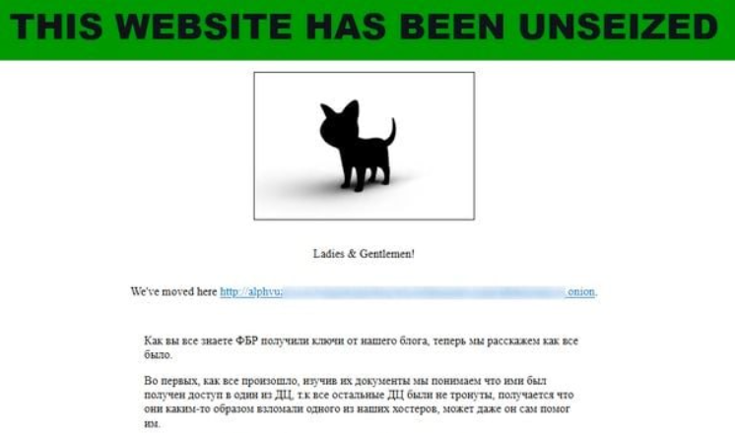In February 2024, Change Healthcare (a subsidiary of UnitedHealth Group) became a victim of the BlackCat/ALPHV ransomware, leading to the largest healthcare data breach in U.S. history. Over 100 million patient records were stolen, causing severe disruptions to the health insurance system and pharmaceutical supply chain.

Figure . - ALPHV permitting affiliates to "block hospitals, nuclear power plants, anything, anywhere."

##### Microsoft Breach by Midnight Blizzard

In January 2024, the Russian-based hacker group Midnight Blizzard carried out a password spraying attack, gaining access to internal emails of Microsoft executives. This attack highlighted the risks associated with OAuth configuration vulnerabilities.

##### Customer Data Breaches at AT&T and Dell

* **AT&T:** In April 2024, 51 million customers had their personal data exposed, including Social Security numbers, addresses, and phone numbers.
* **Dell:** In May 2024, 49 million customer order records were leaked, increasing the risk of phishing and fraud attacks.

#### Common Attachments in Malicious Emails

In 2024, phishing remained the most prevalent cyber attack method, accounting for 33.3% of all email attacks, followed by malicious URLs (22.7%). Cybercriminals used fake websites to steal login credentials or install malware on victims' systems. The use of email attachments as attack vectors also remained widespread, enabling 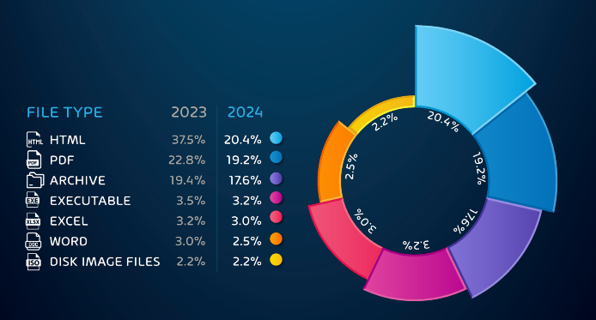hackers to bypass security filters and deliver malicious payloads directly to victims.

Figure .3 - File-Types for Malicious Payloads 2023 and 2024

Among malicious attachments, HTML (37.1%) and PDF (23.3%) were the most frequently used file types. The increasing activity of the Qakbot botnet has made malicious PDFs an effective tool for malware distribution. Additionally, ZIP/RAR files (20.8%) were commonly used to evade antivirus detection by hiding malicious scripts or executable files within compressed archives.

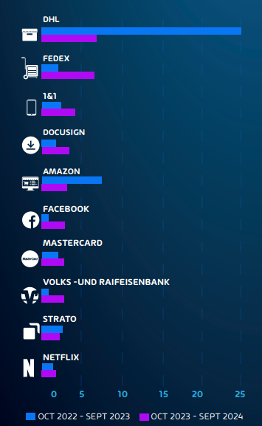

Figure .4 - Brands/organizations exploited

Brand impersonation also surged, with DHL (26.1%), Amazon (7.7%), Microsoft (2.4%), and FedEx (2.3%) being the most frequently spoofed brands. Cybercriminals crafted phishing emails posing as order confirmations, account update requests, or urgent security alerts, leveraging logos and formatting identical to legitimate emails to deceive recipients. These emails often contained malicious attachments or fraudulent links leading to phishing websites designed to steal login credentials and financial data.

Brand impersonation not only results in financial losses for individuals and businesses but also damages consumer trust. To reduce risks, organizations must strengthen email authentication using DMARC, SPF, and DKIM, while users should stay alert to the warning signs of email fraud.

#### Attack Trends and Enterprise Security Vulnerabilities

One of the most concerning issues is the exploitation of unpatched vulnerabilities (zero-day vulnerabilities). Reports indicate that 57% of vulnerability exploits in 2024 targeted CVEs from 2020 or earlier, highlighting that many enterprises still fail to apply security patches in a timely manner.

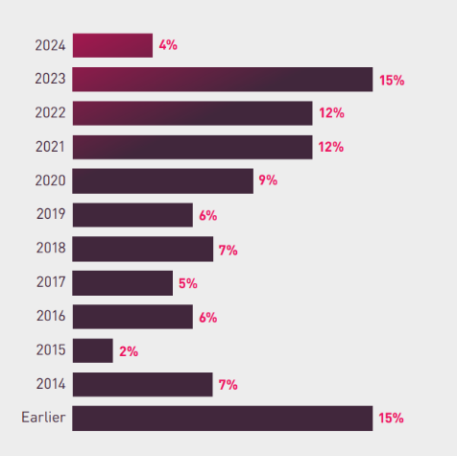Additionally, attacks on virtualization infrastructure (ESXi ransomware attacks) are becoming increasingly prevalent, with 11% of all ransomware incidents in 2024 targeting VMware ESXi servers. These attacks exploit CVE-2023-20867 and CVE-2024-37085, allowing hackers to gain full control over virtualized environments, causing severe disruptions for businesses relying on this infrastructure.

Figure .5 - Percentage of attacks leveraging vulnerabilities by disclosure year in 2024.

Furthermore, ransomware tactics have shifted from traditional data encryption to extortion through data exposure. If a company refuses to pay the ransom, cybercriminals threaten to publicly leak the stolen data, resulting in significant reputational damage and loss of customer trust.

#### Rising DDoS Attacks in 2024

DDoS (Distributed Denial of Service) attacks have emerged as one of the most alarming cybersecurity threats targeting Vietnamese organizations in 2024. These attacks aim to overwhelm servers or network resources with massive volumes of traffic, rendering services inaccessible to legitimate users. The operational consequences are sever, disrupted digital services, damaged customer trust, and increased recovery costs.

According to the Viettel Cyber Security 2024 report, the total number of DDoS attacks reached 924,006 incidents, marking a significant 34.3% increase compared to 688,191 attacks in 2023.

Figure . - DDoS Attack Volume in 2023 and 2024

A breakdown of DDoS attacks by quarter reveals that the first quarter (Q1) of 2024 was particularly intense, recording 387,690 attacks—equivalent to over 40% of the year’s total. Attack volumes dropped in Q2 (125,989), but a resurgence was observed in Q3 (177,961) and Q4 (232,366), suggesting a rebound in attack frequency during the second half of the year.

Figure . - DDoS Attacks by Quarter in 2024

These trends suggest that DDoS attacks are not only increasing in volume but also becoming more strategic and time-targeted. The dramatic spike in early 2024 demonstrates attackers’ ability to cripple systems through volume-based flooding, requiring organizations to adopt proactive defense strategies using tools.

### Current Detection and Prevention Limitations

Numerous enterprises still find it difficult to identify and prevent contemporary threats including APTs, ransomware, phishing, and DDoS assaults even with several security measures in place. APTs accounted for more than 26% of the 659,000 recorded cyberattacks in 2024 in Vietnam alone, indicating how constrained conventional defenses may be.

Heavy dependence on signature-based detection, which frequently overlooks new or unknown threats, is one of the key problems. Early warning indicators like unexpected data transfers or privilege escalation are difficult to identify without behavioral analysis. Often working in isolation, tools like firewalls, IDS/IPS, and email filters make it more difficult to detect coordinated assaults.

Many systems are also manual. Response teams can quickly become overloaded and sluggish to react as warnings pour in. Logging threats is insufficient; without integrated response systems to isolate infected devices or block IPs, events can develop fast.

With over 924,000 DDoS attacks reported in 2024, it’s clear that organizations need smarter, more connected systems that can react in real time and adapt to evolving threats.

### The Need for an Integrated Security Approach

In the context of increasingly complex IT infrastructures and the relentless rise of cyber threats in both volume and sophistication, traditional security measures are proving insufficient to meet modern demands. While tools such as firewalls, intrusion detection and prevention systems (IDS/IPS), and endpoint protection software remain foundational, they are often ineffective when deployed in isolation. As a result, the emergence of an integrated security architecture, where all components work in coordination to enable real-time monitoring, rapid response, and even automated incident handling, has become not merely a trend but an essential part of the cybersecurity strategy for today’s enterprises.

Important data sometimes goes unanalyzed when security systems run in isolation, therefore enabling major threats—like insider incidents or targeted breaches—to go unreported. Abnormal behaviour can persist for lengthy durations before it is found without real-time monitoring.

Another major drawback is manual reaction. Response times are postponed without automation, which allows attackers greater opportunity to take use of weaknesses. In the fast-moving digital world of today, such delays can erode consumer confidence and result in monetary loss.

A unified system provides a superior answer. Wazuh, for instance, gathers and examines logs from many different sources—including pfSense firewalls, IDS/IPS, and endpoints—transforming raw data into real-time insights. Wazuh may even automatically block harmful traffic when paired with pfSense, hence being useful against DDoS or brute force efforts. Implementing a unified security architecture with solutions like Wazuh and pfSense allows companies overall to detect attacks quicker, respond more effectively, and strengthen their defenses in an increasingly complicated environment.

# PROJECT MANAGEMENT PLAN

## Problem setting

### Name of Capstone Project

**English:** Building an incident management system with Wazuh and pfSense in an enterprise network environment.

**Vietnamese:** Xây dựng hệ thống quản lý sự cố với Wazuh và pfSense trong môi trường mạng doanh nghiệp.

### Problem Abstraction

As cyber threats grow more frequent and complex, we decided to focus on building a solution for many small and medium-sized enterprises (SMEs) struggle to keep up due to limited resources. Traditional systems and old-date often lack automation and centralized monitoring, making detection and response slow and ineffective. There is a clear need for an affordable, easy-to-deploy incident management system that offers real-time visibility, threat detection, and automated response.

### Project Overview

By integrating Wazuh (SIEM) and pfSense (firewall), this project seeks to create a incident management system that can track, detect, and address cybersecurity threats. At a fair price, the solution helps businesses, especially small and medium-sized enterprises (SMEs), protect against ransomware, phishing, malware, and brute-force.

Wazuh Agents monitor server activity, a pfSense Firewall controls traffic and blocks malicious connections, a Kibana Dashboard provides a centralized monitoring interface, and a Wazuh Server compiles and analyzes logs from endpoints, firewalls, and network devices.

By improving security monitoring, facilitating early threat detection, and streamlining incident response operations, this solution effectively strengthens an organization's cybersecurity posture by leveraging open-source technologies.

## Project Organization

### Solution Process Model

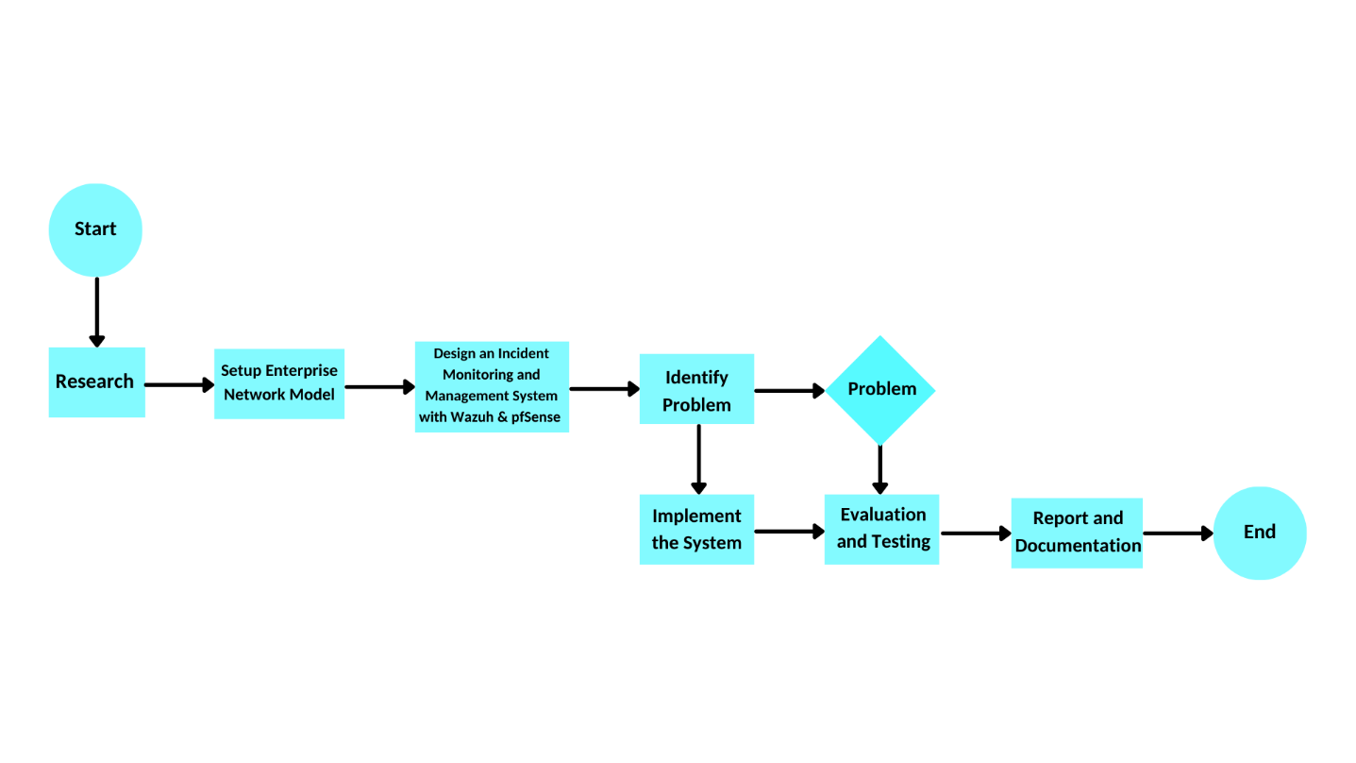

Figure . - Solution Process Model

### Roles and Responsibilities

|  |  |  |  |
| --- | --- | --- | --- |
| **Phrase** | **Fullname** | **Role** | **Responsible** |
| Planning | Nguyễn Xuân Yến | Team Leader, Technical, Consultant, Document | Identifying team member,  Setting working rules,  Contact to supervisor to get details information about the project |
| Nguyễn Thanh Hợp | Technical, Consultant, Document | Collecting documents,  gathering necessary equipment,  researching relevant technologies. |
| Trần Minh Quang | Technical, Consultant | Collecting documents,  identifying hardware and software resources,  assessing network infrastructure requirements. |
| Đặng Hoàng Việt | Technical, Consultant | Defining the project process model,  reviewing cybersecurity frameworks. |
| Design | Nguyễn Xuân Yến | Team Leader, Technical, Consultant, Document | Delegating tasks,  analyzing project goals,  planning milestones,  monitoring progress,  overseeing security architecture,  configuring pfSense firewall. |
| Nguyễn Thanh Hợp | Technical, Consultant, Document | Designing network infrastructure |
| Trần Minh Quang | Technical, Consultant | Evaluating security models,  assisting in infrastructure setup,  reviewing design specifications. |
| Đặng Hoàng Việt | Technical, Consultant | Conducting technical research,  evaluating system design,  configuring IDS/IPS integration. |
| Risk Assessment | Nguyễn Xuân Yến | Team Leader, Technical, Consultant, Document | Identifying risks,  Conducting risk analysis research,  Methods and technologies,  Review and evaluation. |
| Nguyễn Thanh Hợp | Technical, Consultant | Identifying risks,  Conducting risk analysis research,  Methods and technologies,  Review and evaluation. |
| Trần Minh Quang | Technical, Consultant | Identifying risks,  Conducting risk analysis research,  Methods and technologies,  Review and evaluation. |
| Đặng Hoàng Việt | Technical, Consultant | Identifying risks,  Conducting risk analysis research,  Methods and technologies,  Review and evaluation. |
| Developing & Testing | Nguyễn Xuân Yến | Team Leader, Technical, Consultant, Document | Overseeing implementation,  configuring Wazuh and pfSense,  troubleshooting integration issues. |
| Nguyễn Thanh Hợp | Technical, Consultant | Conducting system tests,  analyzing security alerts,  ensuring rule optimization,  troubleshooting integration issues. |
| Trần Minh Quang | Technical, Consultant | Deploying and testing Wazuh Agents,  configuring security rules,  collecting test data,  troubleshooting integration issues. |
| Đặng Hoàng Việt | Technical, Consultant | Evaluating system performance,  validating detection accuracy,  documenting testing results,  troubleshooting integration issues. |

Table .. Roles and Responsible

### Tools and Techniques

|  |  |  |
| --- | --- | --- |
| **No** | **Tool** | **Function** |
|  | VMWare | Provides virtual machines for running multiple operating systems like Windows, Linux, for testing and simulating network incidents. |
|  | Wazuh | SIEM tool for monitoring, log analysis, real-time threat detection, and automated incident response. |
|  | pfSense | Open-source firewall for managing network traffic and enhancing network security through custom firewall rules. |
|  | ELK Stack | A set of tools (Elasticsearch, Logstash, Kibana) used for real-time log data analysis, visualization, and incident management in a web-based dashboard. |
|  | Canva | A design tool used for creating flowcharts, diagrams, and models to represent the architecture of the system, incident workflows, etc. |
|  | Syslog | A protocol used for sending log or event messages to a central log server, enabling Wazuh to collect and analyze logs from pfSense. |
|  | Hping3 | Packet crafting tool used to simulate DoS attacks and test firewall/IDS/IPS configurations. |
|  | Email (Gmail) | Used for sending automated alerts from Wazuh to system administrators. |
|  | VirusTotal | An online malware scanning service integrated via API to verify file hashes and scan suspicious files during the malware detection scenario. |
|  | Python (script) | The system evaluates the severity of virus alerts triggered by Wazuh, and the Active Response script blocks intrusion and prevents malware propagation. |
|  | Hydra | A powerful brute-force tool used to simulate SSH brute-force login attacks by trying multiple username and password combinations. |

Table .. Tools and Techniques

## Project Management Plan

### Tasks

#### Planning

|  |  |
| --- | --- |
| Description | The team collaborates with the supervisor to outline the project objectives, scope, and timeline. Discussions focus on integrating Wazuh (SIEM) and pfSense (firewall) for incident management. |
| Distribution | Team members contribute ideas, evaluate security solutions, and assign tasks based on expertise (network security, system administration, and incident response). |
| Resources needed | Online resources, cybersecurity research papers, Wazuh and pfSense official documentation, and supervisor guidance. |
| Dependencies and Constraints | Effective collaboration is required to ensure a well-structured implementation plan, with clear task assignments and milestone tracking. |
| Risks | Potential team conflicts are managed through open communication to maintain a positive work environment. |

Table .. Project Management - Planning

#### Research

|  |  |
| --- | --- |
| Description | Each member researches key components: Wazuh architecture and functionalities, pfSense firewall capabilities, cybersecurity threats, and incident response best practices. |
| Distribution | |  | | --- | | Research is divided into IDS/IPS concepts, SIEM integration, firewall configurations, and enterprise security policies. | |
| Resources needed | Official documentation, white papers on security monitoring, case studies on SIEM and firewall integration, and cybersecurity reports. |
| Dependencies and Constraints | The accuracy and relevance of collected data will determine the effectiveness of the system design and implementation. |

Table .. Project Management - Research

#### Developing Solutions

|  |  |
| --- | --- |
| Description | The team configures and integrates Wazuh SIEM with pfSense firewall to create a real-time security monitoring and incident response system. |
| Distribution | Tasks include deploying Wazuh Server, setting up Wazuh Agents, configuring pfSense for log forwarding, defining security rules, and testing attack scenarios. |
| Resources needed | |  |  | | --- | --- | | Virtualized test environment, network security tools, Wazuh and pfSense setup guides, and access to real-world attack datasets for testing. | | |  | |
| Dependencies and Constraints | Challenges may include **log collection issues, rule misconfigurations, and tuning alerts to reduce false positives,** requiring iterative testing and optimization. |

Table .. Project Management – Developing Solutions

#### Writing Document

|  |  |  |  |  |
| --- | --- | --- | --- | --- |
| Description | | A detailed report documenting the design, implementation, testing, and evaluation of the incident management system using Wazuh and pfSense. | | | --- | --- | |  | |
| Distribution | |  |  | | --- | --- | | All team members contribute by documenting system architecture, deployment process, test cases, security findings, and system performance evaluation. | | |  | |
| Resources needed | |  |  | | --- | --- | | Report template from FPT University, system logs, attack detection results, screenshots of Kibana dashboards, and configuration files. | | |  | |
| Dependencies and Constraints | The quality of the report depends on **accurate documentation of configurations, security events, and practical findings from test cases.** |

Table .. Project Management – Writing Document

### Task Sheet: Assignments and Timetable

|  |  |  |  |
| --- | --- | --- | --- |
| **Task** | **Author** | **Start Date** | **End Date** |
| Project Initiating | All Members | 06/01/2025 | 06/01/2025 |
| Identifying goals, planning, and delegating tasks | Nguyễn Xuân Yến | 06/01/2025 | 08/01/2025 |
| Reading resources and documents about Wazuh & pfSense | Nguyễn Xuân Yến, Nguyễn Thanh Hợp | 09/01/2025 | 13/01/2025 |
| Discussing risk assessment and management | Nguyễn Xuân Yến, Nguyễn Thanh Hợp | 14/01/2025 | 15/01/2025 |
| Analyzing how Wazuh & pfSense work | Trần Minh Quang, Đặng Hoàng Việt | 15/01/2025 | 18/01/2025 |
| Analyzing the Enterprise Network Infrastructure | Nguyễn Thanh Hợp, Trần Minh Quang | 18/01/2025 | 19/01/2025 |
| Design topology | Nguyễn Thanh Hợp | 19/01/2025 | 21/01/2025 |
| Install and configure Wazuh & pfSense | Trần Minh Quang, Đặng Hoàng Việt | 21/01/2025 | 25/01/2025 |
| Integrate Wazuh with pfSense via Syslog | Trần Minh Quang, Đặng Hoàng Việt | 26/01/2025 | 08/02/2025 |
| Review rules in Wazuh | Đặng Hoàng Việt | 09/02/2025 | 13/02/2025 |
| Prepare contents of presentation for Review 1 | Nguyễn Xuân Yến, Nguyễn Thanh Hợp | 11/02/2025 | 13/02/2025 |
| Prepare presentation slides for Review 1 | Nguyễn Xuân Yến, Nguyễn Thanh Hợp | 11/02/2025 | 13/02/2025 |
| Integrate ELK with Wazuh | Trần Minh Quang | 15/02/2025 | 23/02/2025 |
| Create the Enterprise Policy | Nguyễn Xuân Yến | 15/02/2025 | 23/02/2025 |
| Develop the Overview Scenario | Nguyễn Xuân Yến, Trần Minh Quang | 24/02/2025 | 28/02/2025 |
| Update and refine network infrastructure diagram | Nguyễn Thanh Hợp | 01/03/2025 | 03/03/2025 |
| Develop scenario for Block Brute-Force SSH demo | Nguyễn Xuân Yến, Đặng Hoàng Việt | 03/03/2025 | 05/03/2025 |
| Draw incident management flowcharts for Brute-Force SSH demo | Nguyễn Thanh Hợp, Nguyễn Xuân Yến | 04/03/2025 | 11/03/2025 |
| Find a suitable Malware Backdoor | Đặng Hoàng Việt, Trần Minh Quang | 03/03/2025 | 05/03/2025 |
| Deploy a Whitelist Policy | Nguyễn Xuân Yến, Trần Minh Quang | 03/03/2025 | 04/03/2025 |
| Deploy Brute-Force SSH demo | Trần Minh Quang, Đặng Hoàng Việt | 04/03/2025 | 11/03/2025 |
| Integrate VirusTotal | Trần Minh Quang, Đặng Hoàng Việt | 05/03/2025 | 08/03/2025 |
| Write rules for Brute-Force SSH demo | Đặng Hoàng Việt, Nguyễn Thanh Hợp | 09/03/2025 | 11/03/2025 |
| Customize Emails Alert for Brute-Force SSH demo | Đặng Hoàng Việt | 12/03/2025 | 13/03/2025 |
| Prepare contents of presentation for Review 2 | Nguyễn Xuân Yến, Nguyễn Thanh Hợp | 12/03/2025 | 13/03/2025 |
| Prepare presentation slides for Review 2 | Nguyễn Xuân Yến | 12/03/2025 | 13/03/2025 |
| Develop scenario for Trojan Attack demo | Nguyễn Xuân Yến, Trần Minh Quang | 15/03/2025 | 17/03/2025 |
| Draw incident management flowcharts for Trojan Attack demo | Nguyễn Thanh Hợp, Nguyễn Xuân Yến | 16/03/2025 | 18/03/2025 |
| Deploy Trojan Attack demo | Trần Minh Quang, Đặng Hoàng Việt | 17/03/2025 | 26/03/2025 |
| Write rules for Trojan Attack demo | Đặng Hoàng Việt, Nguyễn Thanh Hợp | 20/03/2025 | 26/03/2025 |
| Customize Emails Alert for Trojan Attack demo | Đặng Hoàng Việt | 25/03/2025 | 27/03/2025 |
| Develop scenario for DoS Attack demo | Đặng Hoàng Việt, Trần Minh Quang | 27/03/2025 | 29/03/2025 |
| Find tools and how to make a DoS Attack | Trần Minh Quang | 28/03/2025 | 29/03/2025 |
| Draw incident management flowcharts for DoS demo | Nguyễn Thanh Hợp, Nguyễn Xuân Yến | 28/03/2025 | 31/03/2025 |
| Deploy DoS Attack | Trần Minh Quang, Đặng Hoàng Việt | 01/04/2025 | 07/04/2025 |
| Analyzing back-up demos | Nguyễn Thanh Hợp, Trần Minh Quang | 01/04/2025 | 04/04/2025 |
| Write rules for DoS demo | Đặng Hoàng Việt, Nguyễn Thanh Hợp | 05/04/2025 | 06/04/2025 |
| Customize Emails Alert for DoS Attack demo | Đặng Hoàng Việt, Nguyễn Thanh Hợp | 06/04/2025 | 07/04/2025 |
| Draw incident management flowcharts for back-up demo | Nguyễn Thanh Hợp | 06/04/2025 | 07/04/2025 |
| Analyze incident management library for enterprise | Nguyễn Xuân Yến, Nguyễn Minh Quang | 07/04/2025 | 09/04/2025 |
| Deploy the Kibana Dashboard | Trần Minh Quang, Đặng Hoàng Việt | 21/03/2025 | 22/03/2025 |
| Compile each demo into a complete 4-step incident management process | Nguyễn Xuân Yến, Trần Minh Quang | 23/03/2025 | 08/04/2025 |
| Write documentation | Nguyễn Xuân Yến | 06/01/2025 | 17/04/2025 |
| Prepare contents of presentation for Review 3 | Nguyễn Xuân Yến, Nguyễn Thanh Hợp | 06/04/2025 | 07/04/2025 |
| Prepare presentation slides for Review 3 | Nguyễn Xuân Yến | 06/04/2025 | 08/04/2025 |
| Prepare contents of presentation for Capstone Project Defense | Nguyễn Xuân Yến, Nguyễn Thanh Hợp | 11/04/2025 | 15/04/2025 |
| Prepare presentation slides for Capstone Project Defense | Nguyễn Xuân Yến, Nguyễn Thanh Hợp | 13/04/2025 | 17/04/2025 |

Table .. Assignments and Timetable

### All Meeting Minutes

|  |  |
| --- | --- |
| Subject | Capstone Project (IAP491) |
| Instructor | Trần Văn Ninh |
| Date | 06/01/2025 |
| Time | 13h-14h30 |
| Members | Nguyễn Xuân Yến  Nguyễn Thanh Hợp  Trần Minh Quang  Đặng Hoàng Việt |
| Absense | None |

Table .. All Meeting Minutes

# RISK ASSESSMENT

## The Essential of Assessment

Risk assessment is a crucial process in cybersecurity enabling enterprises and organizations to detect, analyze, and correct issues in their network environment. Examining weaknesses or vulnerabilities, possible threats, and required resources enables businesses to give priorities to risks and allocate resources more effectively.

## Identify Critical Information Assets

Important assets help the administrator to better know and control the general risks connected to every asset.

|  |  |  |
| --- | --- | --- |
| **Asset Category** | **Subcategory** | **Details** |
| Servers & Firewalls | Virtual Machines | Wazuh Server,  pfSense Firewall |
| Log Management | Wazuh Indexer,  Wazuh Dashboard |
| Networking | Network Devices | Router,  Switch,  Access Points |
| Network Communication | Wi-Fi,  Ethernet |
| Security Systems | Intrusion Detection | Wazuh Agent |
| Security Monitoring | SIEM Integration, Rule-based Alerting |
| Monitoring Systems | Traffic Capture | pfSense,  Wazuh |
| Security Dashboards | Kibana |

Table .. Critical Information Assets

## Risk Identification

### Threat Identification

Threat identification is critical to the development of a successful incident management system. Knowing various potential attack vectors lets companies notice irregularities more precisely and respond quickly.

|  |  |
| --- | --- |
| **Agent** | **Threat** |
| Technology | * Vulnerabilities, * Misconfiguration, * Outdated Security, * Exploits |
| Human | * Insider Threats, * Phishing, * Social Engineering, * Misuse |
| Nature | * Power Outage, * Hardware Failure, * Natural Disasters |

Table .. Threat Identification

### Vulnerability Identification

Vulnerabilities in enterprise networks often stem from human error, outdated policies, and poorly maintained systems. Without clear visibility into these weaknesses, organizations struggle to respond quickly and effectively when incidents occur.

|  |  |
| --- | --- |
| **Cause** | **Description** |
| Network Misconfiguration | Poorly configured firewalls, weak IDS/IPS settings, and unpatched network services can lead to data breaches. Open ports and insecure protocols increase the attack surface. |
| Outdated or Improper Software Setup | Systems with misconfigurations or unpatched services are highly vulnerable. Attackers can exploit open ports or outdated protocols to launch DoS attacks, inject malware, or escalate privileges. |
| Human Error | Breaches often result from weak passwords, lack of security awareness, or improper user practices. Strengthening authentication and training are essential. |

Table .. Vulnerability Identification

## Risk Analysis

### Impact Assessment

Risk impact assessment examines the likelihood of each specific risk materializing and its potential effects on a project's objectives, including budget, schedule, time, quality, or performance.

There are three levels of impact:

|  |  |  |  |  |
| --- | --- | --- | --- | --- |
| **Risk Level** | | **Likelihood Level** | | |
| Low | Medium | High |
| **Impact Level** | High | Medium | Medium | High |
| Medium | Low | Medium | Medium |
| Low | Low | Low | Medium |

Table .. Levels of Impact

### Likelihood Assessment

Judging the probability and effects of risk occurrences is likelihood assessment. The results of the study help to prioritize risks by means of a categorization of the hazards according to their relevance.

|  |  |  |
| --- | --- | --- |
| **Level** | **Probability** | **Characteristic** |
| Very Low | Rare event | May occur only in exceptional cases |
| Low | May occur within 4 years | Unlikely but possible under certain conditions |
| Medium | May occur within 2 years | Moderate probability, could happen occasionally |
| High | May occur within 1 year | Likely to occur at least once within a year |
| Very High | Multiple occurrences in 1 year | Most likely to happen frequently based on past statistics |

Table .. Likelihood Assessment

### Risk Level Description

By examining both their probability and impact, risk level assessment lets one gauge the severity of possible hazards. Organizations that categorize risks appropriately will be able to create efficient reaction plans to reduce possible security events.

|  |  |  |
| --- | --- | --- |
| **Risk Level** | **Description** | **Impact on System** |
| Low | Minimal risk with negligible consequences | No significant disruption, minor security concerns |
| Medium | Manageable risk that may require attention | Some delays, slight performance impact |
| High | Significant risk with potential security threats | Possible data breaches, increased vulnerabilities |
| Critical | Severe risk that requires immediate mitigation | System failures, major security incidents, financial loss |

Table .. Risk Level Description

## Control Identification and Assessment

### Control Methods

#### Technical (Safeguard, Tools)

|  |  |  |
| --- | --- | --- |
| **No** | **Work** | **Level** |
|  | Install VMWare 17 | Low |
|  | Install Wazuh 4.5 | Low |
|  | Install pfSense 7.2 | Low |
|  | Install ELK Stack 7.17.13 | Medium |
|  | Configure Wazuh 4.5 | Medium |
|  | Configure pfSense 7.2 | Medium |
|  | Connect Wazuh and pfSense via Syslog | Medium |
|  | Customize Wazuh email alert templates with detailed content | Medium |
|  | Integrate VirusTotal API for suspicious file scanning | Medium |
|  | Deploy Kibana dashboard to display only critical incidents | Medium |
|  | Classify logs by severity level and assign handlers in Kibana | Medium |
|  | Simulate DoS attack using hping3 | Medium |
|  | Configure pfSense to apply bandwidth limits and rate-limiting (DoS prevention) | Medium |
|  | Simulate brute-force SSH attack using Hydra | Medium |
|  | Create Wazuh alert rule for Brute-force SSH Detection | High |
|  | Create Wazuh alert rule for Malware Detection (e.g., Trojan) | High |
|  | Configure Wazuh to send email alerts to Admin | High |
|  | Implement Wazuh to detect suspicious SSH login attempts | High |
|  | Configure pfSense to block suspicious IP addresses based on Wazuh alerts | High |
|  | Integrate ELK Stack with Wazuh for log visualization | High |
|  | Configure Wazuh Active Response to auto-delete malware | High |
|  | Detect cracked software download and trigger Wazuh response | High |
|  | Auto-assign Log_IDs and push incidents to Incident Management Library | High |

Table .. Technical Control Methods

#### Non-Technical

Company policies and procedures dictate that non-technical controls are essential for reducing risks and enhancing security posture within an event management system. Significant non-technical measures comprise:

|  |  |
| --- | --- |
| **Control Area** | **Description** |
| User Awareness and Training | Implement structured training initiatives tailored to specific threats such as phishing and insider risks, conducted annually and reinforced via simulated campaigns. |
| Physical Security | Deploy surveillance, access controls, and secure storage to protect critical infrastructure and prevent unauthorized physical access. |
| Data Backup Plan | Develop and maintain a backup plan for critical configuration files, authentication logs, and Wazuh detection rules to ensure fast recovery after an incident. |
| Authentication Policy | Enforce strong password policies, account lockout mechanisms, and mandatory credential rotation to mitigate brute-force attempts on SSH services. |

Table .. Non-technical controls

### Control Types

* Deterrent controls: Reduce the risk of an attack by deterring prospective threats (e.g. security rules, personnel training, access limitations).
* Preventive Controls: Use firewalls, IDS/IPS, and strong authentication techniques to prevent attacks from exploiting weaknesses.
* Detective Controls: Detect and report security incidents (such as Wazuh log analysis, SIEM alerts, and anomaly detection).
* Corrective Controls: Respond to and mitigate ongoing threats (e.g. automated threat response, patch management, incident recovery).
* Corrective Controls: Respond to and mitigate ongoing threats (e.g. automated threat response, patch management, incident recovery).
* Compensating Controls: Provide alternative security measures when primary controls are unavailable (e.g. network segmentation, multi-factor authentication (MFA)).

### Risk Monitoring and Controlling

Risk monitoring and controlling is an ongoing process to ensure security measures remain effective. Wazuh SIEM detects anomalies through log analysis, while pfSense firewall enforces traffic control to block threats. Incident response mechanisms must be in place to contain threats immediately. Regular security audits and compliance checks help maintain system integrity. Continuous monitoring and adaptation strengthen the Incident Management System, enhancing network resilience against cyber threats.

# RISK MANAGEMENT PLAN (RMP)

## Objectives of RMP

### Lists of Threats/Vulnerabilities

|  |  |  |
| --- | --- | --- |
| **No** | **Threats** | **Vulnerability** |
|  | Brute-Force Attack | - Use of default or weak SSH passwords  - No login attempt rate-limiting  - Missing detection rules for failed SSH authentication  - No account lockout mechanism |
|  | Malware & Ransomware Attacks | - Unpatched software and outdated security patches  - Lack of endpoint protection and antivirus solutions  - Phishing emails tricking users into downloading malware |
|  | Denial of Service (DoS) Attack | - Insufficient network traffic filtering (firewall misconfigurations)  - No rate-limiting mechanisms  - Lack of DoS/DDoS protection  - No blacklisting of suspicious sources |
|  | Insider Threats | - Excessive user privileges without monitoring  - Lack of logging and audit trails  - No security awareness training for employees  - Lack of IP-based access control  - No alert on access outside working hours  - No segmentation by department/role |
|  | Unpatched Vulnerabilities | - Outdated operating systems and third-party software  - End-of-life (EOL) applications still in use  - No automated patch management process  - Lack of vulnerability scanning and reporting |
|  | Data Leakage | - Misconfigured data shares  - Weak or no encryption for sensitive data  - Improper data handling by employees  - No Data Loss Prevention (DLP) policy  - Lack of secure file transfer protocols (e.g., SFTP) |
|  | Weak Network Security | - Poor firewall rules allowing unnecessary open ports  - Lack of network segmentation  - No intrusion detection/prevention system (IDS/IPS)  - Vulnerable to ARP spoofing attacks |
|  | Social Engineering Attacks | - Lack of employee cybersecurity awareness training  - No email filtering for phishing protection  - No policies for verifying caller/email sender identities  - No simulations or red-teaming to test awareness  - No protection against spoofed domains or impersonated brands |

Table .. Lists of Threats and Vulnerabilities

### Cost associated with risks

To assess the financial and operational impact of security risks, we categorize risks into four levels:

* Low: Minimal impact; no immediate threat. Monitor to prevent escalation.
* Medium: Moderate disruption or loss possible. Should be addressed to avoid future risk.
* High: Serious threat to security and operations. May cause major damage if ignored.
* Critical: Immediate and severe risk (e.g., attacks, breaches). Requires urgent action to prevent system failure

|  |  |  |
| --- | --- | --- |
| **No** | **Risk** | **Cost** |
|  | Unauthorized Access | High |
|  | Malware & Ransomware Attacks | Critical |
|  | Denial of Service (DoS) Attack | Medium |
|  | Insider Threats | High |
|  | Unpatched Vulnerabilities | High |
|  | Data Leakage | Critical |
|  | Weak Network Security | Medium |
|  | Social Engineering Attacks | Medium |

Table .. Cost associated with risks

### List of Recommendations to Reduce the Risks

|  |  |  |  |
| --- | --- | --- | --- |
| **No** | **Risk** | **Recommendations** | **Cost** |
|  | Brute-force SSH Attack | - Weak or default SSH passwords  - No account lockout or login rate limiting  - Lack of SSH brute-force detection (e.g., missing Wazuh rule) | Medium |
|  | Malware & Ransomware Attacks | - Deploy Next-Generation Antivirus (NGAV) and EDR  - Conduct employee training on phishing threats  - Implement malware detection for file integrity and behavior monitoring | High |
|  | Denial of Service (DoS) Attack | - Use firewall and rate-limiting  - Implement DDoS protection services | Medium |
|  | Insider Threats | - Restrict access based on job roles  - Conduct regular security awareness training  - Implement user activity monitoring to detect unusual behaviors | Medium |
|  | Unpatched Vulnerabilities | - Enforce automated patch management  - Use vulnerability scanning tools | Medium |
|  | Data Leakage | - Encrypt sensitive data  - Apply Data Loss Prevention (DLP) policies | High |
|  | Weak Network Security | - Configure strict firewall rules  - Deploy Intrusion Detection/Prevention Systems (IDS/IPS)  - Implement ARP security protocols to protect against ARP spoofing  - Segregate networks to reduce attack surfaces | High |
|  | Social Engineering Attacks | - Provide security awareness training  - Implement email filtering and anti-phishing solutions | High |

Table .. List of Recommendations to Reduce the Risks.

### Costs Associated with Recommendations

|  |  |  |
| --- | --- | --- |
| **Risk** | **Cost Before Applying Recommendation** | **Cost After Applying Recommendation** |
| Brute-force SSH Attack | High | Low |
| Malware & Ransomware Attacks | Critical | Medium |
| Denial of Service (DoS) Attack | High | Medium |
| Insider Threats | High | Medium |
| Unpatched Vulnerabilities | High | Low |
| Data Leakage | Critical | Medium |
| Weak Network Security | High | Medium |
| Social Engineering Attacks | Medium | Low |

Table .. Costs Associated with Recommendations

## Assigning Responsibilities

|  |  |  |
| --- | --- | --- |
| **Fullname** | **Role** | **Responsibilities** |
| Nguyễn Xuân Yến | Leader,  Technical,  Consultant | Analyzing goals,  Planning milestones,  Monitoring work,  Document Writer |
| Nguyễn Thanh Hợp | Technical,  Consultant | Researching network &  monitor connection,  Review and evaluation, Document Writer. |
| Trần Minh Quang | Technical,  Consultant | Advising solution,  Researching network &  monitor connection,  Review and evaluation. |
| Đặng Hoàng Việt | Technical,  Consultant | Code developer,  Researching network &  monitor connection, Review and evaluation. |

Table .. Assigning Responsibilities

## Describing Procedures and Schedules for Accomplishment

|  |  |
| --- | --- |
| **Risk** | **Procedures and Schedules** |
| Brute-force SSH Attack | Implement SSH hardening (one-time), enable login rate-limiting (one-time), monitor failed login attempts (continuous) |
| Malware & Ransomware Attacks | Deploy NGAV & EDR, conduct phishing awareness training (bi-annually), implement real-time malware detection |
| Denial of Service (DoS) Attack | Firewall & rate-limiting (one-time), real-time monitoring (continuous), annual DoS/DDoS protection review |
| Insider Threats | User activity monitoring (continuous), security training (annually), immediate investigations |
| Unpatched Vulnerabilities | Automated patch management (continuous), monthly vulnerability scanning |
| Data Leakage | Implement DLP & encryption policies (one-time), quarterly audits |
| Weak Network Security | Firewall & IDS/IPS enforcement (one-time), annual penetration testing |
| Social Engineering Attacks | Deploy anti-phishing solutions, quarterly phishing simulations, immediate investigations |

Table .. Procedures and Schedules for Accomplishment

## Reporting Requirements

### Present Recommendation

Our goal is to develop/build an Incident Management System (IMS) tailored for small and medium-sized enterprises (SMEs) in enterprise network environments. This system integrates Wazuh and pfSense to proactively detect and block brute-force SSH attacks, identify and remove malware, and prevent various network-based threats and service disruptions such as DoS attacks. The system will also send real-time email notifications to administrators or technical support teams whenever a threat is detected, ensuring timely awareness and response. Additionally, we will implement an Incident Management Library to categorize and record security events, making it easier to track and manage incidents. Ultimately, this approach strengthens overall cybersecurity by providing real-time threat detection, automated responses, and a well-structured system for managing security events.

### Document Management Response to Recommendations

|  |  |  |
| --- | --- | --- |
| **Recommendation** | **Management Response and Action** | **Action By** |
| Regular system maintenance and updates | Perform routine updates to maintain security compliance and patch known vulnerabilities | Technical Team |
| Monitor security configurations regularly | Conduct quarterly audits of firewall, IDS/IPS, and critical system configurations | Security Team |
| Real-time monitoring and alerting | Deploy Wazuh SIEM for continuous monitoring and automated incident alerts | Monitoring Team |
| Security awareness training | Deliver periodic training on phishing, malware, and response procedures | HR & Security Team |
| Ensure secure data storage and transmission | Apply encryption for data at rest and in transit | IT & Management Teams |
| Mitigate DDoS and brute-force attacks | Implement firewall rate-limiting and block repeated failed login attempts (SSH, FTP) | Network Security Team |
| Improve SSH access policy | Apply login rate-limiting and actively monitor authentication behavior | Network & Security Team |
| Strengthen Active Response rules | Tune Wazuh rules regularly to improve accuracy and reduce false positives | SOC / Monitoring Team |
| Establish an Incident Management Library | Maintain a centralized incident log to support response tracking and forensic analysis | Compliance & Security Team |

Table .. Document Management Response to Recommendation

## Plan of Action and Milestones

|  |  |  |  |
| --- | --- | --- | --- |
| **Action** | **Responsible** | **Start Date** | **End Date** |
| **Brainstorming** | | 06/01/2025 | 08/01/2025 |
| **First group meeting and project initializing** | All Members | 06/01/2025 | 06/01/2025 |
| **Identifying goals, planning, and delegating tasks** | Nguyễn Xuân Yến | 06/01/2025 | 08/01/2025 |
| **Researching** | | 09/01/2025 | 20/01/2025 |
| **Reading resources and documents about Wazuh & pfSense** | Nguyễn Xuân Yến, Nguyễn Thanh Hợp | 09/01/2025 | 13/01/2025 |
| **Discussing risk assessment and management** | Nguyễn Xuân Yến, Nguyễn Thanh Hợp | 14/01/2025 | 16/01/2025 |
| **Analyzing Wazuh & pfSense** | Trần Minh Quang, Đặng Hoàng Việt | 17/01/2025 | 20/01/2025 |
| **Designing topology** | Nguyễn Thanh Hợp | 17/01/2025 | 20/01/2025 |
| **Installing and configuring Wazuh & pfSense** | Trần Minh Quang, Đặng Hoàng Việt | 21/01/2025 | 25/01/2025 |
| **Integrating Wazuh with pfSense via Syslog** | Trần Minh Quang, Đặng Hoàng Việt | 26/01/2025 | 08/02/2025 |
| **Reviewing and writing rules in Wazuh** | Đặng Hoàng Việt, Nguyễn Thanh Hợp | 09/02/2025 | 13/02/2025 |
| **Integrating ELK with Wazuh** | Trần Minh Quang, Đặng Hoàng Việt | 15/02/2025 | 23/02/2025 |
| **Developing attack scenarios (Brute-Force SSH, Trojan Attack, DoS)** | Nguyễn Xuân Yến, Trần Minh Quang | 24/02/2025 | 28/02/2025 |
| **Updating network diagram and incident flowcharts** | Nguyễn Thanh Hợp, Nguyễn Xuân Yến | 01/03/2025 | 03/03/2025 |
| **Deploying demos (Brute-Force SSH, Trojan Attack, DoS)** | Trần Minh Quang, Đặng Hoàng Việt, Nguyễn Thanh Hợp | 04/03/2025 | 25/03/2025 |
| **Developing incident management library** | Nguyễn Thanh Hợp, Nguyễn Xuân Yến | 15/03/2025 | 25/03/2025 |
| **Evaluating** | | 26/03/2025 | 11/04/2025 |
| **Compiling all demos into incident management process** | All Members | 26/03/2025 | 04/04/2025 |
| **Writing documentation** | Nguyễn Xuân Yến | 06/01/2025 | 13/04/2025 |
| **Preparing presentation slides** | Nguyễn Xuân Yến | 15/04/2025 | 17/04/2025 |
| **Presenting** | All Members | 29/04/2025 | 29/04/2025 |

Table .. Plan of Action and Milestones

## Charting the Progress of a RMP

### Milestone Plan Chart

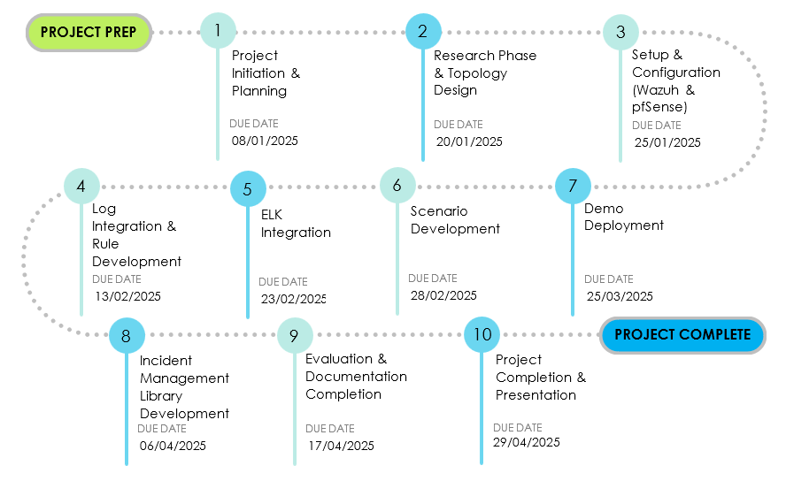

Figure . - Milestone Plan Chart

### Gantt Chart

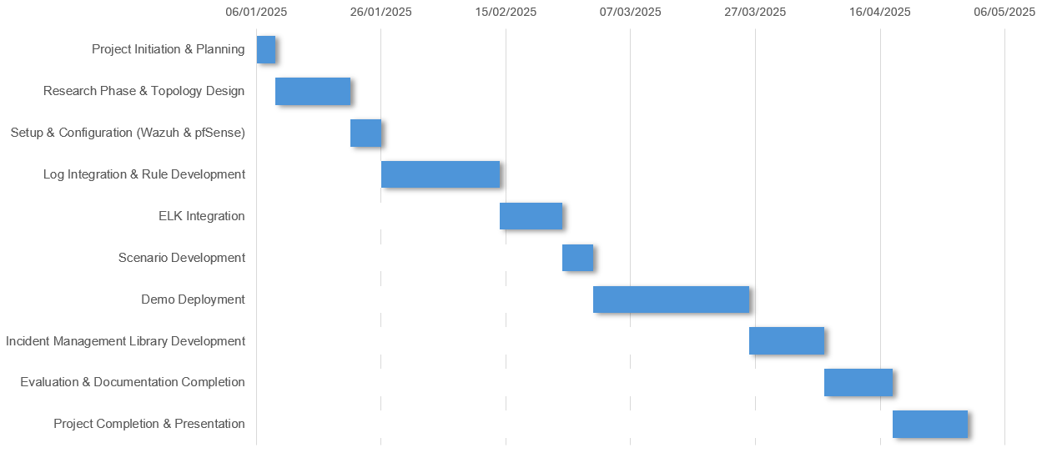

Figure . - Gantt Chart

## Tools and Practices

|  |  |  |
| --- | --- | --- |
| **No** | **Tool** | **Function** |
|  | VMWare | Provides virtual machines for running multiple operating systems like Windows, Linux, for testing and simulating network incidents. |
|  | Wazuh | SIEM tool for monitoring, log analysis, real-time threat detection, and automated incident response. |
|  | pfSense | Open-source firewall for managing network traffic, blocking unauthorized access, and enhancing network security through custom firewall rules. |
|  | ELK Stack | A set of tools (Elasticsearch, Logstash, Kibana) used for real-time log data analysis, visualization, and incident management in a web-based dashboard. |
|  | Canva | A design tool used for creating flowcharts, diagrams, and models to represent the architecture of the system, incident workflows, etc. |
|  | Syslog | A protocol used for sending log or event messages to a central log server, enabling Wazuh to collect and analyze logs from pfSense. |
|  | Hping3 | Packet crafting tool used to simulate DoS attacks and test firewall/IDS/IPS configurations. |
|  | Email (Gmail) | Used for sending automated alerts from Wazuh to system administrators. |
|  | VirusTotal | An online malware scanning service integrated via API to verify file hashes and scan suspicious files during the malware detection scenario. |
|  | Python (script) | The system evaluates the severity of virus alerts triggered by Wazuh, and the Active Response script blocks intrusion and prevents malware propagation. |
|  | Hydra | A powerful brute-force tool used to simulate SSH brute-force login attacks by trying multiple username and password combinations. |

Table .. Tools and Practices

# DEVELOPMENT AND IMPLEMENTATION PLAN

## Risk Response Planning

### Major Risk Treatment

|  |  |
| --- | --- |
| **Risk** | **Risk Treatment** |
| Disaster | Maintain offsite backups and disaster recovery plans; ensure data redundancy across multiple locations. |
| System Failure Due to Cyberattack | Regularly update and test backup Wazuh and pfSense configurations to restore service quickly. |
| Hardware Failures | Maintain spare networking and computing equipment to support hot-swappable replacements. |
| Misconfiguration in Wazuh & pfSense | Conduct periodic audits, enforce security policies, and provide detailed setup guidelines for system administrators. |
| Power Outages | Deploy uninterruptible power supplies (UPS) and generators to ensure continuous operation of security systems. |
| Network Congestion or Failure | Implement network redundancy, optimize Quality of Service (QoS), and establish automatic failover mechanisms. |

Table .. Major Risk Treatment

### Risk Mitigation Treatment

|  |  |  |
| --- | --- | --- |
| **Risk** | **Mitigation Strategy** | **Implementation Approach** |
| Disaster | Ensure business continuity and data resilience. | Store backups in multiple geographic locations, implement cloud-based recovery options, and establish an emergency response plan. |
| System Failure Due to Cyberattack | Ensure system resilience with backup Wazuh and pfSense configurations. | Perform periodic system snapshots, regularly update IDS/IPS rules, and simulate recovery procedures. |
| Hardware Failures | Keep backup equipment ready for quick replacement. | Maintain an inventory of critical components, including network devices, storage drives, and power supplies. |
| Misconfiguration in Wazuh & pfSense | Improve configuration management. | Schedule automated security audits, enforce configuration baselines, and provide a user-friendly setup guide. |
| Power Outages | Guarantee uninterrupted power supply. | Install UPS and backup generators, conduct periodic maintenance, and test failover mechanisms. |
| Network Congestion or Failure | Enhance network stability. | Implement redundant network paths, configure pfSense load balancing, and apply traffic shaping policies. |

Table .. Risk Mitigation Treatment

### Risk Mitigation Plan (RMiP)

|  |  |  |
| --- | --- | --- |
| **Task** | **Goal** | **Action** |
| Prepare for Disasters | Minimize data loss and ensure operational continuity during catastrophic events. | Store encrypted backups offsite, test disaster recovery procedures quarterly, and implement cloud failover solutions. |
| Prepare for Cyberattacks | Reduce system downtime and data loss during security incidents. | Maintain backup configurations of Wazuh and pfSense, conduct monthly security assessments, and test disaster recovery plans. |
| Hardware Availability | Prevent prolonged outages due to hardware failures. | Keep spare parts for critical systems, configure pfSense with failover settings, and test hot-swappable components. |
| Configuration Management | Minimize misconfigurations and enhance system security. | Perform automated configuration scans, apply best practices for firewall rules, and train administrators on Wazuh policy management. |
| Power Continuity | Ensure uninterrupted power supply to critical security systems. | Install and maintain UPS/generators, conduct regular power failover tests, and optimize energy consumption. |
| Network Stability | Maintain stable and secure network connectivity for the IDS and monitored devices. | Deploy redundant internet connections, configure pfSense QoS to prioritize critical traffic, and monitor network health using Wazuh. |

Table .. Risk Mitigation Plan

## Theoretical Basis

### Wazuh

#### Definition

Wazuh is a free, open-source platform for threat prevention, detection, and response. It is capable of securing workloads in on-premises, virtualised, containerised, and cloud settings.

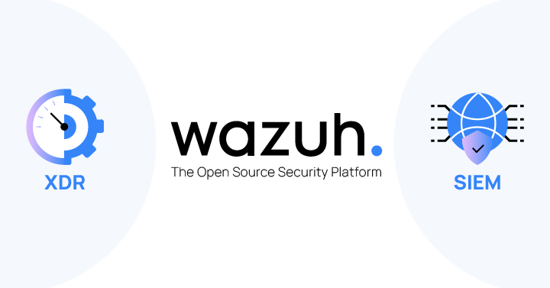 The Wazuh solution comprises of an endpoint security agent placed on the monitored systems and a management server that gathers and analyses data collected by the agents. Furthermore, Wazuh is completely linked with the Elastic Stack, providing a search engine and data visualisation tool to help customers traverse their security alerts.

Figure .. Wazuh SIEM and XDR

#### The needs of Wazuh

Organizations and enterprises today face increasingly complex cybersecurity challenges. These include cyberattacks, a lot of security events, and not well-organized security systems. Wazuh helps to solve these by offering a central system for security monitoring that can do the following:

* Real-Time Detection of Threats: Helps find out and fix security threats quickly to lower how long it takes to react and the possible damage.
* Central Log Management: Makes it simpler to gather, compare, and look at logs from different sources so that the understanding of the situation is better and forensics is stronger.
* Regulatory Compliance: Helps firms achieve the fulfillment of conditions by backing up audit trails and producing detailed reports aligned with the likes of PCI DSS, GDPR, and HIPAA
* Cost-Effectiveness: Its enterprise-level security features are given without the imposition of any license charges so it proves to be a low-priced choice for companies of all sizes.

#### Capabilities

|  |  |
| --- | --- |
| **Capability** | **Description** |
| Log Collection and Analysis | Collects logs, network devices, and operating systems; normalizes data for real-time threat detection and analysis. |
| Intrusion Detection (HIDS) | Detects suspicious behavior or unauthorized access using signature-based and anomaly-based methods, covering both known and unknown threats. |
| File Integrity Monitoring (FIM) | Monitors changes in critical system files and configurations; provides early warnings for malware outbreaks or tampering. |
| Vulnerability Detection | Scans for outdated software and known vulnerabilities; correlates findings with threat intelligence for actionable insights. |
| Compliance Auditing | Evaluates system configurations against standards like PCI DSS, HIPAA, GDPR, NIST, and ISO 27001 to help maintain compliance. |
| Threat Intelligence & Visualization | Enriches internal event data with external threat feeds; integrates with the Elastic Stack for centralized, interactive dashboards and visual analytics. |
| Cloud & Container Security | Supports monitoring across cloud providers (AWS, Azure, GCP) and containerized environments (Docker, Kubernetes), ensuring broad infrastructure coverage. |
| Automated Incident Response | Enables automatic responses such as blocking IPs, isolating systems, and sending real-time alerts, reducing response time and impact. |

Table .. Capabilities of Wazuh

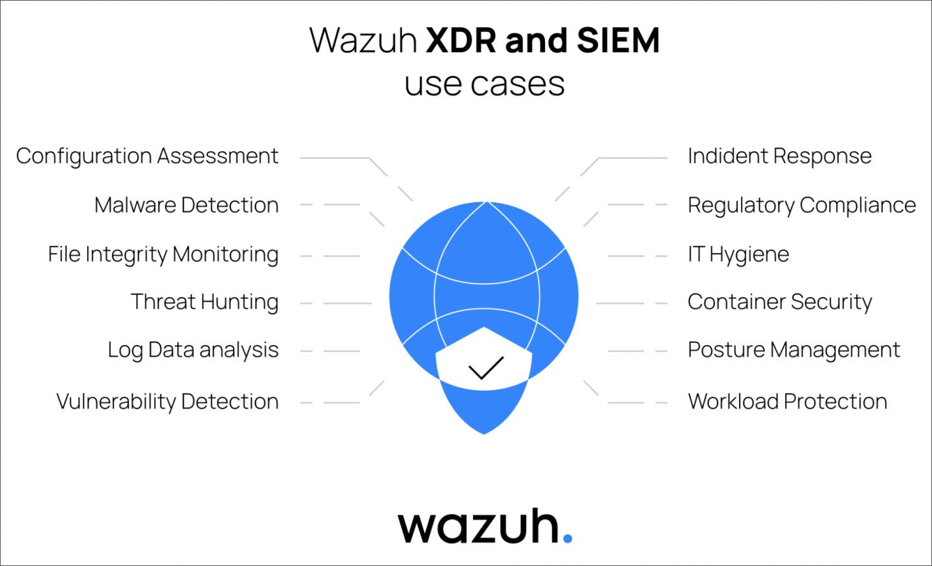

Figure . - Role of Wazuh in building a robust cybersecurity architecture

#### The Components of Wazuh

Wazuh architecture provides comprehensive security monitoring, log management, and compliance auditing through its key components working together seamlessly to protect and ensure system integrity. These include:

* Wazuh Agent: These ones are installed on endpoints (servers, workstations, cloud) to collect logs, monitor file integrity, and detect vulnerabilities. It supports various OS platforms and can also monitor devices without agents via Syslog or API.
* Wazuh Manager: The core engine that analyzes data from agents using decoders, detection rules, and correlation logic. It identifies threats, manages agent settings, and supports horizontal scaling for large environments.
* Wazuh Indexer: Indexes and stores alerts received from the manager, enabling fast search and analysis. Acts like a security search engine to quickly locate key log data.
* Wazuh Dashboard: A web interface for visualizing alerts, checking compliance, and conducting investigations. Integrated with Elastic Stack, it supports monitoring for standards like PCI DSS, GDPR, and HIPAA.

These components work together to form a scalable, real-time security monitoring system  
that integrates seamlessly with SIEM solutions, cloud security tools, and external threat  
intelligence sources. The Wazuh components and data flow are depicted in the diagram  
below.

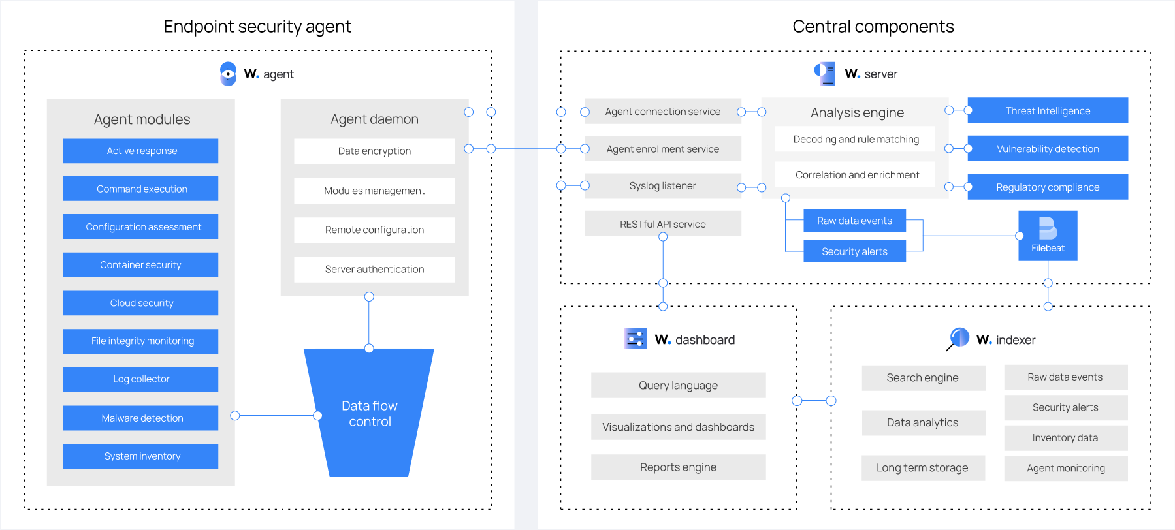

Figure . - Wazuh components and data flow

#### Wazuh Deployment

Wazuh can be deployed in various environments, including on-premises, cloud-based, and hybrid infrastructures. It follows a modular architecture, meaning organizations can scale their security monitoring system as needed, adding components or nodes to handle increased workloads.

The primary deployment models include:

|  |  |
| --- | --- |
| Deployment Model | Description |
| Single-Node Deployment | Suitable for small or test environments. All components (Manager, Indexer, Dashboard) run on one system. Easy to set up but limited in scalability. |
| Multi-Node Deployment | Used in enterprise setups. Multiple Wazuh Managers handle larger volumes and allow load distribution across servers. |
| Cloud Deployment | Integrated with platforms like AWS, Azure, or GCP. Ideal for hybrid infrastructures needing scalable cloud + on-premises monitoring. |

Table .. Deployment models of Wazuh

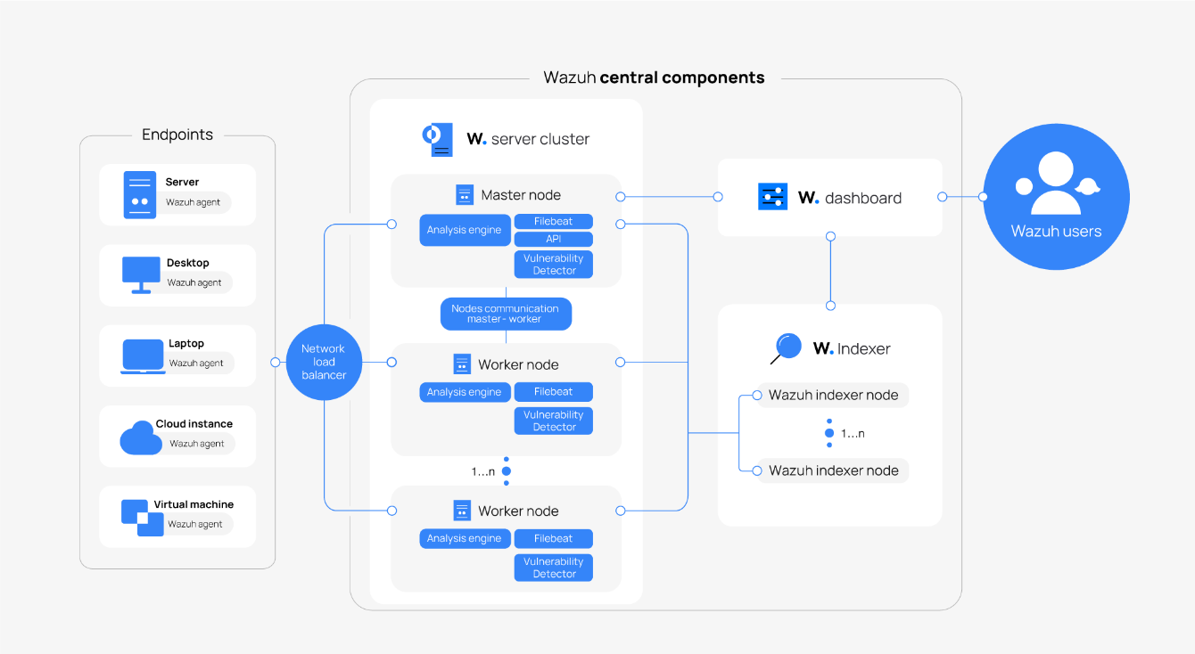

Figure . - Wazuh Deployment Architecture

#### Required ports

|  |  |  |  |
| --- | --- | --- | --- |
| **Component** | **Port** | **Protocol** | **Purpose** |
| Wazuh Server | 1514 | TCP (default) | Agent connection service |
| 1514 | UDP (optional) | Agent connection service (disabled by default) |
| 1515 | TCP | Agent enrollment service |
| 1516 | TCP | Wazuh cluster daemon |
| 514 | UDP (default) | Wazuh Syslog collector (disabled by default) |
| 514 | TCP (optional) | Wazuh Syslog collector (disabled by default) |
| 55000 | TCP | Wazuh server RESTful API |
| Wazuh Indexer | 9200 | TCP | Wazuh indexer RESTful API |
| 9300-9400 | TCP | Wazuh indexer cluster communication |
| Wazuh Dashboard | 443 | TCP | Wazuh web user interface |

Table .. Wazuh Required Ports

Several services facilitate communication among the different Wazuh components. These services work together to ensure smooth data flow and synchronization across the system. The list of default ports used by these services is shown above. Administrators can modify these port numbers based on their needs or security policies to enhance flexibility and prevent conflicts with other applications.

### pfSense

#### Definitions

Originally from FreeBSD, pfSense is a free routing and firewall systems. Among its complex network security features are traffic shaping, VPN support, intrusion prevention, and firewall filtering. pfSense is commonly used in both corporate and home networks to enhance security, control traffic, and effectively manage network configurations since it was meant for flexibility and expansion.

Figure . – pfSense

#### Features

A strong open-source routing platform and firewall, pfSense offers many features to improve network security, dependability, and performance. These features include:

|  |  |
| --- | --- |
| **Feature** | **Description** |
| **Advanced Router** | Acts as a full-featured router, efficiently managing network traffic and supporting multiple WAN and LAN configurations. |
| **Advanced Firewall** | Allows administrators to enforce security policies using stateful packet filtering to control both incoming and outgoing traffic. |
| **VPN Gateway** | Supports IPsec, OpenVPN, and WireGuard protocols to provide secure encrypted connections for remote access to internal networks. |
| **Intrusion Detection and Prevention System (IDS/IPS)** | Integrates with Snort and Suricata to detect and block malicious traffic, enhancing proactive network defense. |
| **Load Balancing** | Distributes network traffic across multiple internet connections to improve speed, reduce downtime, and maintain service availability. |
| **Traffic Shaping** | Implements Quality of Service (QoS) policies to prioritize critical services and ensure optimal bandwidth usage. |
| **Captive Portal** | Controls user access and identification, commonly used in public or guest Wi-Fi networks for secure and managed connectivity. |
| **DNS/DHCP Server** | Provides domain name resolution and automatic IP address allocation, ensuring seamless network operation and communication. |

Table .. Features of pfSense

Figure . - Features of pfSense

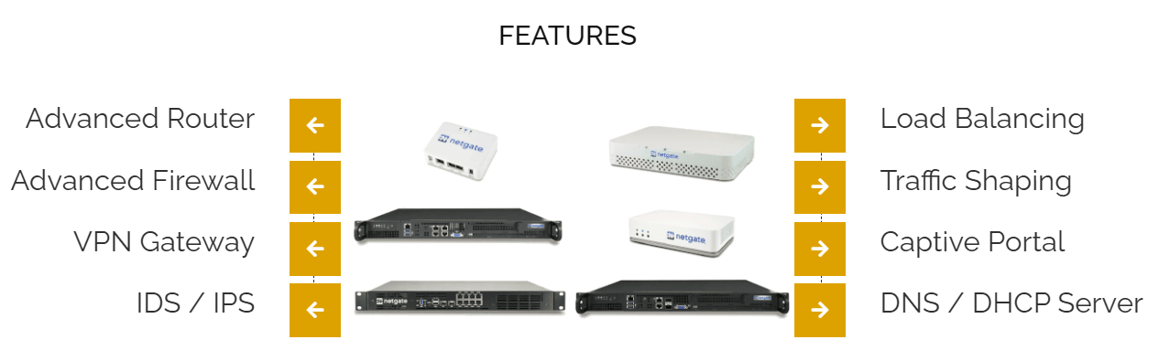

#### Functions

pfSense is a flexible tool for many networking situations since it plays many important functions in the fields of network security, traffic control, and policy enforcement. These functions including:

|  |  |
| --- | --- |
| **Function** | **Description** |
| Packet Filtering and Stateful Inspection | Acts as a robust firewall by filtering incoming and outgoing packets based on rules, allowing only valid communications and blocking unauthorized access attempts. |
| Network Address Translation (NAT) | Enables internal devices to access external networks via a single public IP, enhancing security by masking internal IPs. |
| Virtual Private Network (VPN) Management | Supports VPN protocols like IPsec, OpenVPN, and WireGuard to secure remote communications through encrypted data transfers. |
| Traffic Load Balancing and Redundancy | Distributes traffic across multiple internet connections, improving bandwidth usage and providing failover for connection reliability. |
| Intrusion Detection and Prevention | Integrates with tools like Snort or Suricata (if added) to monitor and block suspicious traffic patterns. |
| User Authentication and Access Control | Utilizes Captive Portal to enforce authentication before granting access, useful for guest or public network environments. |
| DNS and DHCP Services | Provides automatic IP allocation and domain name resolution through built-in DHCP and DNS services. |
| Policy-Based Routing | Allows administrators to define routing rules based on traffic characteristics, ensuring optimal network traffic management. |

Table .. Functions of pfSense

#### Advantages

Its robust and adaptable firewall and routing capabilities give pfSense many advantages for companies, corporations, and private users. These advantages are:

|  |  |
| --- | --- |
| **Advantage** | **Description** |
| Open-Source and Cost-Effective | Free and open-source, eliminating licensing costs while offering enterprise-level security. Actively maintained by the community. |
| User-Friendly Web Interface | Intuitive web-based GUI for easy configuration, monitoring, and management without requiring advanced CLI knowledge. |
| High Customizability and Expandability | Supports third-party packages like pfBlockerNG (DNS filtering), Squid Proxy (caching), Snort/Suricata (IDS). |
| Enterprise-Grade Security and Performance | Offers stateful packet filtering, VPN, and IDS/IPS for strong protection and secure remote access. |
| Scalability and Flexibility | Supports multiple WAN/LAN interfaces, load balancing, and failover, suitable for both small and large networks. |
| Traffic Management and Optimization | Ensures QoS through load balancing, allowing prioritization of essential applications and services. |
| Integrated Networking Services | Includes DHCP, DNS, NAT, VLAN support, and Captive Portal for secure access control and user authentication. |
| Strong Community and Documentation Support | Large user community and detailed documentation provide ongoing updates, support, and troubleshooting resources. |

Table .. Advantages of pfSense

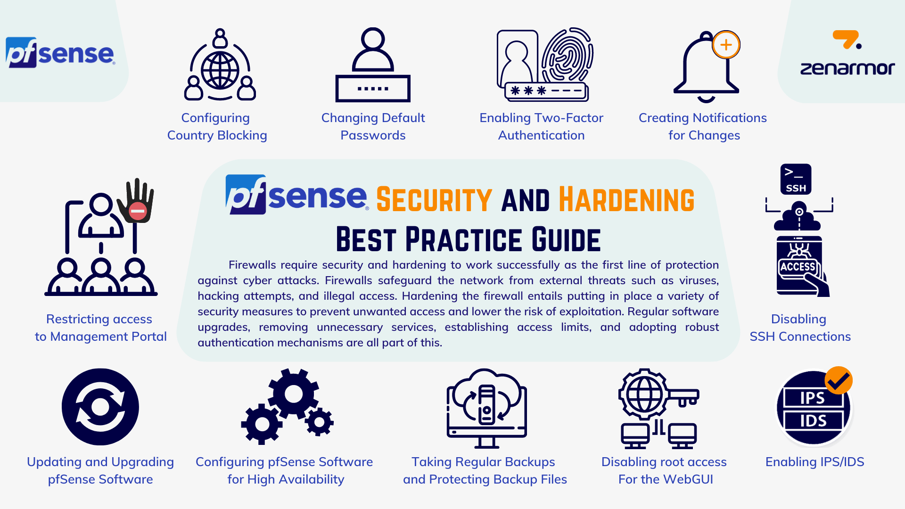

Figure . - pfSense Software Best Practices Guide

### ELK Stack

#### Definitions

Represented by the acronym for three well-known initiatives—Elasticsearch, Logstash, and Kibana—the ELK Stack is a collection of open-source tools. It is created for visualization, data processing, and centralized logging. Offering vital insights for security monitoring, performance assessment, and problem solving, it lets companies collect, keep, process, and analyze log data in real time.

Figure . - ELK Stack

#### Features

##### **Elasticsearch**

Built on Apache Lucene, Elasticsearch is a distributed search and analytics engine meant for high speed and scalability data indexing. It supports schema-free JSON documents, so enabling dynamic and flexible data storage and so appropriate for handling unstructured log data. Security event detection, anomaly analysis, and system monitoring are all areas where Elasticsearch is much used together with real-time processing capabilities.

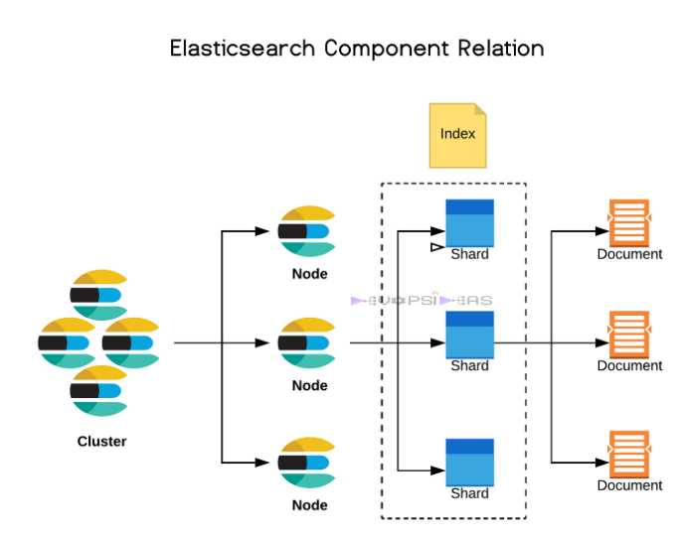

Figure . - Elasticsearch

##### **Logstash**

A data intake and processing pipeline, Logstash gathers logs from several sources including servers, applications, and network devices. It guarantees structured and important indexing by means of preconfigured filters to transform and standardize raw log data before its storage in Elasticsearch. With more than 200 plugins, Logstash enables seamless integration with custom data pipelines and third-party tools, therefore increasing its adaptability for different scenarios.

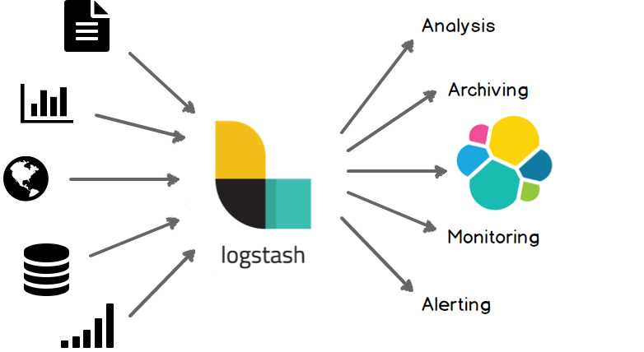

Figure . - Logstash

##### **Kibana**

Kibana is a data exploration and interactive visualization tool providing users real-time dashboards, charts, and graphs for log data analysis. Its advanced features include geolocation support, time-series analysis, and anomaly detection, making it a useful tool for operational intelligence and security monitoring. The main tool for managing, viewing, and searching archived log data is Kibana, which works closely with Elasticsearch.

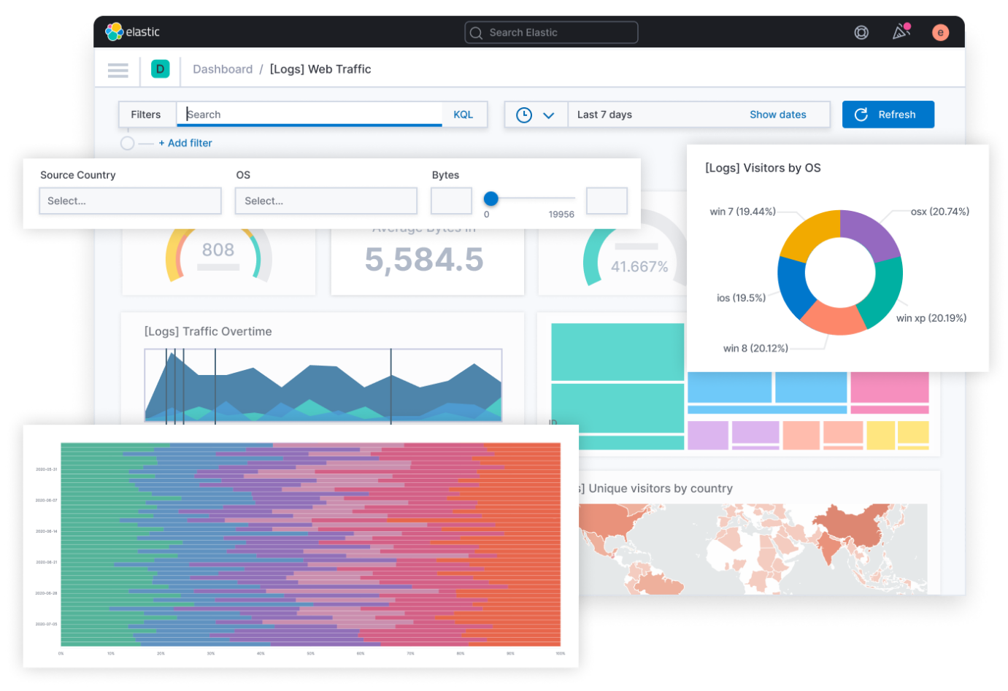

Figure . - Kibana

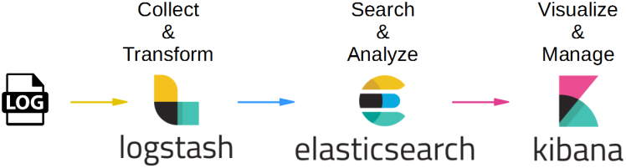

Figure . - Features of ELK

#### **Advantages**

* Powerful Search and Analytics: Elasticsearch's strong search and analytical features let you quickly and quickly query large datasets, which is ideal for their management.
* Open-Source and Flexible: Provided free of charge with thorough modification options to fit several uses.
* Improved Incident Response: Helps security teams in more effectively detecting, investigating, and responding to attacks.
* User-Friendly Interface: Kibana's visualizations let both technical and non-technical individuals effortlessly examine log data.
* Strong Community and Documentation: A lively open-source community and thorough online resources for problem-solving and improvement support this.

#### Elastic Stack Integration with Wazuh

The Elastic Stack (ELK) works effectively with Wazuh, augmenting security monitoring, log management, and threat detection. This connection allows enterprises to consolidate security event data, correlate threats, and show real-time security insights.

* Log Collection and Processing: Wazuh aggregates logs from endpoints, firewalls (e.g., pfSense), and network devices, transmitting them to Logstash for parsing and enrichment prior to storage in Elasticsearch.
* Threat Detection and Correlation: Security events identified by Wazuh are cataloged in Elasticsearch, enabling querying and analysis to discern anomalous patterns and prospective threats.
* Real-Time Visualization: Kibana provides interactive dashboards and reports, allowing security teams to monitor alerts, investigate security incidents, and track system vulnerabilities effectively.
* Compliance and Auditing: The integration assists enterprises in fulfilling compliance obligations (e.g., PCI DSS, GDPR, HIPAA) by guaranteeing log integrity and the traceability of security events.

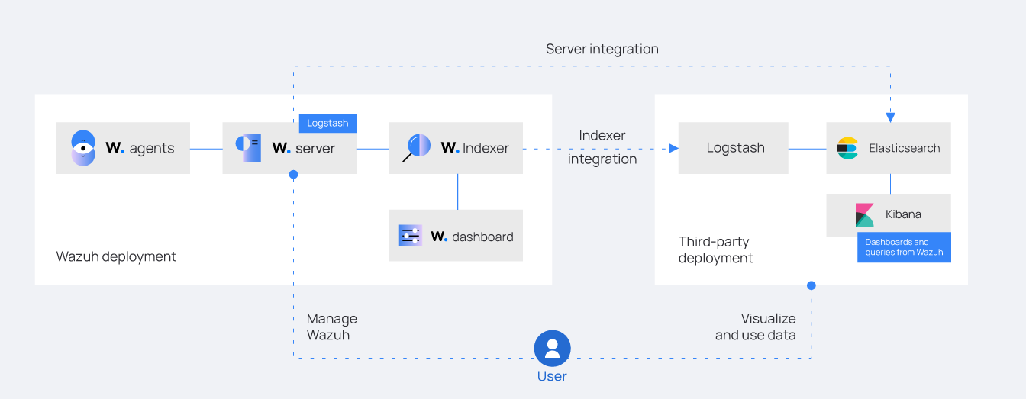

Figure . - ELK integration diagram

### Syslog

#### Definitions

Syslog (System Logging Protocol) is a prevalent standard protocol for the delivery of log messages in networked contexts. It facilitates network devices, including firewalls, routers, switches, and servers, to transmit event logs to a centralized log server for storage, analysis, and monitoring. Syslog improves network visibility, security monitoring, and compliance audits by combining logs from many devices.

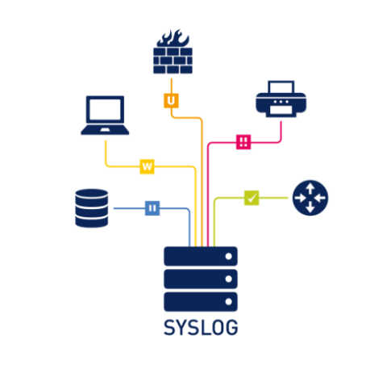Originally designed for the UNIX operating system, Syslog has become a key component of modern Security Information and Event Management (SIEM) systems, therefore allowing companies to efficiently collect, classify, and respond to security events. Though it might optionally use transfer Control Protocol (TCP) for greater log transfer dependability, the protocol operates on the default port 514 using User Datagram Protocol (UDP).

Figure . - Syslog Definition

#### Syslog in Wazuh and pfSense Integration

When combined with pfSense and Wazuh, Syslog offers several capabilities enhancing security monitoring:

|  |  |
| --- | --- |
| **Function** | **Description** |
| Security Event Detection | Analyzes logs from pfSense to detect unauthorized access, brute-force attempts, and anomalies. |
| Incident Response & Notifications | Uses correlation rules to identify threats and send real-time alerts. |
| Firewall Log Analysis | Reviews pfSense logs for blocked connections and intrusion attempts. |
| Compliance and Auditing | Retains historical logs to support standards like PCI DSS, GDPR, and ISO 27001. |
| Threat Intelligence Correlation | Matches pfSense data against known malicious IPs, domains, or attack patterns using threat feeds. |

Table .. Functions of Integrating Syslog

#### Advantages of Using Syslog with Wazuh and pfSense

Integrating Syslog with Wazuh and pfSense improves log management, threat detection, and security monitoring through fast log forwarding, real-time analysis, and centralized visibility. The benefits encompass:

* Seamless Log Forwarding: Automatically sends pfSense logs (firewall, VPN, intrusion) to Wazuh via Syslog, improving monitoring accuracy and efficiency.
* Improved Threat Detection: Enables real-time alerts for unauthorized access and anomalies through Wazuh correlation rules.
* Scalability: Supports centralized log collection from multiple pfSense instances, ensuring visibility across distributed networks.
* Enhanced Security Posture: Integrates with ELK Stack for better threat insights, compliance reporting, and forensic investigation.

### Incident Management

#### Definition of Security Incidents in Enterprise Networks

A security incident inside an enterprise network denotes any unintentional occurrence or malicious action that interrupts standard operations, harms information security, or threatens the confidentiality, integrity, or availability (CIA) of any information or data.

Data breaches, unauthorized access, malware infections, and service interruptions can be caused by external cyberattacks, internal threats, system malfunctions, or human error. Reducing risk and ensuring business continuity depend on efficient incident detection, response, and mitigation.

#### Definition of Incident Management

Incident Management is the systematic process of discovering, responding to, mitigating, and recovering from security events affecting the information technology (IT) infrastructure of an organization, data, or business operations, Incident Management

It includes real-time monitoring, incident detection, analysis, containment, and resolution to minimize disruptions and prevent further damage. A effective Incident Management Plan ensures the quick handling of security event, such as cyberattacks, system outages, or illegal access, to maintain business continuity, regulatory compliance, and data integrity.

#### Incident Management Process

Comprising four fundamental stages, the incident management process follows the criteria set out in NIST SP 800-61 and ISO/IEC 27035:

1. Preparation: Increase cybersecurity knowledge by means of security protocols, policy development, and staff training.
2. Detection: Use pfSense and Wazuh for continuous monitoring, log analysis, and anomaly detection to identify possible threats.
3. Containment: Implement isolation policies to contain the threat, stop more damage, and reduce risks should a security incident be found.
4. Post-Incident: Conduct a root cause analysis, document findings, and enhance security measures to prevent recurrence of similar incidents.

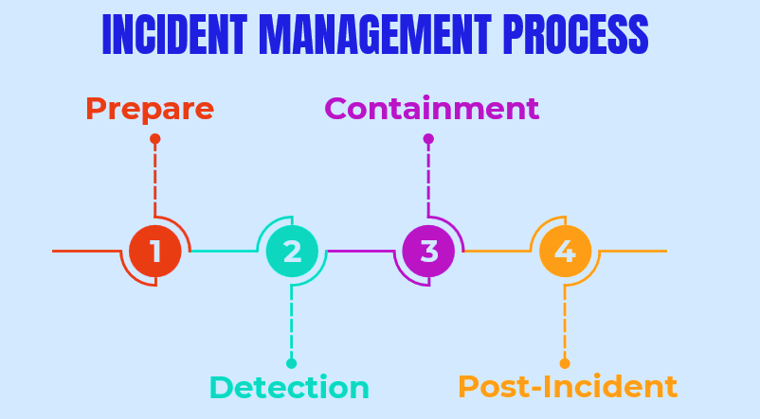

Figure . - Incident Management Process

## Types of Attack

### Brute-force SSH Attack

A brute-force SSH attack refers to a security incident in which an attacker attempts to gain unauthorized access to a system by systematically guessing login credentials—typically through automated tools—over the SSH protocol. This technique involves rapidly trying multiple combinations of usernames and passwords until a valid pair is found.

Brute-force attacks are typically launched from external sources using automated tools that rapidly attempt different combinations of usernames and passwords. These attacks take advantage of weak, default, or reused credentials and are especially common in systems exposed to the internet—such as cloud servers—where SSH is widely used for remote administration.

If not properly mitigated, brute-force attacks can lead to serious security breaches, especially in environments lacking strong authentication and detection mechanisms.

Once access is gained, an attacker can:

* Exploit the compromised account to bypass security policies.
* Install malware or persistence mechanisms on the target system.
* Escalate privileges to gain deeper access.
* Exfiltrate sensitive data or manipulate system configurations.
* Launch lateral movement or pivot to other machines within the network.

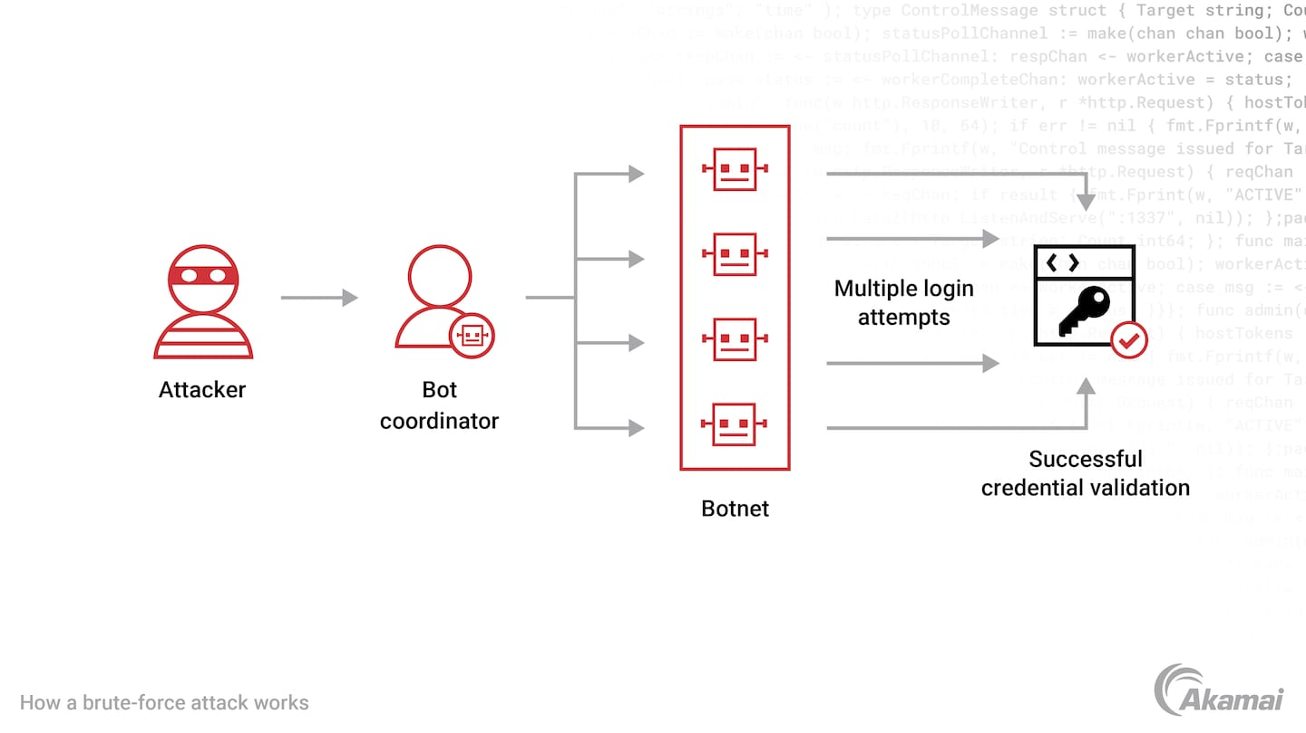

Figure . – Brute-Force Attack

### Trojan Attack – Trojan Horse Virus

A Trojan Horse virus is a kind of malicious software that infiltrates a computer by disguising as a legitimate software. In order to attempt to obtain users' system access through their program, an attacker usually employs social engineering to conceal harmful code within trustworthy applications.

To put it simply, a Trojan is a sort of malware that usually penetrates a user's system by hiding as an attachment in an email or a file that is available for free download. Once downloaded, the malicious code will do the purpose the attacker created it for, such as acquire backdoor access to business systems, spy on users’ online activities, or steal sensitive data.

Once activated, Trojans can be used to:

* Steal sensitive data (e.g., login credentials, financial information).
* Create backdoors for remote attackers to control the system.
* Download and execute additional malware such as ransomware or keyloggers.
* Disable security defenses like antivirus or firewall protections.
* Modify or delete files, leading to system instability or data loss.

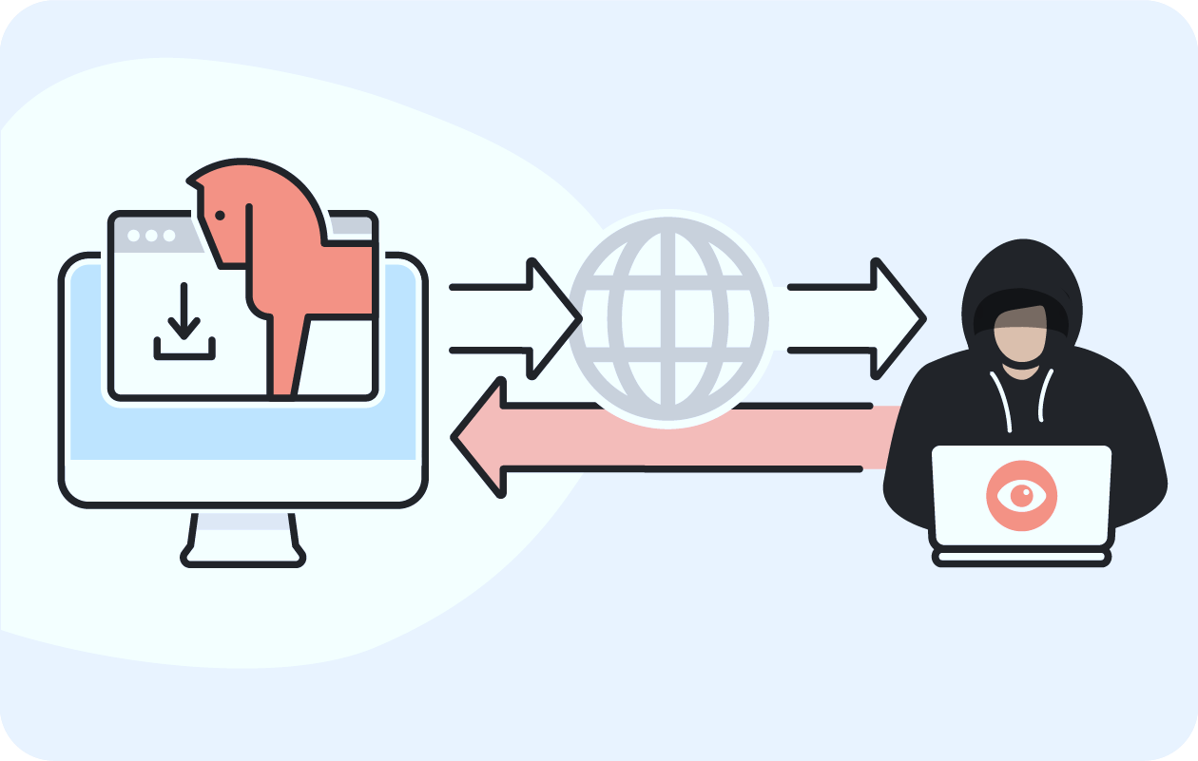

Figure . - Trojan Horse Virus

### Denial of Service Attack (DoS Attack)

A Denial of Service (DoS) attack is a cyber threat designed to disrupt an online service by overwhelming its hosting server, making it temporarily inaccessible to legitimate users.

Unlike a Distributed Denial of Service (DDoS) attack, which uses multiple devices (botnets) to generate excessive traffic, a DoS attack relies on a single device to flood the target system with traffic. This makes it easier to execute but still effective in causing temporary disruptions.

The targeted system becomes overwhelmed by the traffic, exhausting its resources such as bandwidth, memory, and CPU capacity. The attack effectively denies legitimate users access to the service.

DoS attacks can take many forms, based on the techniques used to overwhelm the target. Below are the most common types of DoS attacks:

* Volume-Based Attacks: These attacks flood the network with excessive data, consuming all available bandwidth, and making the network resources unavailable for legitimate users. Examples include UDP Flood and ICMP Flood.
* Protocol Attacks: These exploit vulnerabilities in the network protocol to exhaust server resources, such as processing power or memory. Examples include SYN Flood and Ping of Death.
* Application Layer Attacks: These attacks focus on the application layer, overloading web servers by sending a high volume of HTTP requests. Examples include HTTP Flood and Slowloris, which target web applications to render them unresponsive.

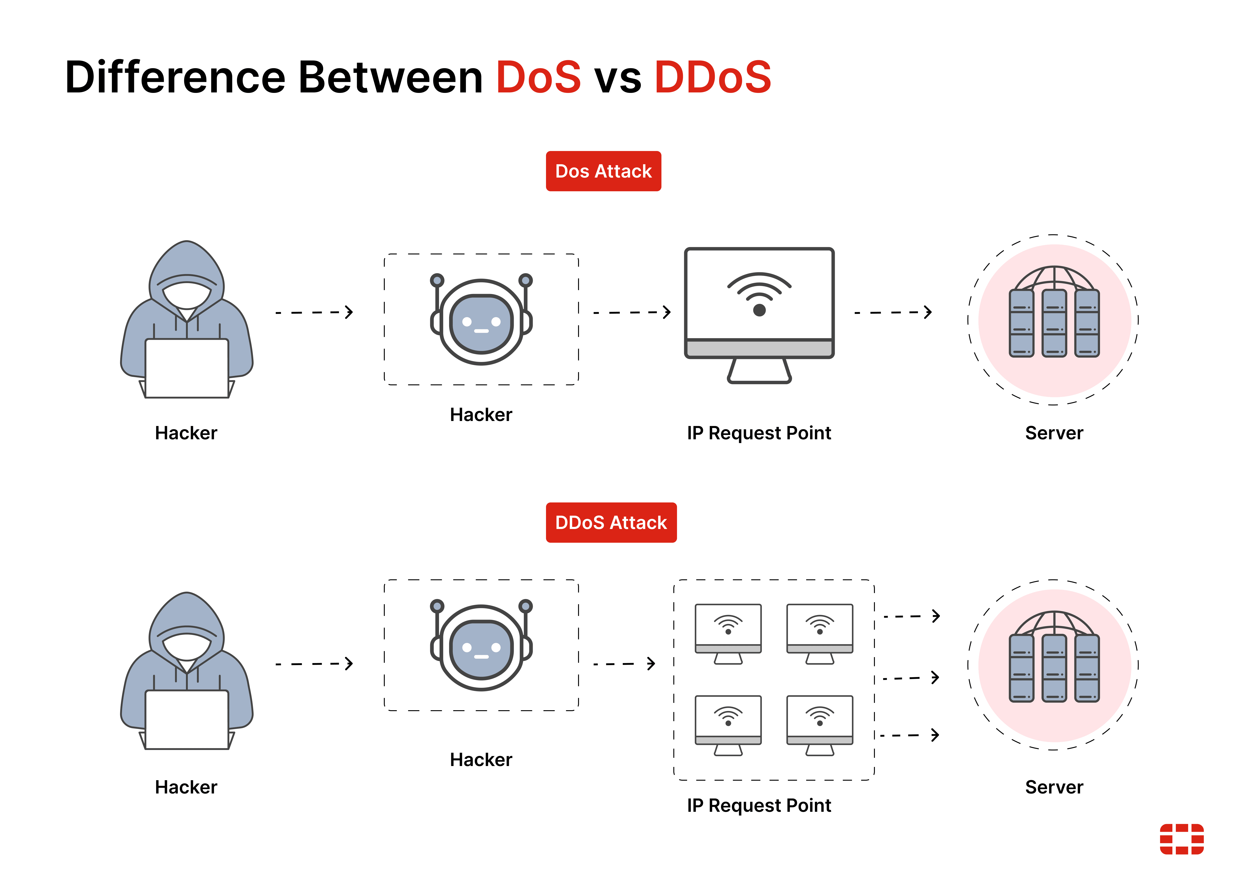

*Figure 5.18 - DoS Attack*

## Project Implementation

### Preparation

#### Equipment/Tools

|  |  |  |
| --- | --- | --- |
| **No.** | **Equipment/Tool** | **Version** |
| 1 | VMWare Workstation | 17 Pro |
| 2 | Wazuh | 4.5 |
| 3 | pfSense | 2.7.2 |
| 4 | ELK Stack | 7.17.3 |
| 5 | Hping3 | Lastest |
| 6 | Email | Lastest |
| 7 | Ubuntu | 24.04 |
| 8 | VirusTotal | Lastest |
| 9 | Python | Lastest |

Table .. Prepared Equipments/Tools

#### Topology

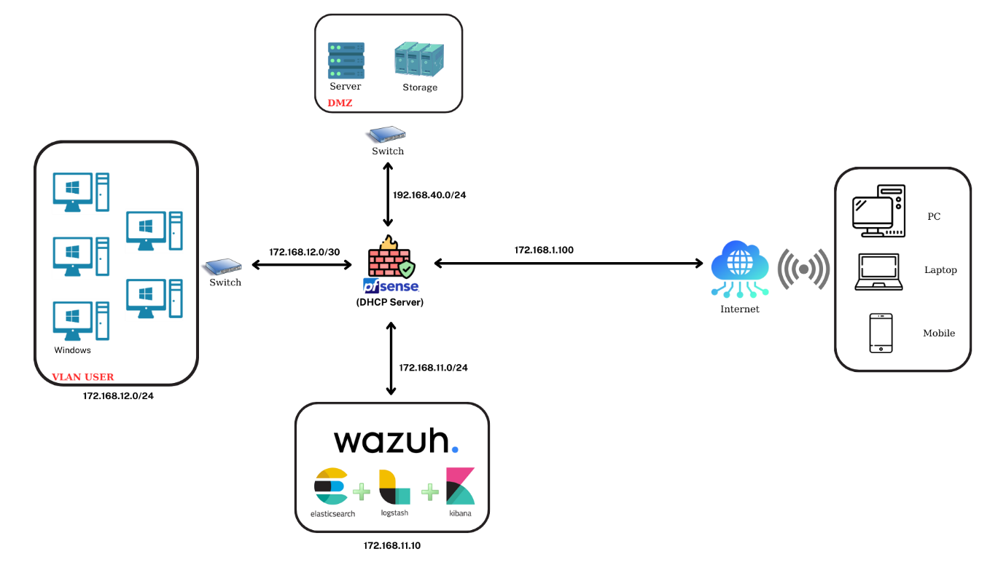

Figure 5.19 - Network Topology

### Install and Configure

We set up a virtual machine running Ubuntu Linux 24.04 and configured the virtual network environment to ensure proper connectivity and system compatibility. Below is the virtual network environment:

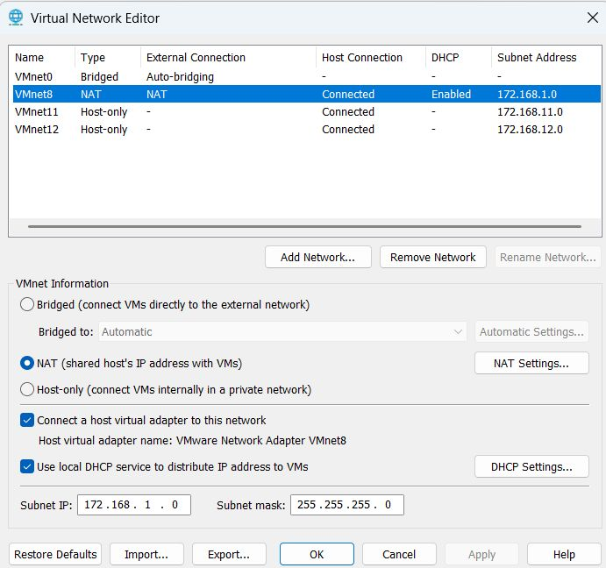

Figure . - Virtual Network Editor

|  |  |  |  |  |  |  |  |
| --- | --- | --- | --- | --- | --- | --- | --- |
| **Network Name** | **Type** | **Subnet IP** | **Subnet Mask** | **Gateway IP** | **DHCP Enabled** | **External Connection** | **Host Connection** |
| VMnet0 (default) | Bridged | - | - | - | No | Auto-bridging | - |
| VMnet8 | NAT | 172.168.1.0 | 255.255.255.0 | 172.168.1.2 | Yes | NAT | Connected |
| VMnet11 | Host-only | 172.168.11.0 | 255.255.255.0 | - | No | - | Connected |
| VMnet12 | Host-only | 172.168.12.0 | 255.255.255.0 | - | Yes | - | Connected |

Table .. Virtual Network Details

#### Install Wazuh

According to the official Wazuh documentation, to download Wazuh 4.5 on an Ubuntu machine, we opened the terminal and executed the following command:

curl -sO https://packages.wazuh.com/4.5/wazuh-install.sh && sudo bash ./wazuh-install.sh -a

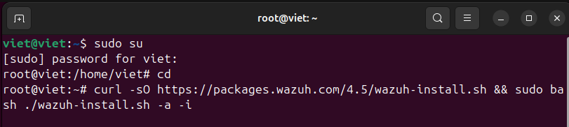

Figure .. Installing Wazuh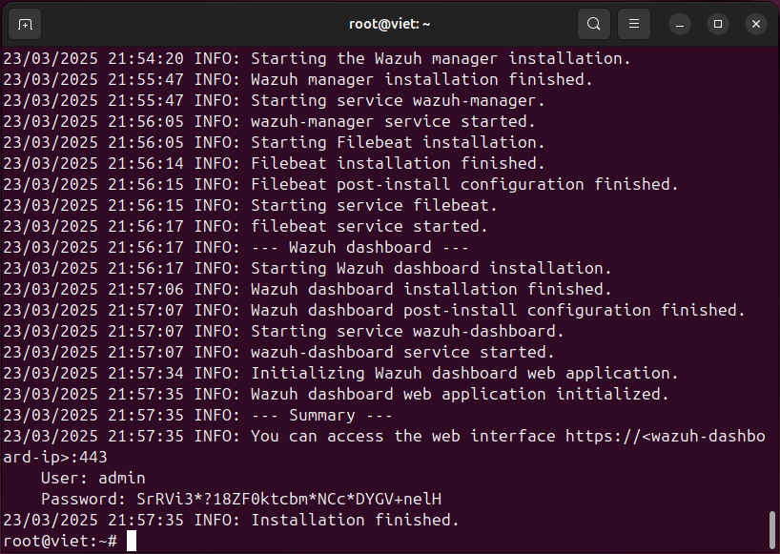

Figure .. Wazuh Installation Finished

Since Ubuntu 24.04 is not officially supported, we used the -i flag to bypass the operating system check. After a short waiting time, the Wazuh installation was successfully completed. The terminal screen displayed is above. And below is Wazuh dashboard after installation.

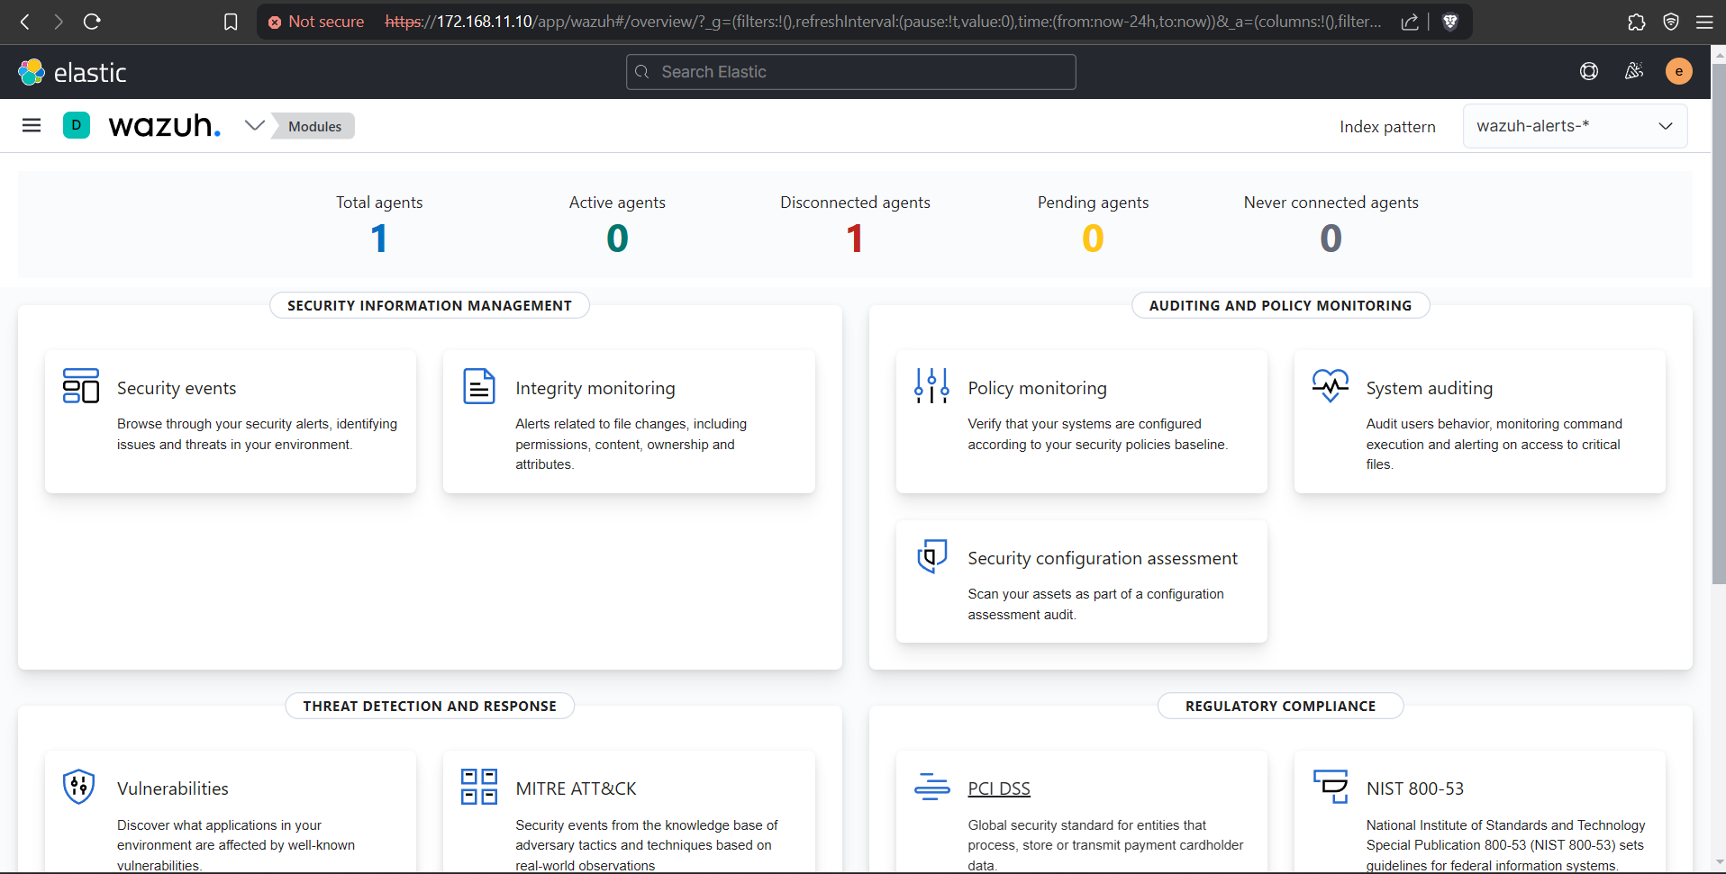

Figure . - Wazuh Dashboard

#### Install pfSense

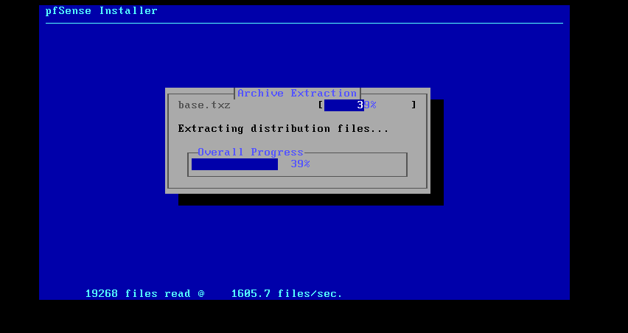After completing the Wazuh installation, we proceeded to download pfSense 2.7.2 and created a new virtual machine to deploy it. Once the virtual machine was set up, we installed pfSense and configured its network environment accordingly.

Figure . - Installing pfSense

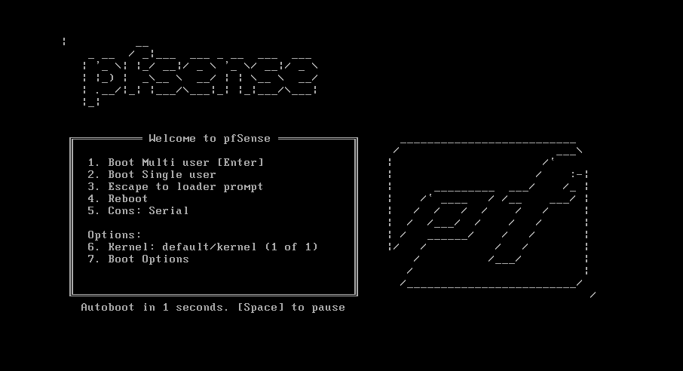 To configure the WAN IP address, we entered "2" at the "Enter an option:" prompt and pressed Enter to access the Set interface(s) IP address menu. We selected the WAN interface by entering WAN or the corresponding interface number (em0) and pressed Enter. Next, we chose the IP assignment method: since we used DHCP for the WAN, we entered n and pressed Enter to skip static IP assignment. pfSense then automatically assigned the WAN interface the IP address 192.168.1.131/24.

Figure . - pfSense Installation Finished

After configuring the WAN, we proceeded to set up the LAN IP address by entering LAN or the corresponding interface number (em1) and pressing Enter. We assigned the LAN IP address as 172.168.11.1, with a Subnet mask of 24 (equivalent to 255.255.255.0). Since a Default Gateway was not required for the LAN, we simply pressed Enter to skip it. IPv6 was also not used, so we entered n and pressed Enter.

Finally, we configured the VLANUSER (opt1) interface by entering em2. We set the IP address as 172.168.12.1, with a Subnet mask of 24, and again skipped both the Default Gateway and IPv6 configuration.The screen below shows the system after the installation is complete:

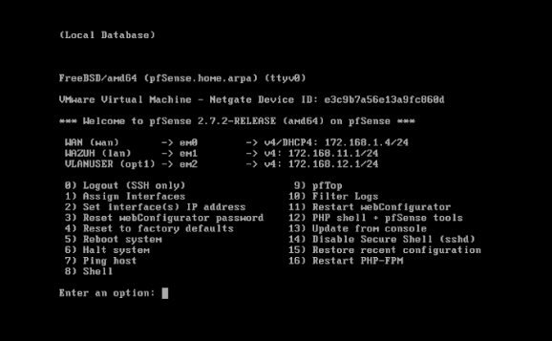

Figure . - Configuration finished

After the configuration was completed, we accessed the pfSense web interface by entering its assigned LAN IP address into a web browser.

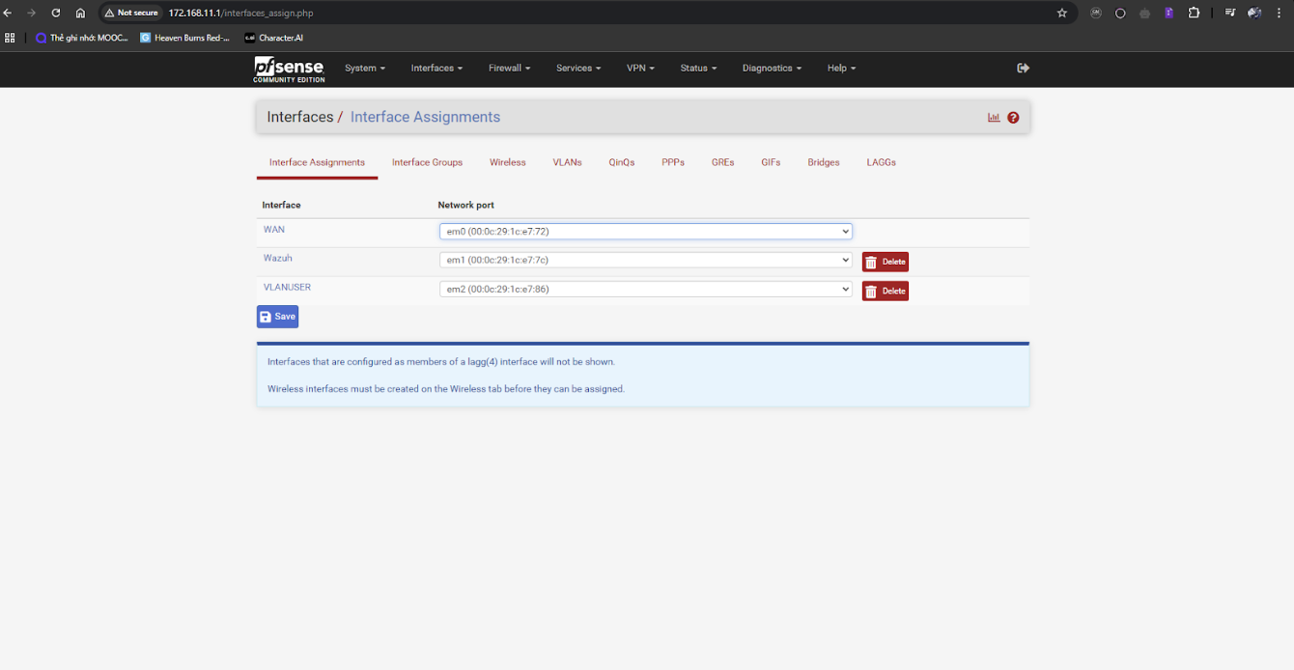

Figure . – pfSense

#### Wazuh Deployment Optimization via Server Migration

Initially, Wazuh was installed on an Ubuntu 24.04 Desktop environment with a graphical user interface (GUI), which allowed for easier interaction and visualization during the testing and configuration phase. However, for deployment in a production-like environment, we transitioned to a dedicated Wazuh server running on Ubuntu Server 24.04, which uses a command-line interface (CLI) only and is optimized for performance and security.

The migration process involved re-installing Wazuh on the new server, ensuring all necessary services were properly enabled (Wazuh manager, API, and indexer), and restoring configuration files such as ‘ossec.conf’, custom rules, and agent registration information from the original instance.

#### Integrating Wazuh and pfSense via Syslog

To integrate Wazuh with pfSense using Syslog, we configured pfSense to forward its logs to Wazuh, allowing centralized log collection and analysis.

On pfSense, we accessed the System Logs settings and enabled remote Syslog forwarding. We specified the Wazuh server's IP address as the remote log server and set the log transport protocol to UDP over port 514 (the default Syslog port). We also selected which log categories to forward, including firewall events, authentication logs, and system logs, ensuring that Wazuh received all relevant security information.

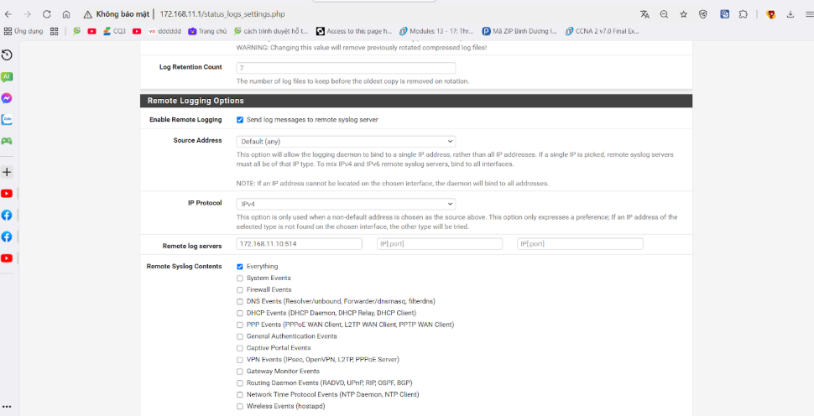

Figure . - Configuring Syslog

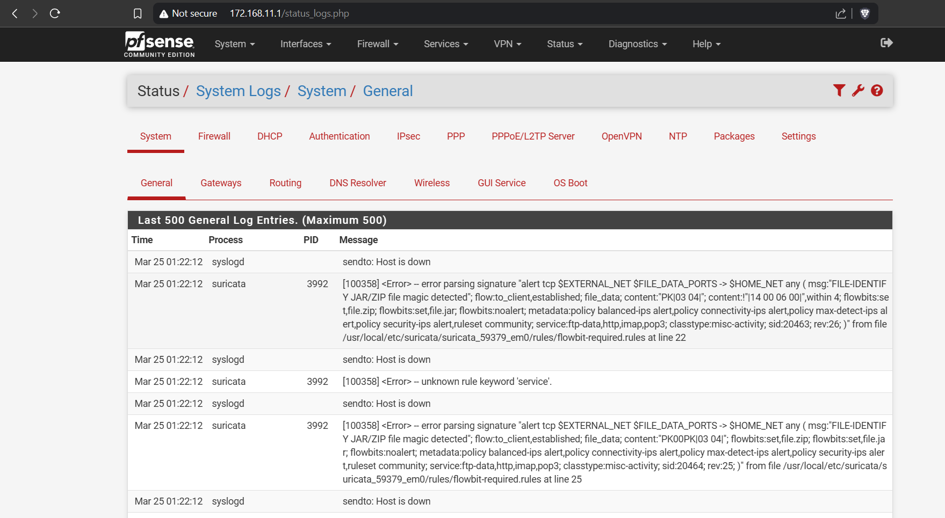

Figure . - pfSense GUI after Configuring Syslog

On the Wazuh server, we configured a Syslog listener to receive logs from pfSense. This involved modifying the ossec.conf file to define the listening port and protocol. Once the logs were received, Wazuh processed them using predefined decoders and rules, enabling automatic detection of unauthorized access attempts, firewall rule violations, and potential network threats. These logs were then indexed in Elasticsearch, allowing for further analysis and visualization through Kibana dashboards.

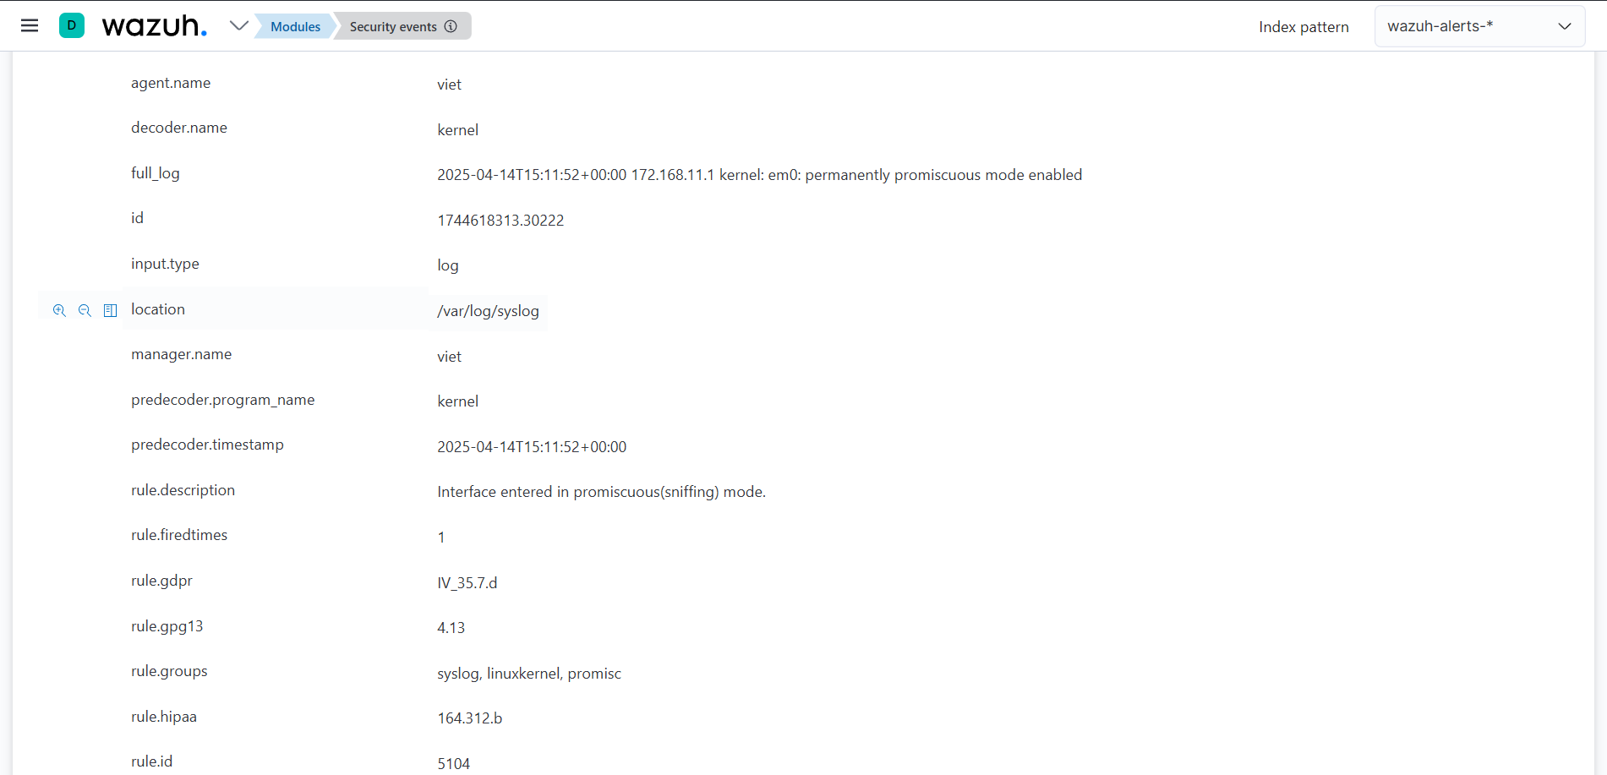

Figure . - Wazuh after Configuring Syslog

#### Integrating Wazuh and ELK Stack

To provide a user-friendly and insightful visual interface for log analysis, we integrated Wazuh with the ELK Stack, which includes Elasticsearch, Logstash, and Kibana.

Logstash played a supporting role by parsing, enriching, and transforming logs before indexing. Although Wazuh has built-in support for Elasticsearch, Logstash offered additional flexibility for filtering logs and improving data quality. We installed Logstash using the following command:

wget -qO - https://artifacts.elastic.co/GPG-KEY-elasticsearch | sudo gpg --dearmor -o /usr/share/keyrings/elastic-keyring.gpg

echo "deb [signed-by=/usr/share/keyrings/elastic-keyring.gpg] https://artifacts.elastic.co/packages/8.x/apt stable main" | sudo tee -a /etc/apt/sources.list.d/elastic-8.x.list

sudo apt update && sudo apt install logstash -y

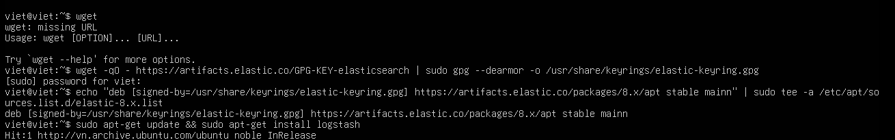

Figure . - Installing Logstash

Next, we ensured that Wazuh was configured to forward its processed alerts to the Wazuh Indexer (a customized Elasticsearch component). This setup allowed Elasticsearch to index logs efficiently and enabled fast querying of large datasets. We installed the Wazuh Indexer using the official APT repository:

sudo apt install wazuh-indexer -y

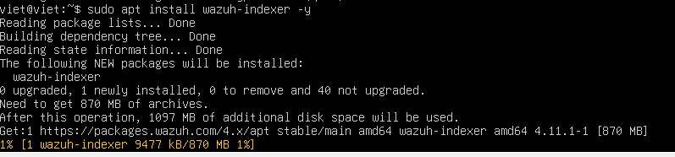

Figure . - Installing Wazuh-Indexer (Elasticsearch)

Next, Kibana was configured to connect to the Elasticsearch instance. We installed the Wazuh Dashboard (Kibana bundled with Wazuh plugin) to visualize real-time alerts, firewall events from pfSense, and endpoint logs from agents:

sudo apt install wazuh-dashboard -y

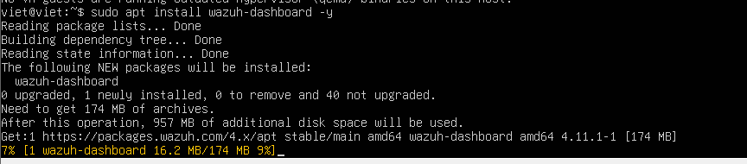

Figure . - Installing Wazuh-Dashboard (Kibana)

The dashboard is accessible via the browser at: https://172.168.11.10

To complete the stack, we installed the Wazuh Manager and API services:

sudo apt install wazuh-manager wazuh-api -y

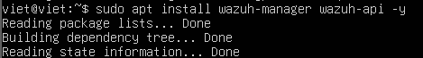

Figure . - Installing Wazuh-Manager & Wazuh-API

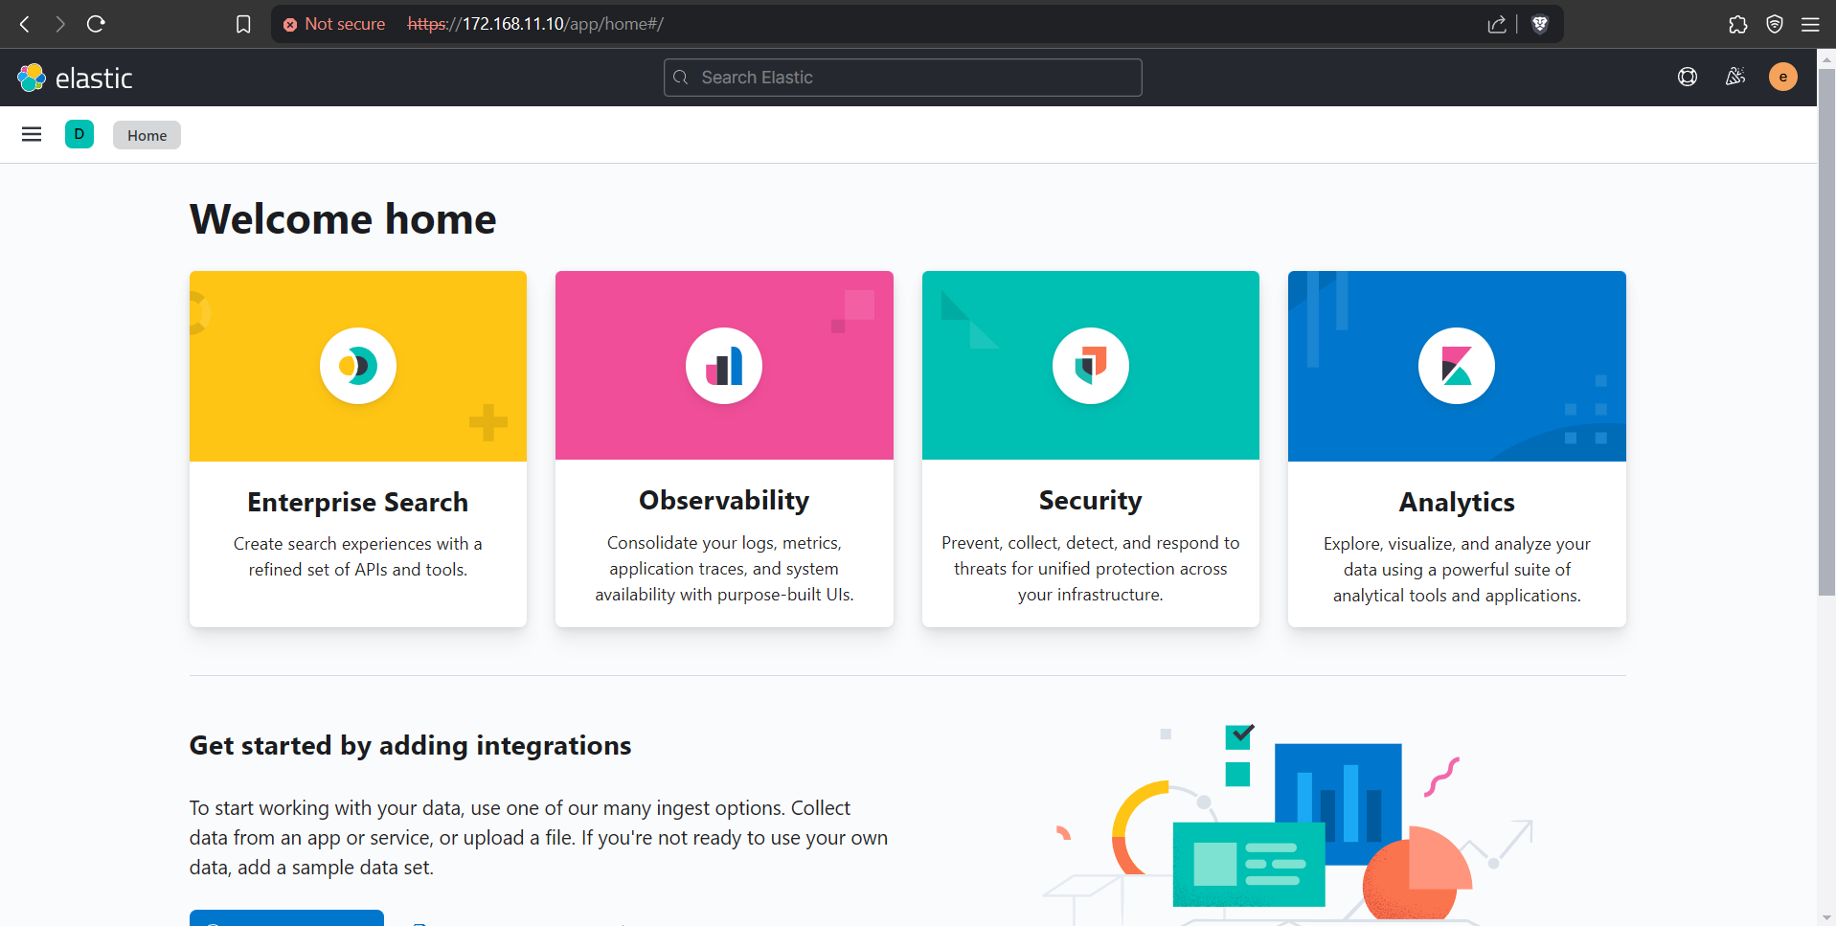

Figure . – Integrating ELK Finished

#### Configuring to send email notifications with Wazuh

To configure Wazuh to send email notifications when a security incident is detected, follow these steps:

First, install the necessary software packages, including postfix, mailutils, libsasl2-2, ca-certificates, and libsasl2-modules. These packages will help set up the email system for Wazuh. Use the following command to install them:

sudo apt-get install postfix mailutils libsasl2-2 ca-certificates libsasl2-modules

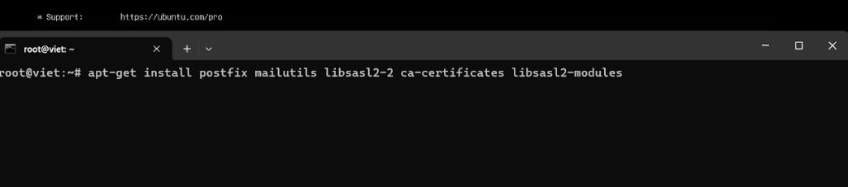

Figure . - Install Required Packages

After the installation, configure Postfix to use Gmail's SMTP (or another SMTP service). Open the main configuration file for Postfix:

sudo nano /etc/postfix/main.cf

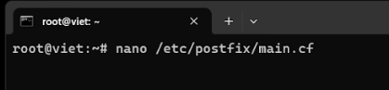

Figure . - Configure Postfix

 The configuration file /etc/postfix/main.cf must be edited with the mail server information:

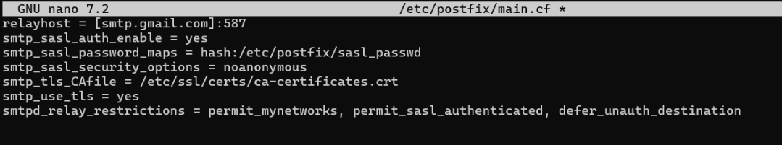

Figure . - Edit Profix file

Next, configure the SMTP authentication by creating the sasl_passwd file to store the email login credentials. Run the following command to create the file:

sudo nano /etc/postfix/sasl_passwd

[smtp.gmail.com]:587 [wazuhcriticallog@gmail.com:your_password](mailto:wazuhcriticallog@gmail.com:your_password)

sudo postmap /etc/postfix/sasl_passwd

To secure the file and create the database for Postfix:

sudo chown root:root /etc/postfix/sasl_passwd /etc/postfix/sasl_passwd.db

After configuring, restart the Postfix service to apply the changes

sudo systemctl restart postfix

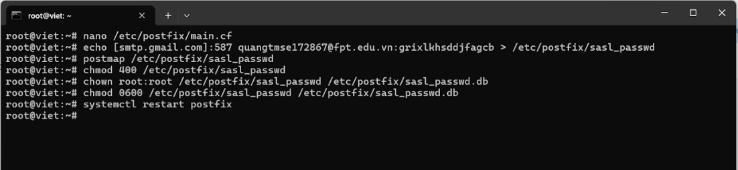

Figure . - Configure the sasl_passwd File

Open the Wazuh configuration file ossec.conf to add email settings and modify the following section to define the email configuration:

<global>

<email_notification>yes</email_notification>

<email_to>your_email@gmail.com</email_to>

<email_from>your_email@gmail.com</email_from>

<smtp_server>smtp.gmail.com</smtp_server>

<smtp_port>587</smtp_port>

<smtp_user>your_email@gmail.com</smtp_user>

<smtp_password>your_password</smtp_password>

</global>

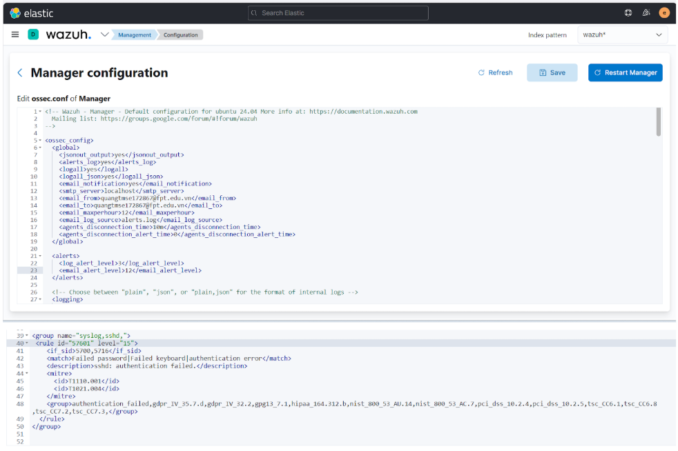

Figure . - Configure Wazuh to Send Email Notifications

After editing the configuration, restart Wazuh.

### Network Security Incident Management Policy

In this project, we assume the role of an IT team within a medium-sized enterprise called WiYoung. To ensure information security and effectively handle security risks, we have developed a Network Security Incident Management Policy specifically for WiYoung. Aiming to protect systems, preserve data, and keep operational stability inside the company, this policy describes the principles, response procedures, and mitigating actions for managing cybersecurity events.

This is our enterprise Incident Management Policy:

**WiYoung Network Security Incident Management Policy**

**1. Overview**

WiYoung's Security Incident Management Policy guarantees an organized approach to detecting, analyzing, responding to, and reducing security incidents. Defining best practices to manage cybersecurity threats, this policy reduces risks to WiYoung's IT infrastructure, business operations, and customer data.

**2. Purpose**

This policy specifies the guidelines for reporting and reacting to security incidents affecting WiYoung's network, systems, and data. Proper incident response ensures:

* Real-time threat monitoring to detect anomalies before they escalate.
* Timely mitigation and containment of security incidents.
* Business continuity and minimal disruption to IT operations.

Without an incident response framework, security breaches could lead to data loss, financial damage, and regulatory non-compliance.

This policy applies to all WiYoung IT assets, including:

* Firewalls, routers, and network appliances (e.g., pfSense).
* Security monitoring tools (e.g., Wazuh SIEM, ELK Stack).
* Endpoints and servers (Windows, Linux, and virtual machines).
* Cloud-based infrastructure and SaaS applications.

**3. Scope**

This policy applies to all security incidents affecting WiYoung, including:

* Unauthorized access attempts (e.g., brute-force attacks, credential stuffing).
* Malware infections and ransomware incidents.
* Network-based attacks (e.g., DDoS, MITM, port scanning).
* Insider threats and policy violations.

**4. Incident Management Program**

**4.1. Computer Emergency Response Plan**

WiYoung’s IT and Security teams are responsible for implementing an Incident Response Plan (IRP) to handle cybersecurity threats. This plan covers:

* Service disruptions caused by network failures or cyberattacks.
* Security breaches affecting sensitive corporate or customer data.
* Threat detection, containment, and remediation procedures.

**4.2. Incident Response Lifecycle**

WiYoung follows a 4-stage Incident Response Lifecycle to efficiently handle security incidents:

1. Preparation: Establish incident response protocols, deploy SIEM solutions (Wazuh, ELK Stack), and configure network security controls (pfSense firewall) and maintain an SSH access whitelist to control authorized IP access.
2. Detection: Monitor network logs, firewall alerts, and security event logs for anomalies using Wazuh SIEM and pfSense log forwarding via Syslog.
3. Containment: Isolate compromised systems, block malicious IPs in pfSense, and quarantine infected endpoints. (If necessary, temporarily adjust the whitelist to grant access to legitimate users or new systems during recovery phases, ensuring continued service availability while mitigating threats.)
4. Recovery/Post-Incident: Restore affected services, apply security patches, conduct forensic analysis, and improve future incident detection rules.

Each incident must be logged, and corrective actions must be tracked for future policy improvements.

**4.3. Intrusion Detection and Response**

* pfSense logs are forwarded to Wazuh via Syslog, enabling real-time network monitoring.
* The Wazuh SIEM platform correlates firewall events with threat intelligence feeds to detect suspicious activity.
* If unauthorized access or an attack is detected, alerts are triggered, and automated actions (e.g., IP blocking, account lockout) are executed.

**4.4. Malware Containment and Remediation**

* Endpoints infected with malware are immediately isolated from the network.
* Affected systems are scanned using security tools, and malicious payloads are removed.
* If ransomware is detected, backups are restored, and forensic analysis is performed.

**4.5. Data Breach Notification Procedures**

* The Legal & Compliance Team assesses whether external reporting is required for customer data breaches.
* If customer data is compromised, affected users are notified following applicable data protection regulations.
* Notifications must include recommended security measures, such as password resets, multi-factor authentication (MFA), and account monitoring.
* If applicable, customers will be informed of any updates to the SSH access whitelist, ensuring that only trusted Ips (e.g., 172.168.11.20) are granted access to critical services in the aftermath of the breach.

**5. Reporting and Communication**

**5.1. Third-Party Incident Reporting**

* If WiYoung’s IT systems suffer a breach exposing third-party data, affected stakeholders must be informed.
* Regulatory authorities must be notified if the incident violates compliance standards.

- The whitelist will be reviewed regularly, and any new findings or adjustments to security policies will be reflected in the list of IPs allowed to access SSH services.

**5.2. Internal Incident Reporting**

* Employees must immediately report suspicious activity to the IT Security Team, including any concerns related to unauthorized access or modifications to the SSH access whitelist.
* Incident reporting guidelines and contact details must be displayed on the company intranet.

**5.3. Customer Notification Procedures**

If a security breach impacts customer accounts or personal data, WiYoung will issue a formal breach notification containing:

* A summary of the incident and its potential impact.
* Actions taken to secure accounts and prevent further breaches.
* Recommended security measures for affected customers (e.g., enabling MFA, monitoring transactions).
* Contact details for WiYoung’s support and security teams.

**6. Roles and Responsibilities**

|  |  |
| --- | --- |
| **Role** | **Responsibilities** |
| CISO (Chief Information Security Officer) | Leads security policy implementation, ensures regulatory compliance, and oversees cybersecurity strategy. |
| IT Security & Incident Response Team (IRT) | Monitors security logs, investigates alerts, executes the Incident Response Plan, isolates security incidents, mitigates threats, and ensures system recovery. |
| Legal & Compliance Team | Handles breach notifications, ensures adherence to data protection laws, and coordinates with regulatory authorities when necessary. |
| Employees | Follow security policies, practice cybersecurity awareness, and report any suspicious activity or incidents immediately. |

Table .. Policy - Roles and Responsibilities

**7. Continuous Improvement**

To ensure WiYoung’s cybersecurity remains resilient, the Incident Response Plan must be:

* Reviewed and updated annually based on lessons learned from past incidents.
* Aligned with evolving cybersecurity threats and industry best practices.
* Tested regularly through incident response simulations and tabletop exercises.

### Scenario

We will conduct 3 attack-defense demonstrations and apply the Incident Management Process to simulate how enterprises handle security incidents within their organizations. Our demonstrations will showcase realistic threat scenarios, detection methods, and incident response strategies, reflecting the approach businesses take to mitigate cybersecurity risks effectively.

#### **Brute-Force SSH**

In this scenario, we simulate a brute-force attack in which an attacker attempts to gain unauthorized access to a sensitive server by repeatedly trying different SSH credentials. We will shows (through the demonistration) how Wazuh can detect brute-force behavior in real time and automatically block the offending IP address using its Active Response mechanism.

##### Attack Simulation: Internal Employee Attempts Unauthorized SSH Access

We simulate that an attacker repeatedly attempts to log into the enterprise's protected server via SSH by guessing usernames and passwords. The attack generates a sequence of failed login attempts within a short timeframe, which is a clear sign of brute-force activity. The attacker's IP address is recorded by the server’s authentication logs and used by Wazuh for detection and response.

##### Defense Mechanism: Wazuh-Based Detection and Response

- Detection with Wazuh: We configured Wazuh to continuously monitor SSH logs using custom rules designed to detect brute-force patterns. When the number of failed login attempts from a single IP exceeds a predefined threshold (e.g., 5 attempts in 1 minute), Wazuh generates a high-severity alert containing metadata such as the source IP, timestamp, and attempted usernames. The alert is then displayed on our Kibana dashboard for immediate visibility.

- Automatic IP Blocking: Upon detection, Wazuh executes its Active Response module, running the firewall-drop script to block the attacker's IP address at the server level. This stops any further login attempts from the same source. The block event is fully logged for traceability.

- Post-Incident Action: After the threat was contained, a review was conducted to confirm the effectiveness of the detection mechanism. No account was compromised, and no access was gained. The rules were revalidated, the blocklist updated, and a report was archived for documentation purposes. The system remains actively protected against similar brute-force attacks in the future.

To illustrate this process clearly, the image below shows how the system detects brute-force SSH attempts and immediately triggers an Active Response. Wazuh identifies the repeated failed logins and blocks the attacker's IP address at the host firewall to prevent further intrusion.

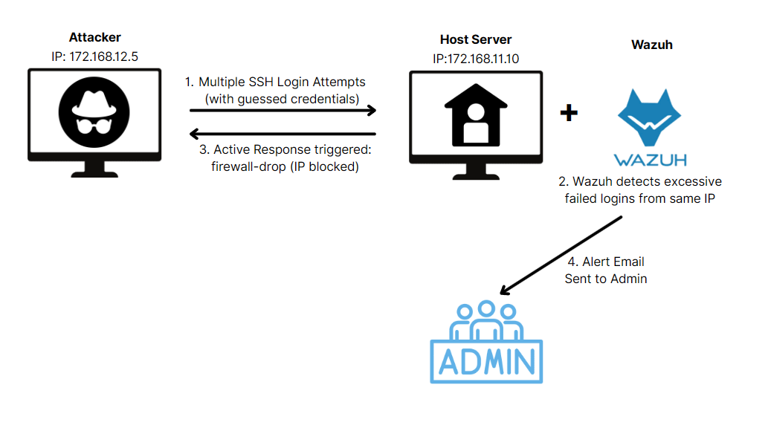

Figure . – Brute-Force SSH Scenario

#### Malware Infection via Cracked Software – Detection and Removal (Trojan Attack)

In this scenario, we simulate a real-world phishing attack to demonstrate how enterprises can detect and respond to malware infections using a structured Incident Management Process.

##### Attack Simulation: User Downloads Cracked Adobe Photoshop Containing Malware

A user within the organization is tricked into downloading a cracked version of Adobe Photoshop, which is hosted on a public GoogleDrive link shared in a group chat or from an unofficial website. The file appears to be a legitimate installer (e.g., AdobePhotoshop2019CC.zip), but it actually contains an executable malware payload designed to evade antivirus software. Once the user extracts and executes the file, the malware attempts to:

* Modify system configurations to maintain persistence across reboots.
* Harvest system information and stored credentials.
* Establish a connection to a remote Command-and-Control (C2) server for data exfiltration or remote access.

##### Defense Mechanism: Wazuh-Based Detection and Response

- Detection with Wazuh: The Wazuh SIEM agent detects suspicious activity using file integrity monitoring (FIM), log analysis, and predefined detection rules as soon as the malware runs. It finds unusual system activity and the generation of a questionable executable in a watched directory. A high-priority alert is then produced and shown on the Kibana dashboard with information including file hash, file path, and process ID, so enabling us (the security team) to confirm the danger.

- Automatic File Deletion: Wazuh is set up with Active Response modules that allow automatic mitigating actions. Wazuh runs a response script removing the harmful file from the compromised system once it is found. Ensuring traceability and auditability, the Wazuh alert database logs the deletion action and the Active Response log verifies it.

- Post-Incident Action: When the vulnerability is eliminated, a complete malware scan on the impacted endpoint guarantees no leftovers or persistence mechanisms still exist. The engaged user gets awareness training emphasizing the dangers of using cracked software. The company also changes its web content filtering and network policies to prevent access to known crack-sharing sites and suspected Drive links.

To visualize the detection and removal process, the image below illustrates how Wazuh, combined with VirusTotal, identifies and automatically deletes a malicious file downloaded from a cracked software link. This response flow demonstrates host-based protection and post-alert automation in action.

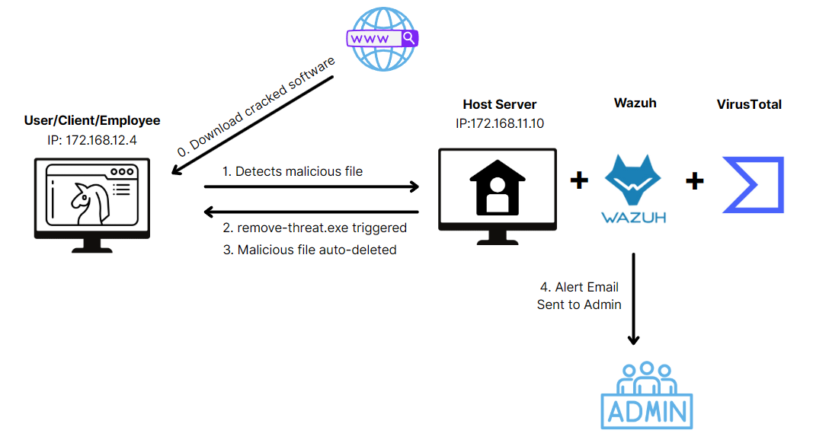

Figure . – Malware Infection via Cracked Software – Detection and Removal (Trojan Attack) Scenario

#### Denial of Service (DoS) Attack

In this scenario, we simulate a Denial of Service (DoS) attack to demonstrate how enterprises can detect, mitigate, and respond to service disruptions using a structured Incident Management Process. The goal of this demonstration is to showcase how Wazuh, combined with pfSense, can provide protection against DoS attacks, ensure service availability, and minimize the impact of such incidents.

##### Attack Simulation: Initiating a DoS Attack

In this scenario, we simulate a Denial of Service (DoS) attack where the goal is to flood a target server with an overwhelming amount of traffic, causing service disruptions and making the system unresponsive. We use the hping3 tool in flood mode to generate a high volume of TCP SYN packets to a specific IP address.

##### Defense Mechanism: Wazuh Detecting and Blocking the Attack

- Detection with Wazuh: The Wazuh SIEM agent continuously monitors the network traffic and logs to detect any abnormal behavior or potential attacks. In this case, pfSense detects a high volume of traffic coming from a suspicious source IP attempting to flood the target server. Wazuh identifies the anomaly based on predefined rules and flags it as a DoS attack, triggering a high-severity alert. The alert is displayed on the Kibana dashboard, providing details such as the source IP, destination IP, protocol used, and the rule that was triggered.

- Automatic IP Blocking: Wazuh’s Active Response capability is configured to block the malicious traffic as soon as the attack is detected. When the DoS attempt is identified, Wazuh automatically executes a response script, which blocks the offending IP address at the network’s firewall. This prevents further malicious packets from reaching the server and stops the attack in real-time. The action is logged in both the Wazuh alert database and the active-response log, ensuring complete traceability and documentation.

- Post-Incident Action: After successfully mitigating the attack, we (the security team aka administrators) conduct a thorough investigation. All relevant logs and alerts are reviewed to ensure that no residual effects or other attacks have occurred. The attack’s origin and methodology are analyzed, and security policies are updated accordingly to better detect and prevent future similar incidents. Additionally, the involved IP is added to a blacklist, and the organization reviews and strengthens its firewall and intrusion detection rules to improve network security further.

The below image provides a visual representation of the DoS attack scenario described above, demonstrating how pfSense and Wazuh work together to detect, block, and report the threat effectively.

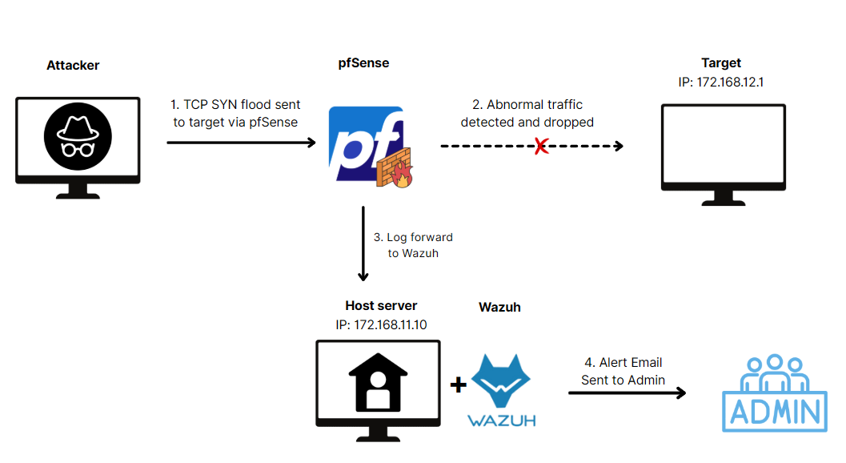

Figure . - Denial of Service (DoS) Attack scenario

### Demonstration

To validate the effectiveness of our Incident Management System, we conducted a series of practical demonstrations simulating real-world cyberattack scenarios. These demos aim to showcase how Wazuh, pfSense, and the ELK Stack can be integrated to detect, respond to, and recover from various types of security incidents.

Each demonstration follows the structured incident response lifecycle (Preparation, Detection, Containment, and Recovery/Post-Incident) mirroring the standard approach used in enterprise environments. This hands-on simulation allows us to evaluate both technical configurations and operational workflows in a controlled environment, thereby enhancing our incident readiness and response capabilities.

#### **Brute-Force SSH**

In this demonstration, we simulate a brute-force SSH attack scenario, where an attacker repeatedly attempts to gain access to a sensitive server by guessing credentials. Although no valid login occurs, we configure the system to detect and mitigate the threat promptly. The demonstration shows how Wazuh can detect such attack patterns and how we enable it to automatically respond by blocking the source IP address.

##### Phrase 1 – Preparation

To simulate a realistic brute-force attack scenario, we prepared a Linux server with the Wazuh agent installed to monitor SSH authentication logs in real time. Before launching the attack, we configured a custom rule set in the local_rules.xml file to detect brute-force behavior. This rule set identifies brute-force patterns by correlating multiple failed SSH login attempts from the same IP address within a short time frame. The figure and code snippet below present the full rule configuration used in this demonstration.

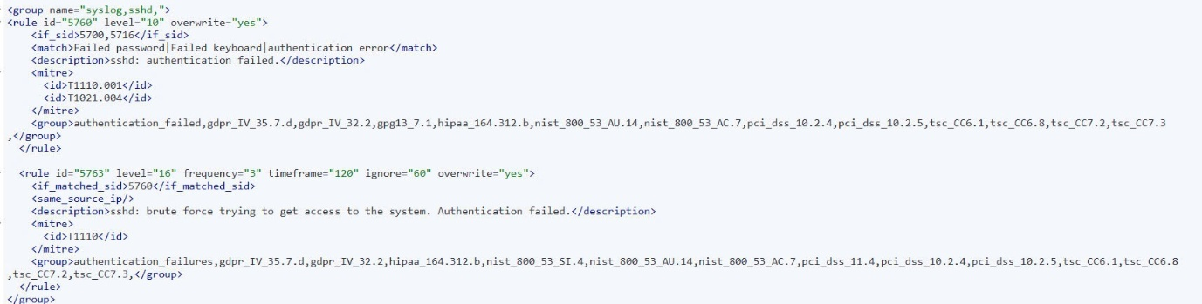

Figure . - Custom Wazuh Rule for Brute-force Detection

<group name="syslog,sshd,">

<rule id="5760" level="10" overwrite="yes">

<if_sid>5700,5716</if_sid>

<match>Failed password|failed keyboard|authentication error</match>

<description>sshd: authentication failed.</description>

<mitre>

<id>T1110.001</id>

<id>T1021.004</id>

</mitre>

<group>authentication_failed,gpdr_IV_35.7.d,gpdr_IV_32.2,gpg13_7.1,hipaa_164.312.b,nist_800_53_AU.14</group>

</rule>

<rule id="5763" level="16" frequency="3" timeframe="120" ignore="60" overwrite="yes">

<if_matched_sid>5760</if_matched_sid>

<same_source_ip />

<description>sshd: brute force trying to get access to the system. Authentication failed.</description>

<mitre>

<id>T1110</id>

</mitre>

<group>authentication_failures,gpdr_IV_35.7.d,gpdr_IV_32.2,hipaa_164.312.b,nist_800_53_SI.4,nist_800_53_AC.7,pci_dss_10.2.4,pci_dss_10.2.5,tsc_CC6.1,tsc_CC6.8,tsc_CC7.2,tsc_CC7.3</group>

</rule>

</group>

With detection in place, we launched the attack using the Hydra tool, targeting the SSH service with a predefined username and a password list. This created rapid, repeated login attempts, simulating a typical brute-force attack scenario.

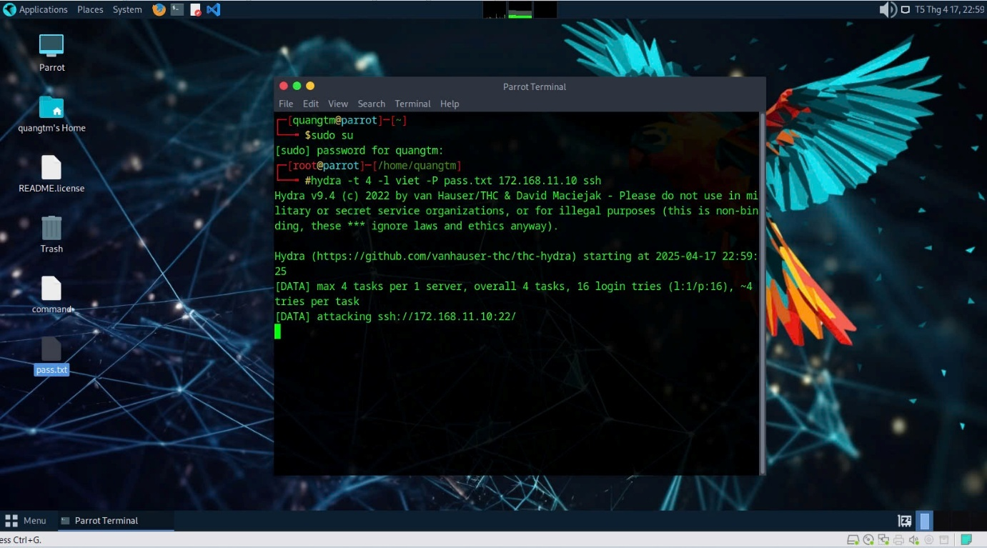

Figure . – Brute-force SSH Attacking

Once this rule set was enabled and tested, we launched the brute-force simulation. The detection rule triggered exactly as expected when login attempts exceeded the defined threshold.

##### Phrase 2 – Detection

After executing the brute-force login attempts using Hydra, Wazuh began collecting SSH authentication logs in real time. Each failed login was parsed and compared with our custom rule conditions. The agent checked whether the source IP matched recent failure records and incremented a counter for repeated failures.

Once the number of failures from a single IP exceeded the threshold (e.g., 5 attempts), Wazuh triggered Rule ID 5763. The system then assigned a severity score and evaluated the event. Since the score surpassed the predefined threshold, the alert was classified as a true positive and forwarded to the administrator.

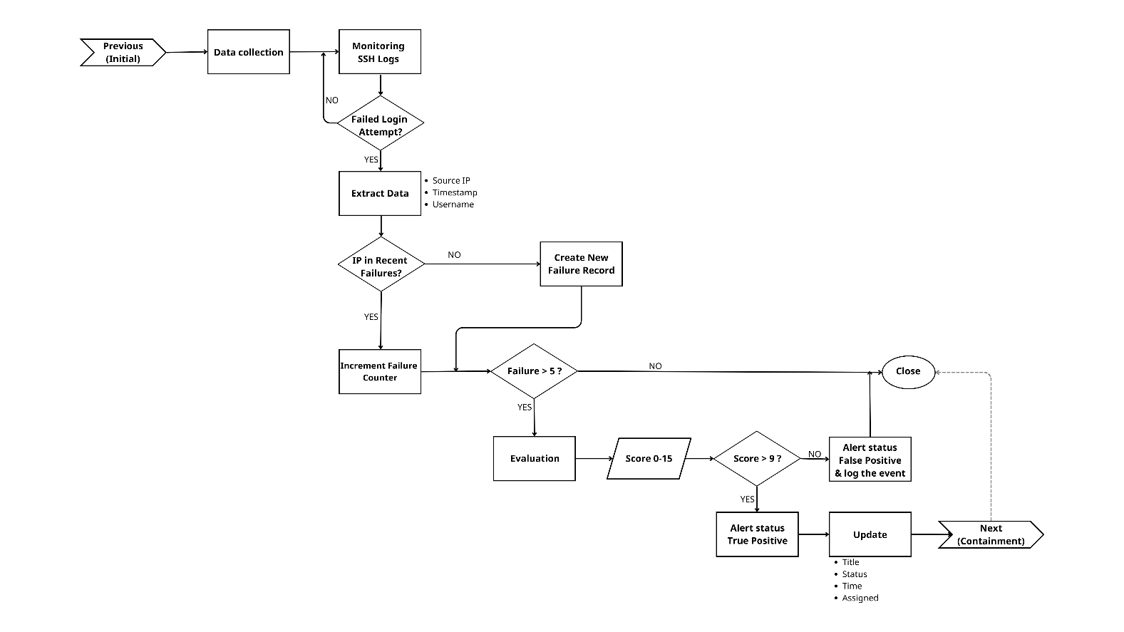

Figure . - Flowchart Brute-Force SSH - Detection

This flowchart illustrates how Wazuh detects brute-force SSH attempts from log collection and pattern recognition to alert generation and notification.

The alert metadata—including source IP (172.168.12.5), timestamp, rule ID (5763), and full log message—was visualized on the Kibana dashboard. Simultaneously, Wazuh sent an automated alert email to the system administrator as an early warning.

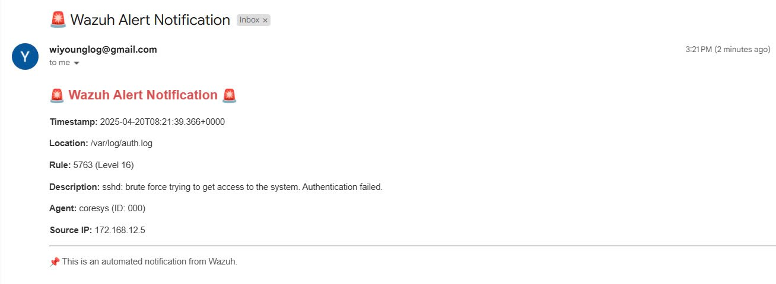

Figure . - Email Sent to Administrator upon Brute-force Detection

Shortly after detection, Wazuh automatically initiated its Active Response module and executed the predefined firewall-drop script. This script dynamically blocked the source IP and terminated any ongoing SSH sessions. The containment action was logged in both the alert index and the active-response log, and a follow-up email notification was sent to confirm that the containment action was successfully executed.

##### Phrase 3 – Containment

Once the brute-force activity was detected, the system immediately transitioned into the containment phase using Wazuh’s Active Response module. Based on the triggered rule (Rule ID 5763), Wazuh automatically executed the predefined firewall-drop script, which dynamically blocked the source IP address involved in the attack.

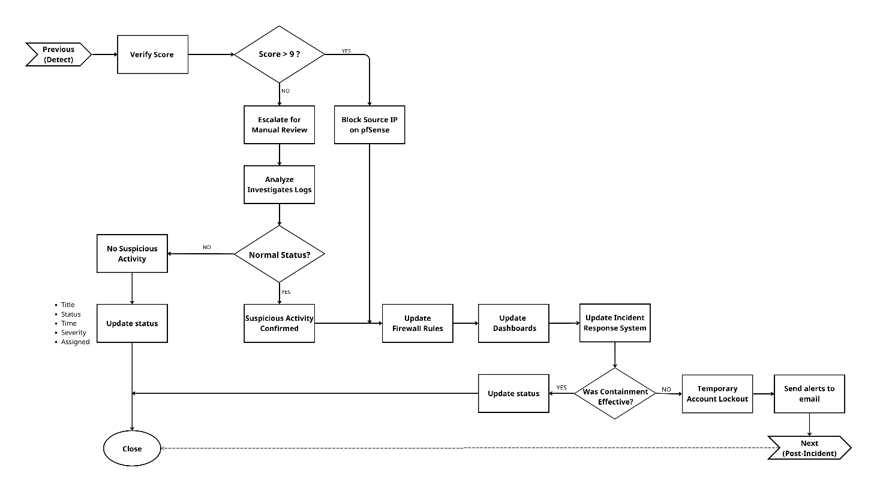

Figure . – Flowchart Brute-Force SSH - Containment

The containment action was executed in real time, effectively terminating the connection attempts and preventing any further brute-force login attempts from the attacking IP. To ensure traceability, the event was recorded in both the alert index and the active-responses.log file.

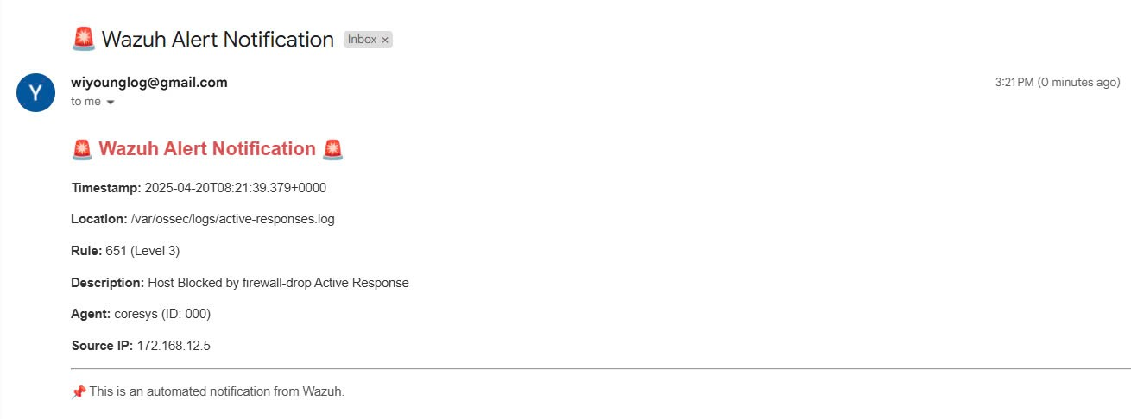

Figure . - Email Sent to Administrator upon Brute-force Containment

After detecting a brute-force SSH attack, Wazuh automatically triggered the firewalldrop active response script. As a result, an email notification was immediately sent to the administrator to confirm that the source IP had been successfully blocked.

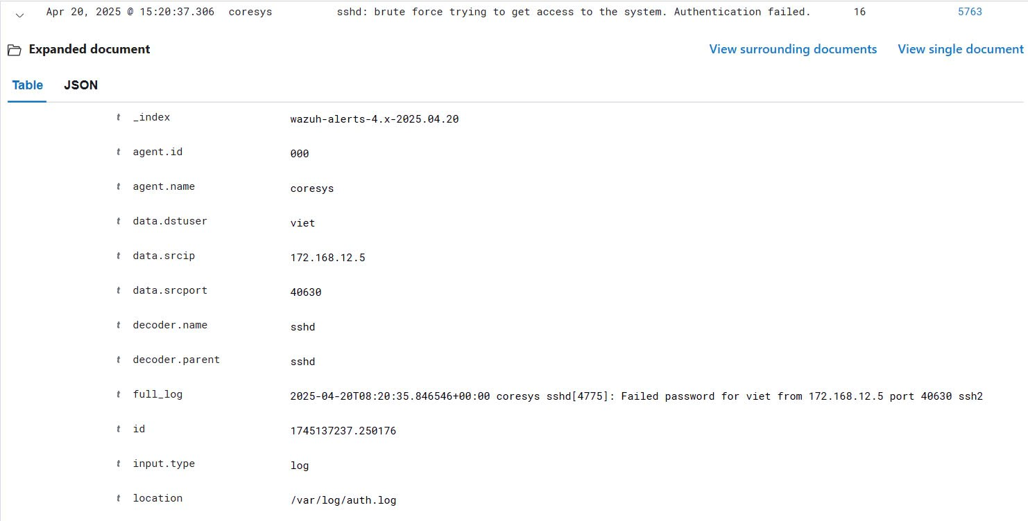

Figure . - Wazuh alert confirming source IP was blocked

In addition to internal logging, Wazuh sent an automated follow-up email to notify the administrator that the containment measure had been executed successfully. This secondary alert served as confirmation of both the system’s detection and its ability to respond automatically and effectively.

We were able to isolate the attacker's activity immediately, mitigating any potential impact and preventing escalation. This scenario demonstrated Wazuh’s ability to respond to brute-force threats swiftly and autonomously, strengthening the system’s overall resilience.

##### Phrase 4 – Post-Incident

After Wazuh successfully detected and responded to the brute-force login attempts, we initiated a post-incident review to evaluate the incident, verify the effectiveness of the containment process, and implement improvements to our security posture. The entire attack timeline, from the initial failed login attempts to automated response and IP blocking and was logged comprehensively in both our Wazuh and Kibana dashboards, forming a complete audit trail for investigation and documentation.

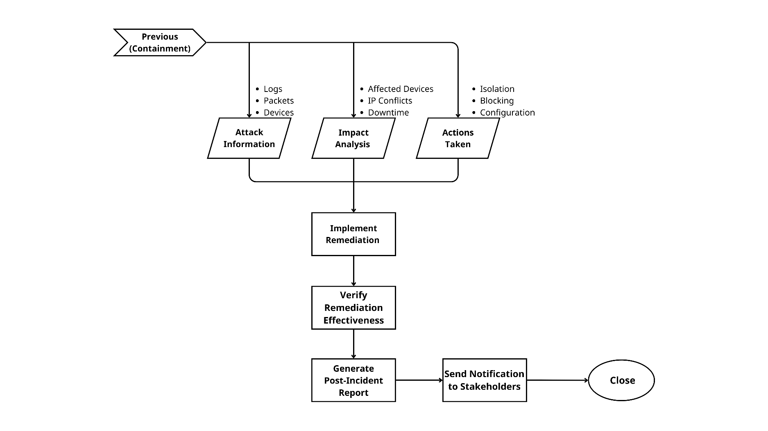

Figure . – Flowchart Post-Incident

This flowchart summarizes the post-incident workflow, covering log analysis, access policy review, and case closure.

During the review, we examined all relevant evidence, including authentication logs, Wazuh alert metadata (specifically Rule 5763), active response logs, and the email notifications generated during the incident. We identified the source of the attack as an external IP that had repeatedly attempted to brute-force SSH login credentials. No successful login was recorded, and we found no lateral movement or other suspicious behavior beyond the initial attempts, confirming that the containment was effective.

To further enhance our defenses, we implemented the following remediation actions:

* Reviewed and optimized brute-force detection thresholds to reduce false positives
* Temporarily blacklisted the attacking IP for extended monitoring
* Ensured that user accounts remained protected by strong password policies
* Updated internal documentation on SSH access and brute-force response procedures
* Conducted a short security briefing to raise awareness among administrators

The incident was formally closed after we confirmed there was no data loss or system compromise. This event highlighted the importance of automated detection and response in defending against brute-force attacks and validated our use of Wazuh as a reliable first line of defense.

##### Conclusion

We successfully detected and blocked a brute-force SSH attack using Wazuh’s real-time monitoring and Active Response. The system raised a high-severity alert and automatically blocked the source IP without manual intervention. No access was gained, and post-incident review confirmed full containment. This scenario highlights Wazuh’s effectiveness in handling brute-force threats quickly and autonomously.

#### Malware Infection via Cracked Software – Detection and Removal (Trojan Attack)

In this demonstration, we simulated a malware infection resulting from the installation of cracked software. A user unknowingly downloaded and executed a pirated software archive from an untrusted source. The file contained a Trojan horse — a type of malicious code disguised as a legitimate application.

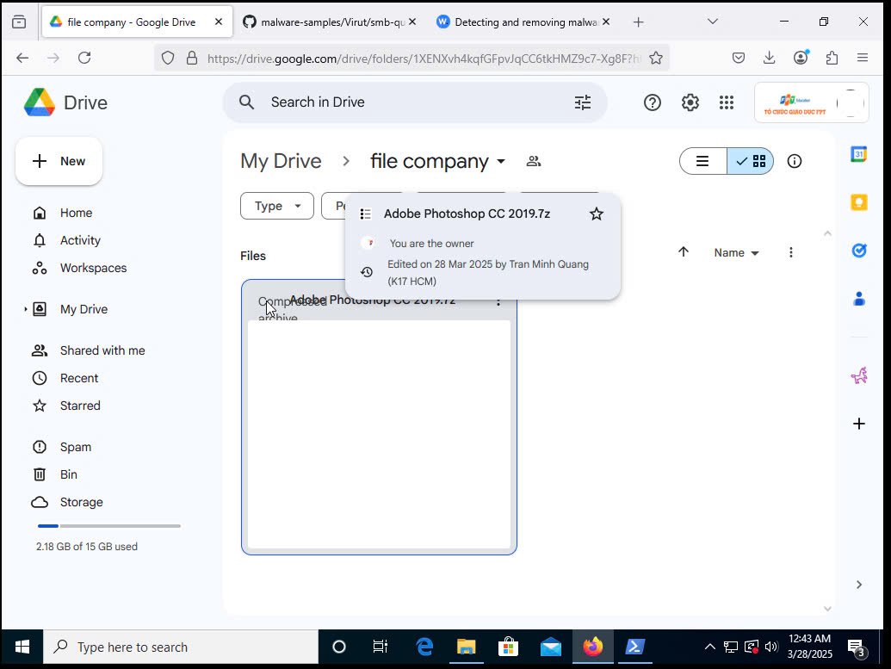

Figure . - Cracked Software in Drive

##### Phrase 1 - Preparation

We prepared the necessary environment and tools to enable both detection and automated response:

* The target system is a Windows workstation with Wazuh Agent pre-installed and actively monitoring system activities.
* In the Wazuh active response directory (C:\Program Files (x86)\ossec-agent\active-response\bin), we added a custom Python script named remove-threat, compiled into an executable file. This script is responsible for automatically deleting the malicious file detected on the system.
* The Python script utilizes the Wazuh active response API to:
  + Parse the alert received from Wazuh Manager.
  + Extract the full path of the malicious file (e.g., from VirusTotal integration or rule metadata).
  + Attempt to delete the file from the infected endpoint.
  + Log the action and results to active-responses.log.

The compiled executable remove-threat.exe is now listed among other active response tools such as restart-wazuh, netsh, and route-null.

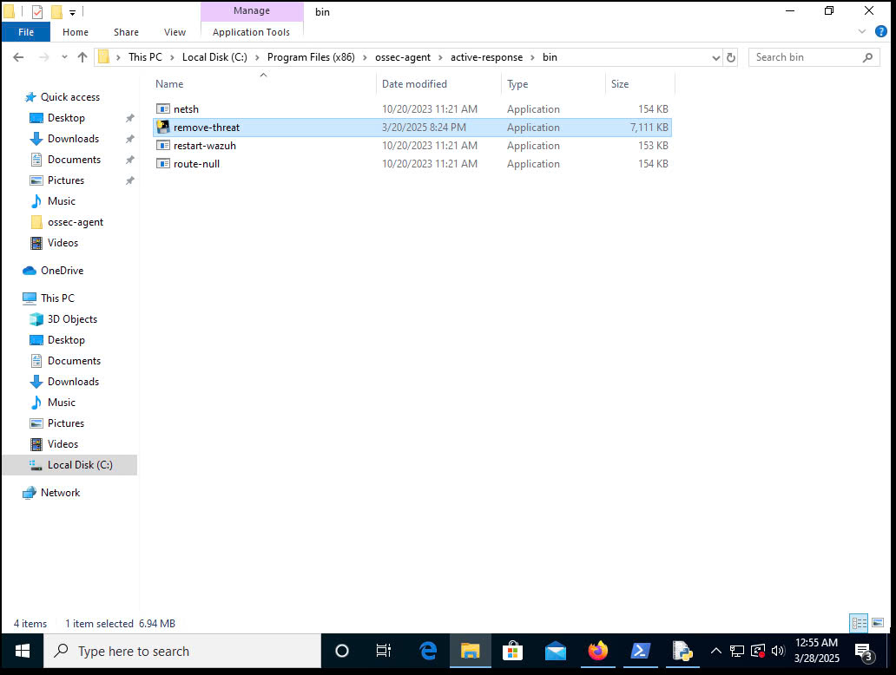

Figure . - Directory containing active response tools on Windows

Additionally, we added a custom Python script, remove-threat.exe, which automates the removal of detected malware from the infected endpoint. The script leverages Wazuh’s Active Response feature and is configured to execute upon detection of any malicious file.

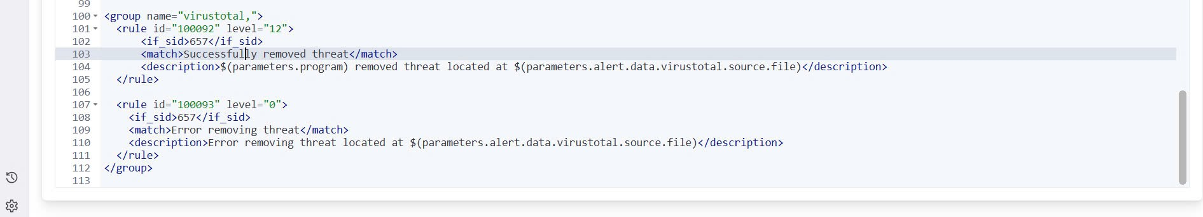

Figure . - Scan Virus/Malware Rule

<group name="virustotal,">

<rule id="100092" level="12">

<if_sid>657</if_sid>

<match>Successfully removed threat</match>

<description>${parameters.program} removed threat located at ${parameters.alert.data.virustotal.source.file}</description>

</rule>

<rule id="100093" level="0">

<if_sid>657</if_sid>

<match>Error removing threat</match>

<description>Error removing threat located at ${parameters.alert.data.virustotal.source.file}</description>

</rule>

</group>

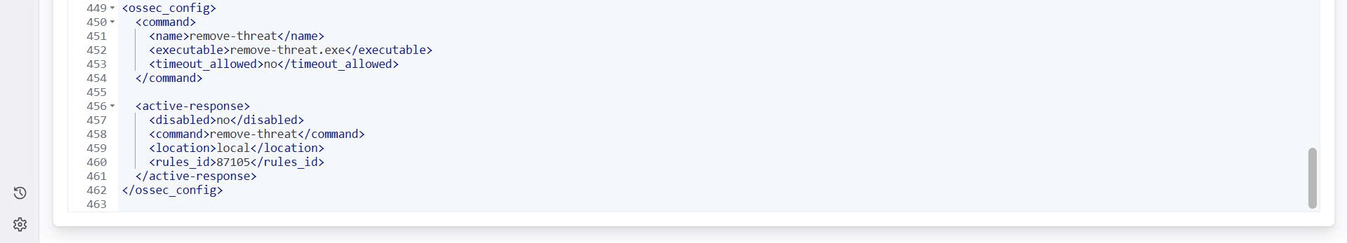

Figure . - Active Response Configuration for Malware Removal

The Wazuh configuration file (ossec_config.xml) includes the definition for the custom response command remove-threat, which ensures that upon detection, Wazuh executes the script to remove the malware from the system. Below is a snippet of the configuration:

<ossec_config>

<command>

<name>remove-threat</name>

<executable>remove-threat.exe</executable>

<timeout_allowed>no</timeout_allowed>

</command>

<active-response>

<disabled>no</disabled>

<command>remove-threat</command>

<location>local</location>

<rules_id>87105</rules_id>

</active-response>

</ossec_config>

##### Phrase 2 – Detection

During the detection phase, the system followed a structured workflow to monitor, analyze, and detect potential malware threats, as illustrated in the diagram below.

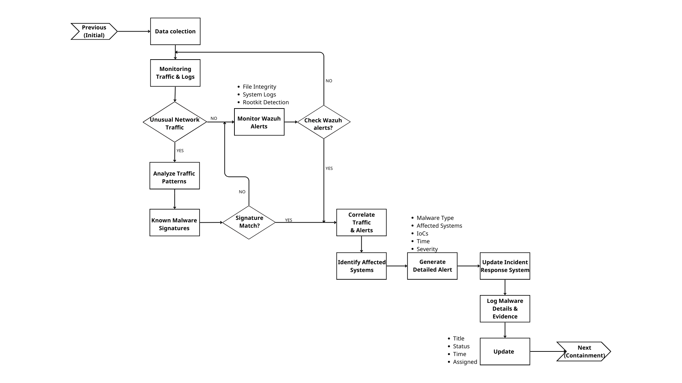

Figure . - Flowchart Malware Infection via Cracked Software - Detection

This diagram outlines the logical flow of Wazuh-based malware detection: monitoring traffic and logs, correlating alerts, matching known signatures, and updating the incident response system.

Once the cracked software (Adobe Photoshop CC 2019.7z) was downloaded and executed by the simulated user, Wazuh immediately began monitoring for suspicious activity. The .7z archive was executed from the Downloads folder, which is a known high-risk location for malware drops.

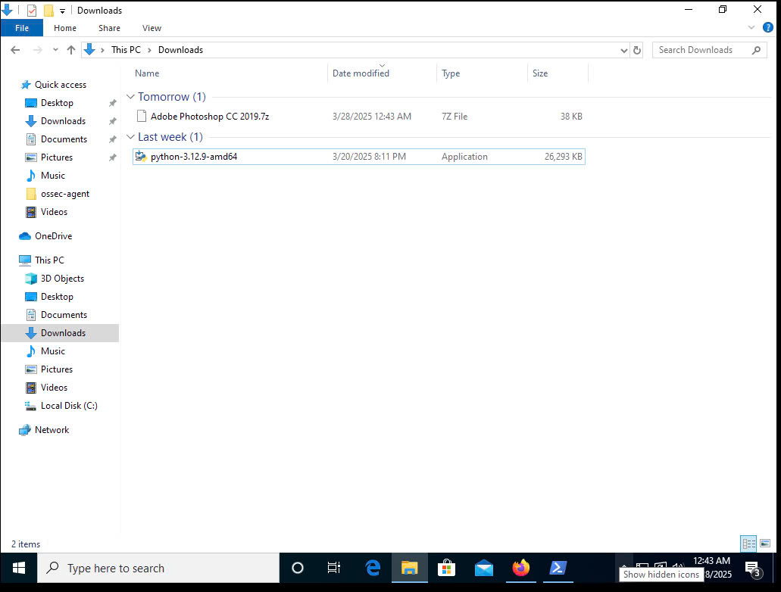

Figure . - Crack Software was downloaded by the user

Wazuh continuously monitored system logs and file activities. Unusual behaviors were flagged, especially execution from user directories, which are commonly targeted by malware. The file was flagged by two engines with classifications such as Virus.Win32.Virut.hpeg and Artemis!Trojan. This indicates that the file has been detected by multiple malware engines, signaling a potential threat.

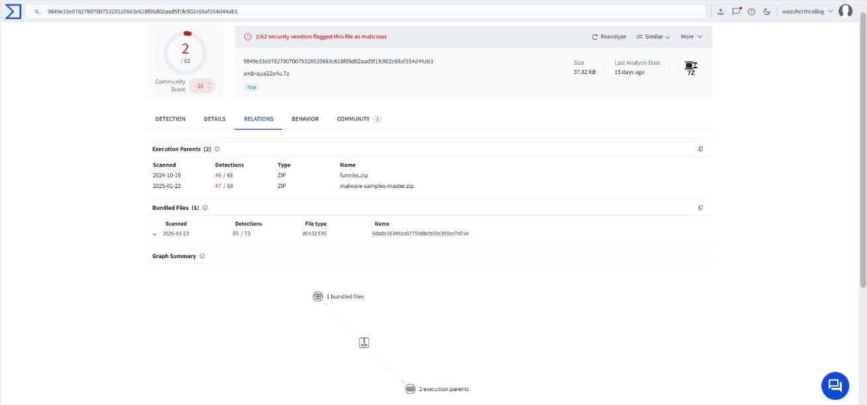

Figure . - VirusTotal scan result identifying the cracked software as malicious

The file’s hash was automatically submitted to VirusTotal for analysis. VirusTotal is a tool that cross-references the file against a database of known malware signatures, helping to confirm the malicious nature of the file. The response showed a match with known Trojan signatures. The image below displays the file’s SHA256 hash, file type, submission history, and detection lineage, providing additional confirmation of the threat.

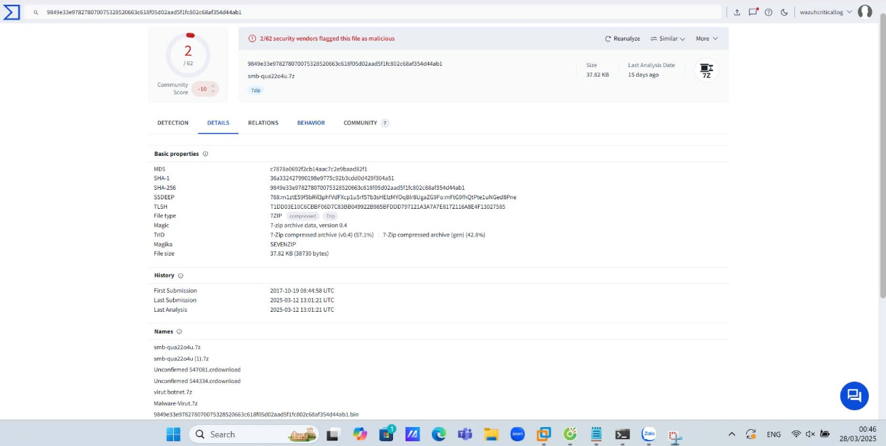

Figure . - VirusTotal metadata of the malicious file

Upon identifying the file as malicious, Wazuh triggered a Level 12 alert (Rule ID: 87105) and populated the Kibana dashboard with detailed metadata. The alert highlights the infected file path (c:\users\quang\downloads...), timestamp, severity level, and detection source. These details are crucial for the incident response team to understand the scope and nature of the threat.

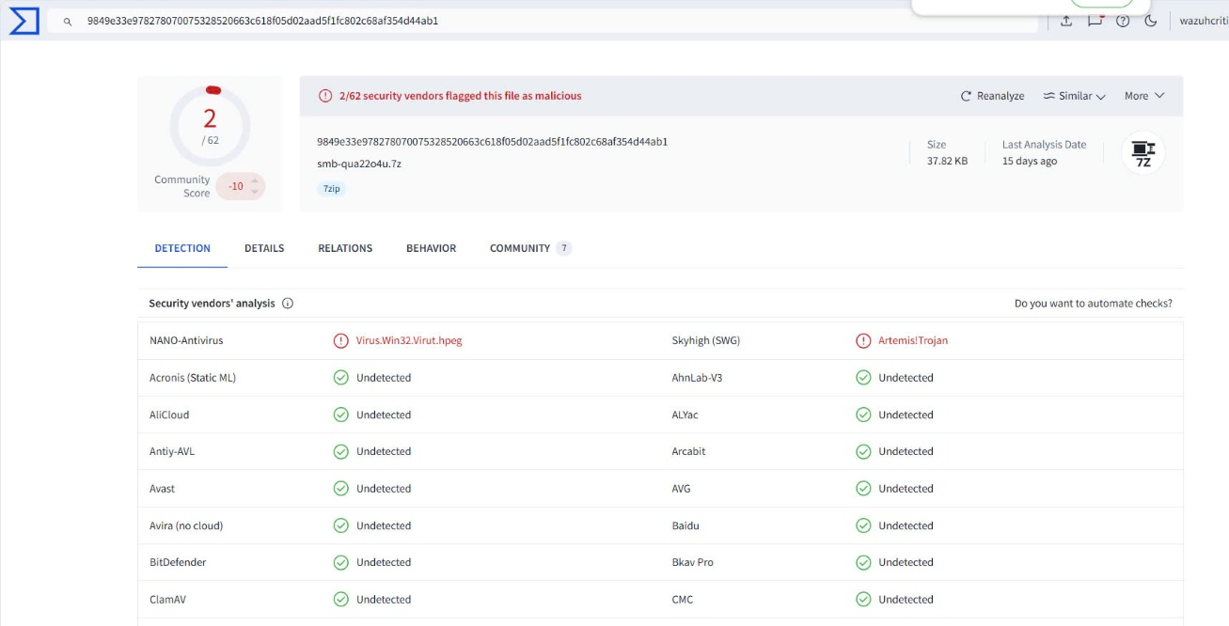

*Figure 5.60 - Alert on Wazuh Dashboard*

A system-generated email was sent from wazuhcriticallog@gmail.com to the administrator, indicating that malware was detected. The email included detailed metadata such as timestamp, alert rule, source IP, and VirusTotal scan results. This email notification confirmed detection, helping the incident response team validate the threat before initiating containment. This automated process ensures that the administrator is immediately informed of the potential risk, allowing for faster action.

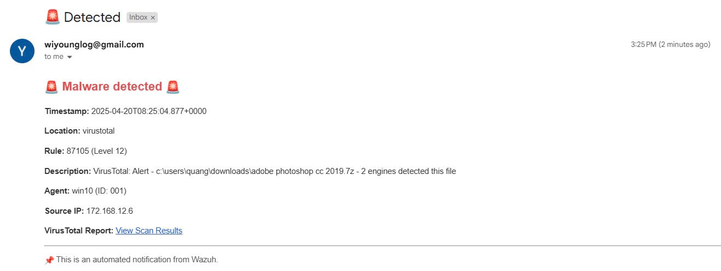

Figure . - Email notification: Malware Detected

##### Phrase 3 – Containment

After the malware was detected and verified, the system proceeded to execute the containment phase, aiming to prevent the threat from spreading further or causing additional damage. This phase followed the logical steps illustrated in the flowchart below.

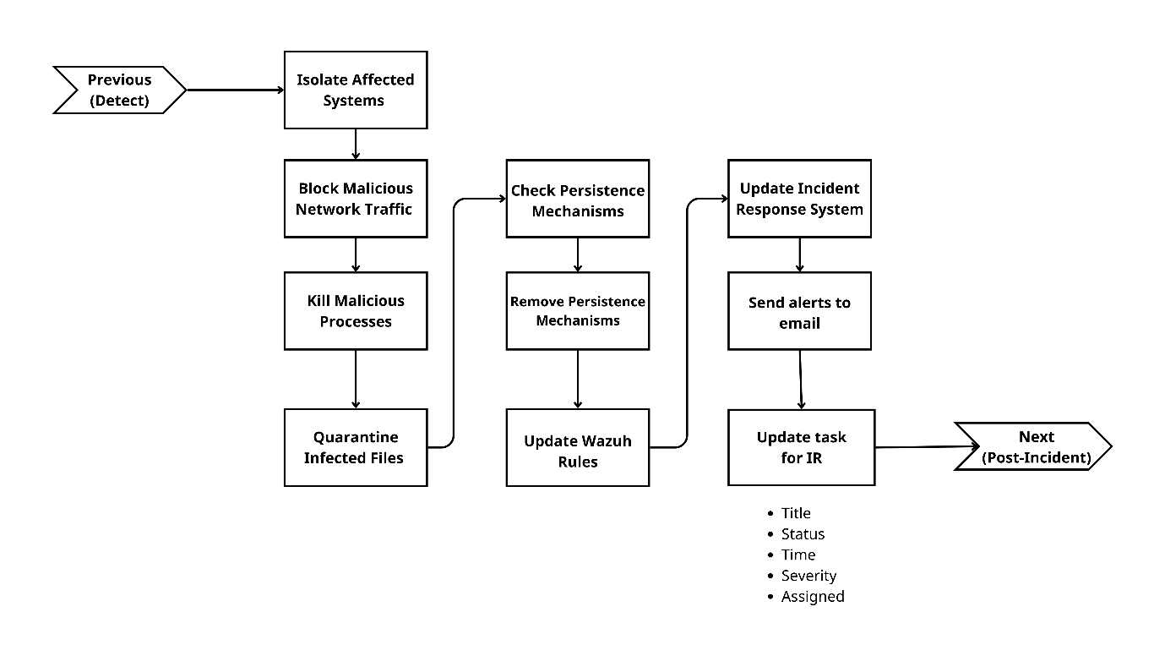

Figure . - Flowchart Malware Infection via Cracked Software – Containment

This diagram shows the key containment actions such as isolating affected systems, killing malicious processes, and removing persistence mechanisms, all of which contribute to a rapid and automated response.

Upon confirmation of the threat, Wazuh triggered an active response configured through the custom rule and script defined in the preparation phase. The Wazuh Dashboard displays the sequence of events, including the initial VirusTotal alert, execution of the custom remove-threat.exe script (Rule ID: 100092), and confirmation that the malicious file was successfully deleted.

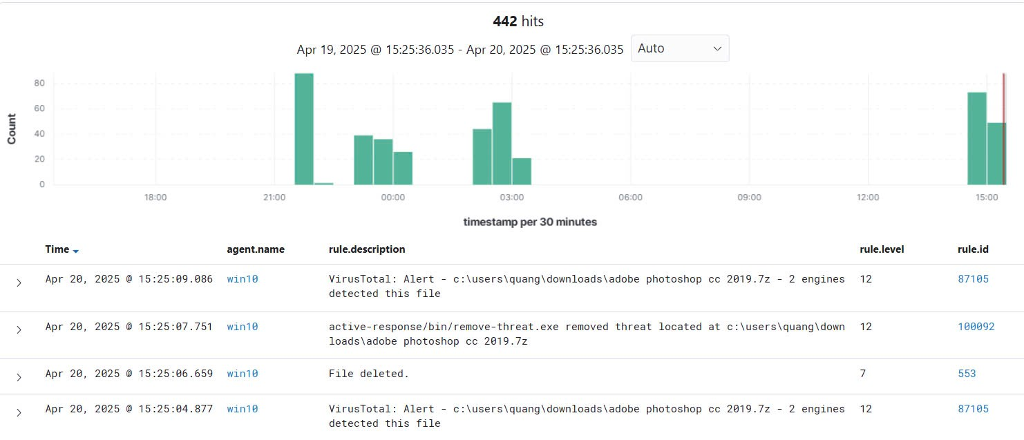

Figure . - Wazuh active response log

A second email was sent from wazuhcriticallog@gmail.com, this time confirming the deletion of the file and referencing Rule ID 100092 — the rule associated with the remove-threat script. The email includes timestamp, file path, rule ID, affected system, and the phrase “File deleted” in the subject line, indicating successful containment.

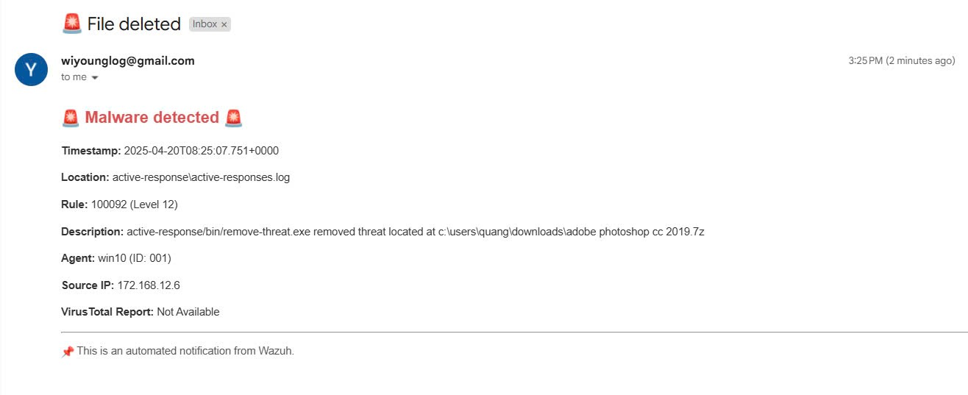

Figure . - Email notification: File Deleted

After the automated deletion by Wazuh, the malicious archive adobe photoshop cc 2019.7z is no longer present in the Downloads folder, confirming successful threat removal.

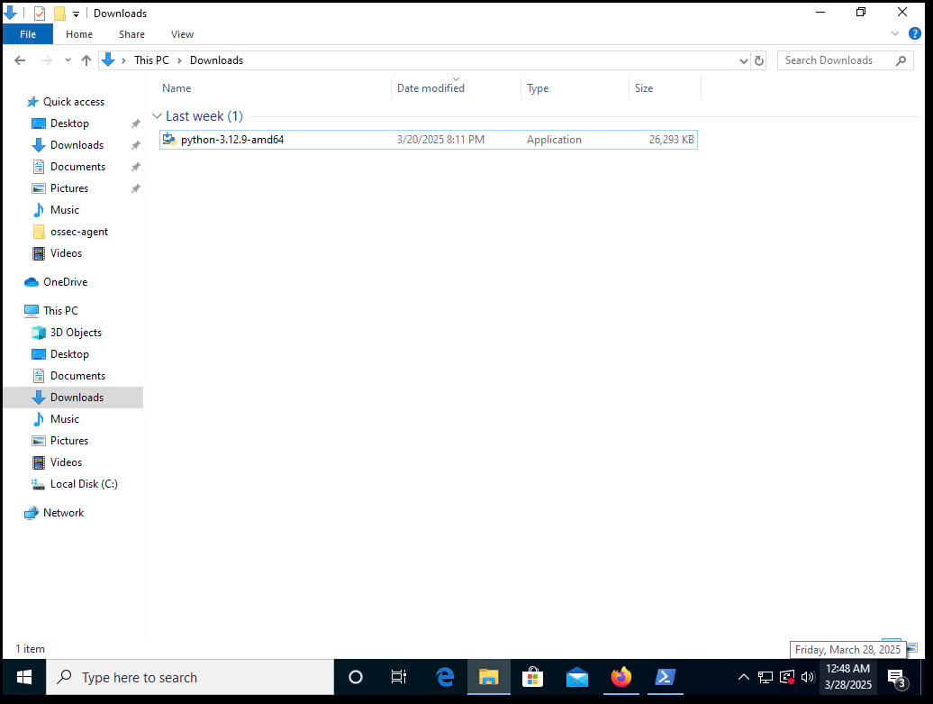

Figure . - After Automated File Removal

##### Phrase 4 – Post-Incident

After the containment phase was successfully completed, the team proceeded to the post-incident phase. This phase focused on reviewing the attack, assessing its impact, documenting the response actions, and updating system defenses to prevent future incidents. The workflow for this phase is illustrated in the diagram below.

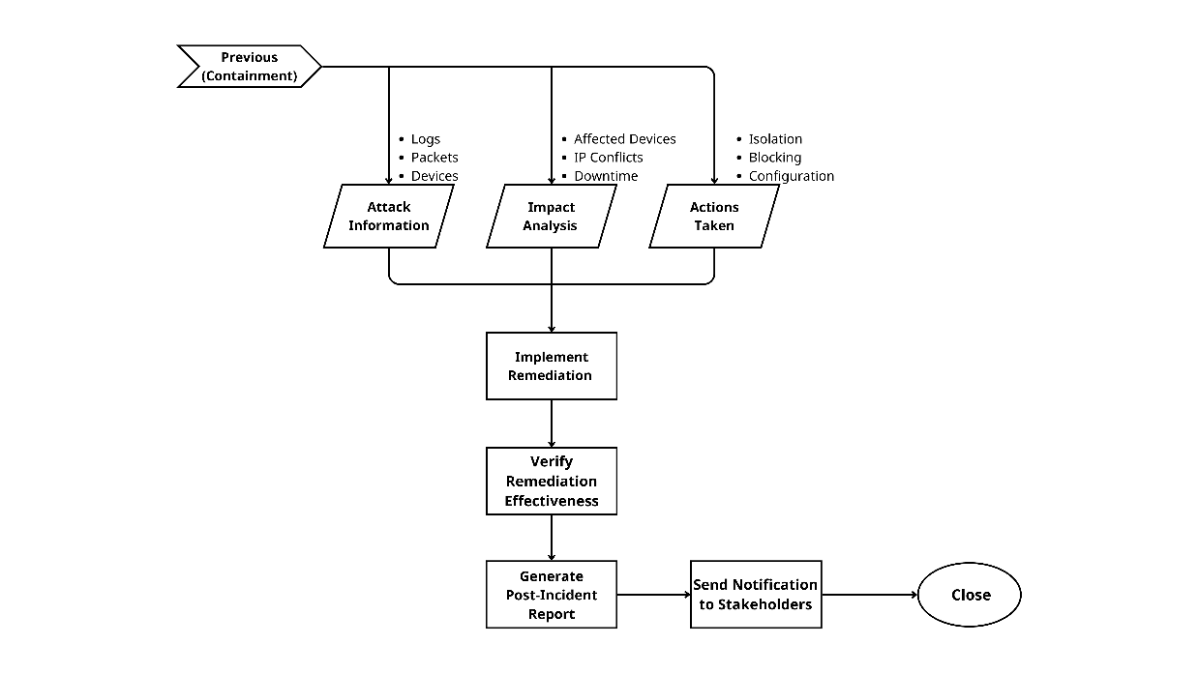

Figure . - Flowchart Malware Infection via Cracked Software – Post-Incident

The flowchart outlines a structured post-incident process: gathering attack data, analyzing its impact, recording actions taken, and closing the case with updated security measures.

All logs, alerts, and artifacts related to the malware infection were gathered for forensic analysis. This included:

* VirusTotal scan results and threat classifications (Virus.Win32.Virut.hpeg, Artemis!Trojan)
* Wazuh alert metadata (Rule ID 87105 for detection, Rule ID 100092 for response)
* Email notifications confirming both detection and containment
* File path, timestamp, and host information for the infected machine

These details were archived in the incident response system for future auditing and threat intelligence purposes.

To enhance visibility and streamline the post-incident review, the Kibana Dashboard which as a part of the ELK Stack and was used to visualize all relevant logs and alerts in real time. It allowed the team to validate rule matches, monitor alert patterns, and identify recurring behaviors across different hosts.

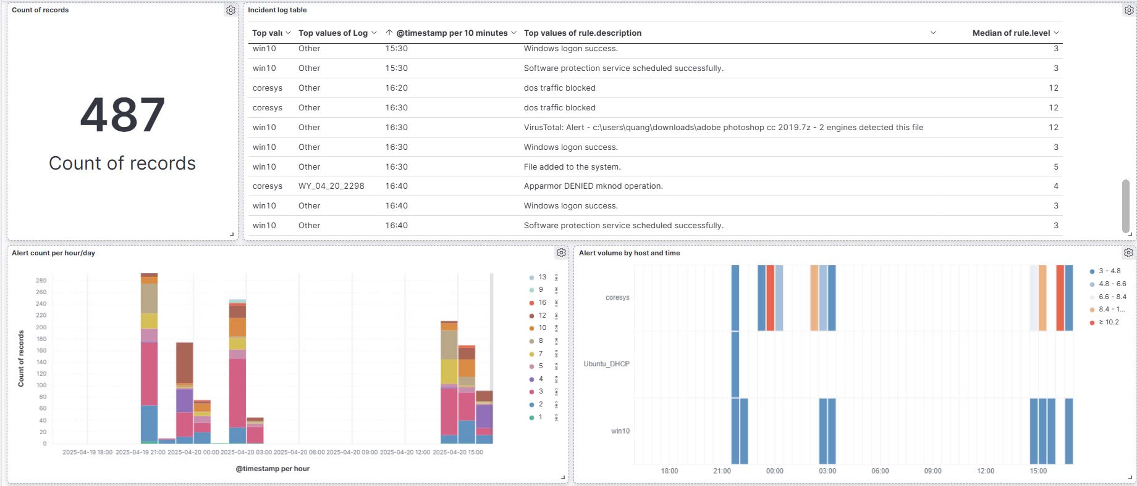

Figure . - Kibana Visualized Dashboard for Malware Infection

##### Conclusion

This simulation demonstrated our team’s ability to configure and validate the system’s capacity to detect and automatically remove a Trojan infection in real time. We configured Wazuh to promptly raise a high-severity alert upon detecting the malicious executable, and to trigger an Active Response action that deleted the file. Email notifications kept us informed throughout the process, and we conducted a post-incident review that confirmed the system was fully cleaned. No further signs of compromise were found. We provided targeted training to the affected user, and our organization updated access control and download policies accordingly. Overall, the demonstration validated our use of Wazuh in handling malware incidents from initial detection to full containment and recovery.

#### Denial of Service (DoS) Attack

In this demonstration, we simulated a Denial of Service (DoS) attack targeting a critical server within the enterprise network. Our goal was to showcase how an integrated security monitoring system combining Wazuh and pfSense can detect, mitigate, and respond to DoS attacks in real time.

##### Phrase 1 – Preparation

We prepared the necessary environment and tools to enable both detection and automated response during the DoS attack simulation. The setup includes:

* pfSense Configuration: We created custom firewall rules in pfSense to detect and drop high-volume suspicious traffic. These rules are designed to automatically block malicious IP addresses based on anomaly patterns like SYN floods.
* Wazuh Active Response Setup: On the Wazuh side, we defined custom detection rules to monitor for traffic spikes and packet flooding.

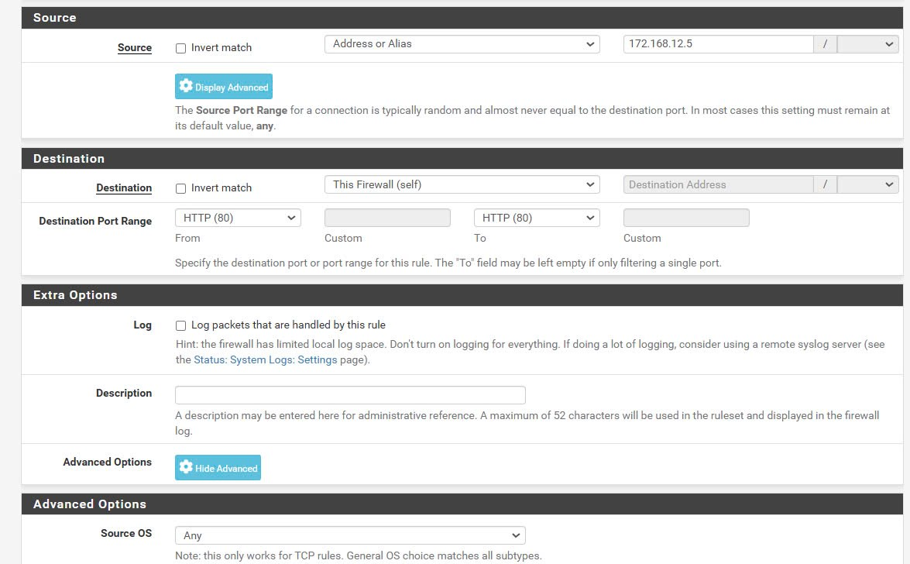

Figure . - Configure pfSense Rule

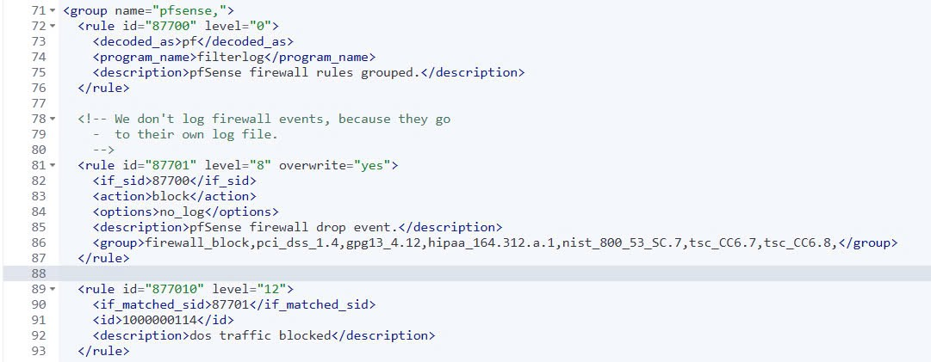

Figure . - Block DoS Rule

<group name="pfsense,">

<rule id="87700" level="0">

<decoded_as>pf</decoded_as>

<program_name>filterlog</program_name>

<description>pfSense firewall rules grouped.</description>

</rule>

<rule id="87701" level="8" overwrite="yes">

<if_sid>87700</if_sid>

<action>block</action>

<options>no_log</options>

<description>pfSense firewall drop event.</description>

<group>firewall_block,pci_dss_1.4,gpg13_4.12,hipaa_164.312.a.1,nist_800_53_SC.7,tsc_CC6.7,tsc_CC6.8</group>

</rule>

<rule id="877010" level="12">

<if_matched_sid>87701</if_matched_sid>

<id>1000000114</id>

<description>dos traffic blocked</description>

</rule>

</group>

To simulate the DoS attack, we used hping3 on a ParrotOS terminal, executing the following command:

hping3 -S -p 80 --flood 172.168.12.1

This continuously flooded the target IP (172.168.12.1) on port 80 with SYN packets, overwhelming it with traffic.

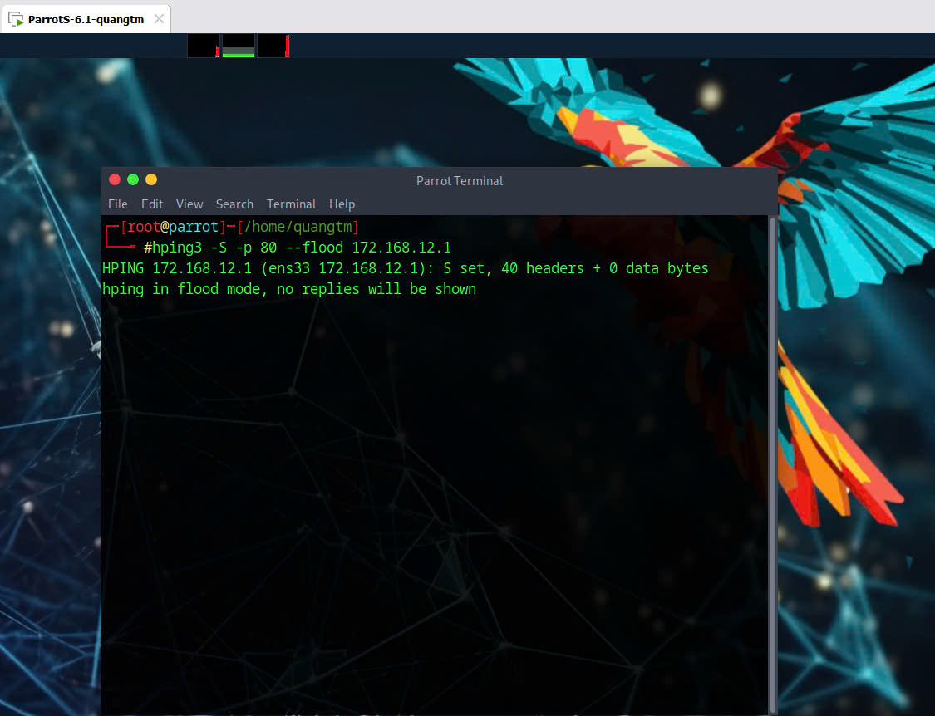

Figure . - DoS Attacking by Hping3

##### Phrase 2 – Detection

As the attack began, Wazuh monitored traffic through pfSense logs and system-level activity. Our detection process followed the structure illustrated in the flowchart below:

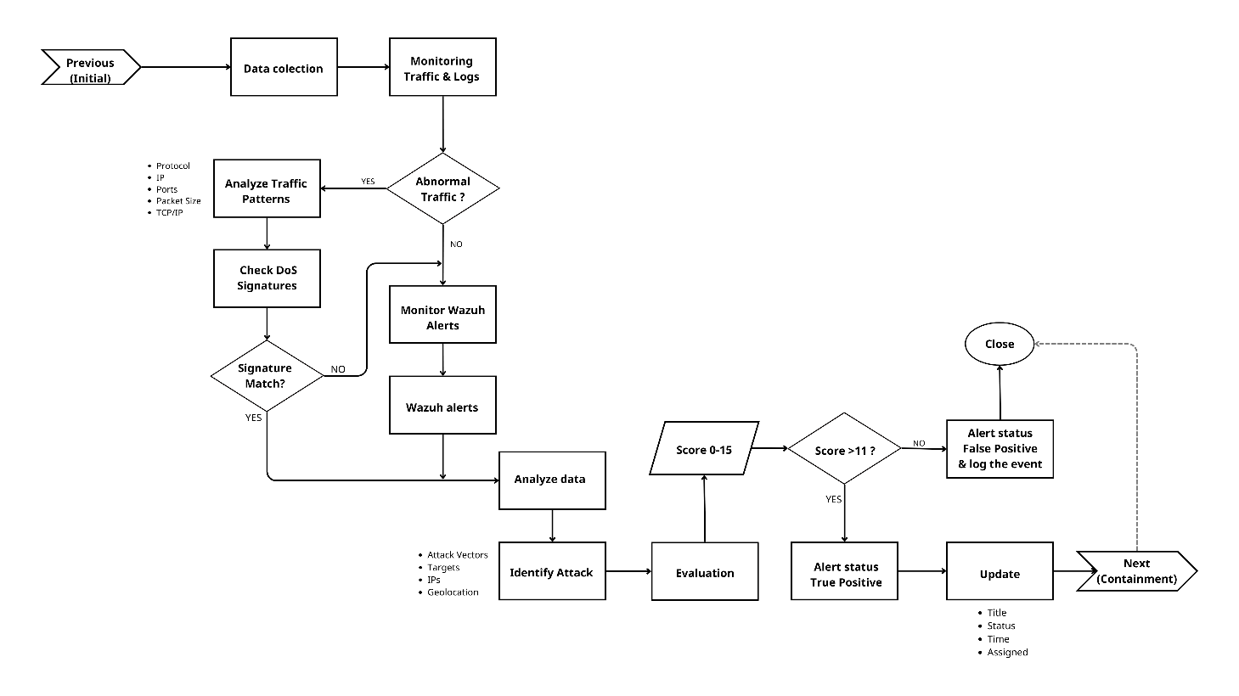

Figure . - Flowchart of DoS Attack - Detection

Wazuh monitored network traffic through pfSense logs and system activities. Using the pre-defined rule, Wazuh analyzed traffic rate and checked for anomalies, such as high traffic volume or packet flooding, indicating a potential DoS attack.

The Wazuh rule matched the incoming traffic against known DoS signatures. Once the traffic volume surpassed the baseline, Wazuh flagged the event.

At the same time, an automated email notification was sent to the incident response team, allowing us to take immediate containment action.

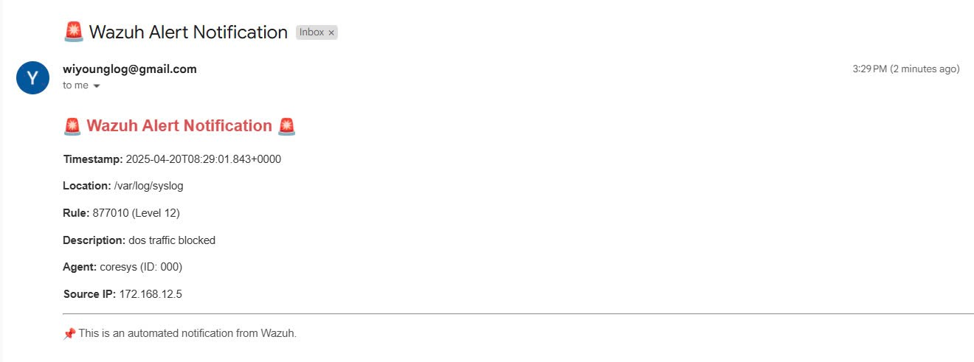

Figure . - Email Notification of DoS Attack

Wazuh's ability to automatically detect and flag abnormal traffic in real time helped the team quickly identify and confirm the potential DoS attack.

##### Phrase 3 – Containment

Once the DoS event was detected, our system initiated containment actions as defined in our response framework, illustrated below:

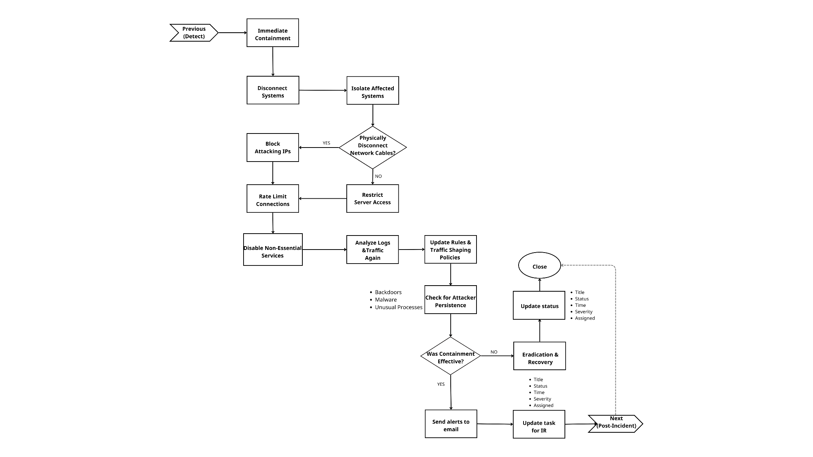

Figure . - Flowchart of DoS Attack – Containment

Once the DoS attack was detected, Wazuh and pfSense took immediate action to mitigate the attack and block the malicious traffic.

Upon detection of the suspicious traffic, Wazuh triggered an active response through pfSense. The system executed a rule to block the source IP (172.168.12.5), effectively preventing further attack attempts from the malicious source.

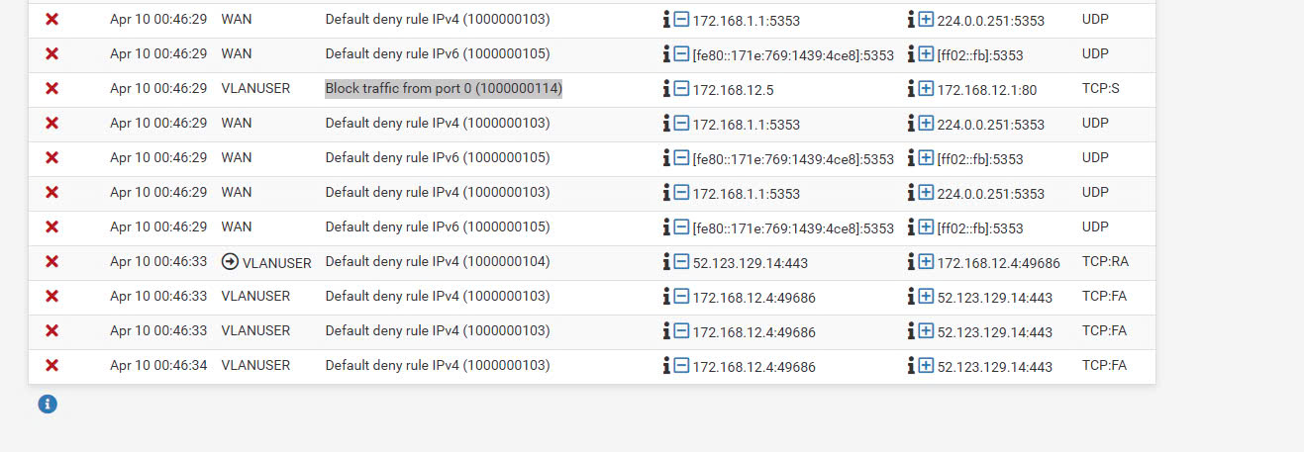

Figure . - pfSense Block Action Log

Wazuh’s active response module automatically blocked the source IP using pfSense firewall rules. The traffic from this IP address was immediately denied access to the targeted server, ensuring that the attack was stopped in real time.

After implementation, we reviewed the firewall logs and verified that no further traffic from the attacker IP was being allowed. This ensured that the attack had been stopped in real time with no spillover.

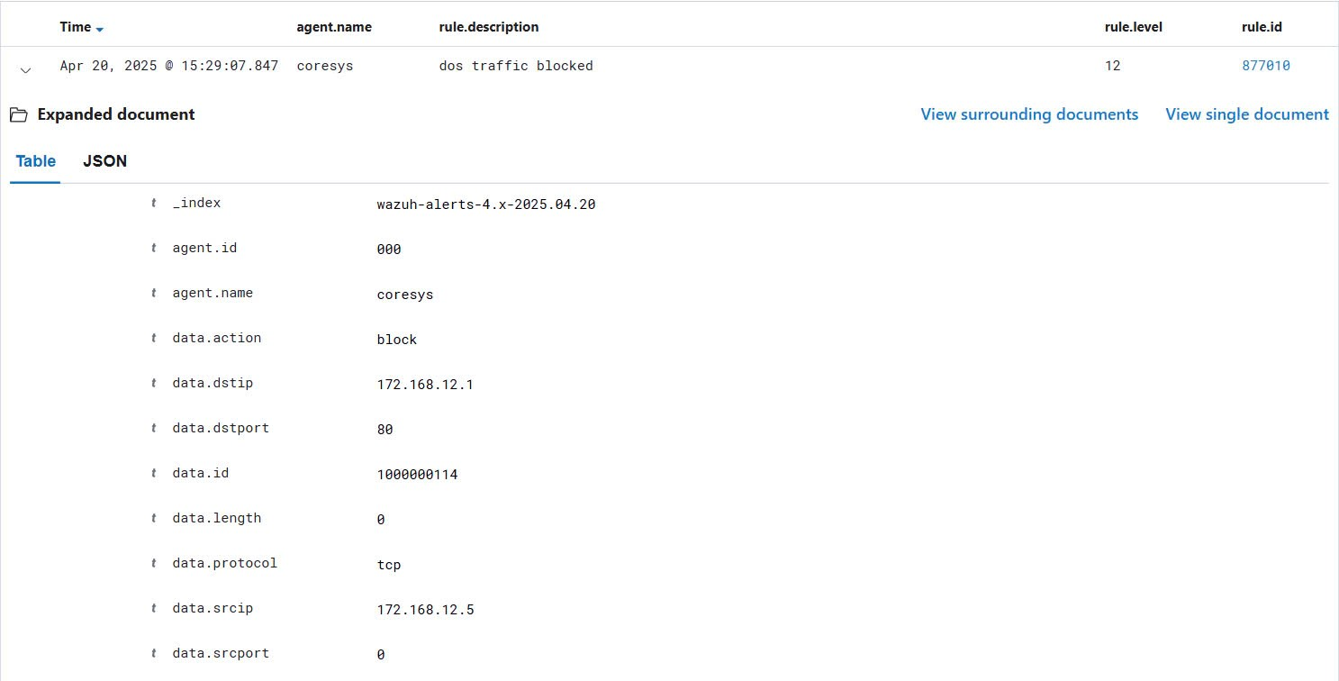

Figure . - Wazuh Active Response Log for IP Block

##### Phrase 4 – Post-Incident

After the containment phase was successfully completed, we proceeded to the post-incident phase. This phase focused on reviewing the attack, assessing its impact, documenting the response actions, and updating system defenses to prevent future incidents. The workflow for this phase is illustrated in the diagram below.

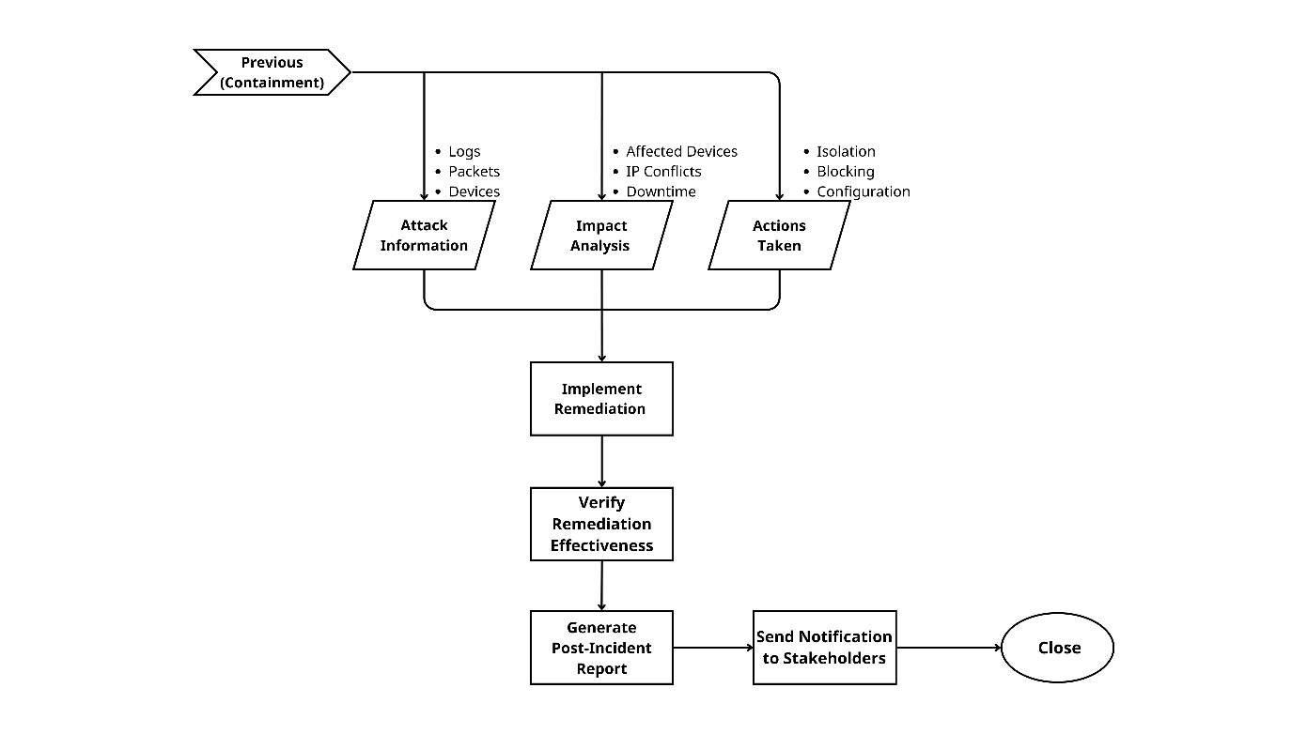

Figure . - Flowchart DoS Attack – Post-Incident

The flowchart outlines a structured post-incident process: gathering attack data, analyzing its impact, recording actions taken, and closing the case with updated security measures.

We gathered all relevant logs, including pfSense firewall logs, Wazuh alerts, and system logs, for forensic analysis. This helped in confirming the attack vectors, the extent of the attack, and the response effectiveness. Key data reviewed included:

* Logs of blocked traffic from specific IP addresses and ports.
* Wazuh alerts triggered during the attack detection phase (including Rule ID: 877010).
* Email notifications confirming the attack detection and IP blocking actions taken.

Our analysis showed that no critical systems were compromised, and there was no data loss. The impact was limited to temporary service disruption.

To support this phase with comprehensive visibility and structured review, we leveraged the Kibana Dashboard which is an integral part of the ELK Stack integration.



Figure . - Kibana Visualized Dashboard

Based on the findings, we fine-tuned our firewall rules and integrated updated threat intelligence feeds into Wazuh to improve detection granularity. The malicious source IP was permanently blacklisted.

##### Conclusion

This simulation demonstrated how we used our integrated Wazuh–pfSense system to detect, respond to, and contain a DoS attack in real time. We configured Wazuh to detect abnormal traffic via signature-based rules and behavior analysis, triggering a high-severity alert (Rule ID: 877010). The alert launched an automated Active Response, and pfSense immediately blocked the attack source. We received email notifications throughout the process to stay informed. After containment, we reviewed the incident, confirmed no persistence, updated firewall rules, and enhanced our monitoring to prevent future attacks. This validated our incident management framework’s ability to minimize disruption through timely detection and automated response.

# VALIDATION DOCUMENT

## Project Result

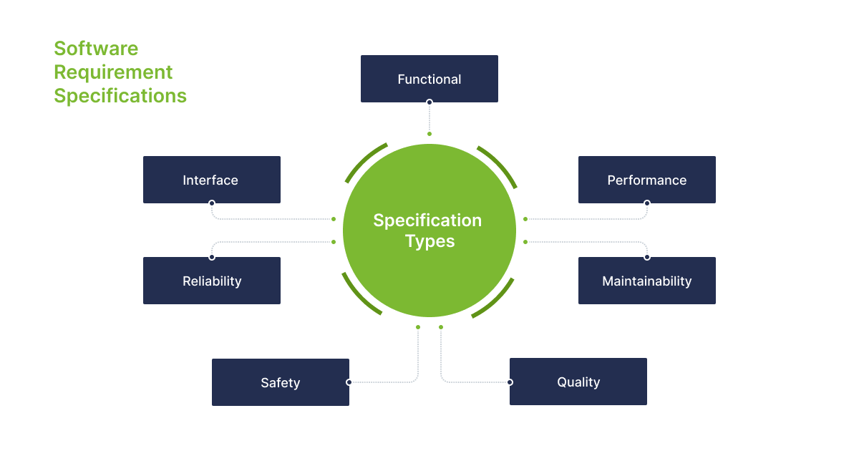

Figure . - Software Requirement Specifications

|  |  |
| --- | --- |
| **Aspect** | **Description** |
| Functionality | The system was able to detect, categorize, and respond to simulated threats in real-time through the integration of pfSense (firewall) and Wazuh (log analysis and alerting). |
| Performance | In a lightweight virtual environment, the system handled log collection and alert generation efficiently using Wazuh agents and Elastic Stack, without noticeable delay. |
| Interface | Kibana dashboard helped visualize alerts clearly. While logs were easy to access, interpreting them still required basic cybersecurity knowledge. |
| Maintainability | The modular structure allowed for quick updates, rule tuning, and policy changes without affecting overall stability—tested successfully during multiple rule adjustments in demo scenarios. |
| Reliability | Across various simulations (e.g., Trojan detection, SSH block, DoS attack), the system consistently triggered alerts and active responses as expected, with logs properly retained. |
| Safety | All testing was done in isolated VMs, and Wazuh's configuration included safeguards like alert suppression and rule targeting to avoid unintended disruptions. |
| Quality | The solution met core goals such as early detection, automated containment, and incident traceability. It served well as both a technical proof-of-concept and a practical learning tool. |

Figure .. Specificaltions of Project

## Advantages and Disadvantages of the Solution

### Advantages

Our solution is built entirely on open-source tools such as Wazuh and pfSense, offering a cost-effective, flexible platform for real-time threat detection and automated response. Throughout the project, the system effectively handled simulated incidents, such as malware infections, DoS and brute-force SSH, demonstrating its capability to detect and mitigate threats autonomously.

We integrate Wazuh with Kibana to be enabled centralized real-time monitoring, while automated email alerts provided timely notifications to administrators. The system successfully enforced the simulated enterprise principles/policy.

Additionally, the project offered a valuable hands-on learning experience, allowing participants to gain practical skills in log analysis, rule customization, and incident response planning within a controlled environment.

### Disadvantages

Despite its strengths, our current system relies solely on rule-based detection, which may not identify novel or stealthy threats lacking known signatures. During testing, several false positives were encountered, underscoring the need for ongoing rule tuning and refinement. The initial configuration, especially regarding log forwarding and detection rules, also presented notable technical complexity.

In early phases, the volume of generated alerts posed risks of alert fatigue, highlighting the importance of implementing effective filtering mechanisms. Moreover, the system was deployed in a virtualized, time-constrained setting; thus, critical factors such as scalability and long-term performance in real-world environments have yet to be thoroughly evaluated.

Furthermore, our system currently lacks a dedicated incident playbook or ticketing system, which limits the ability to manage incident life cycles across multiple response stages.

## Development Strategy of the Solution

We aim to evolve this solution into a scalable, modular, and user-friendly platform suitable for both academic and enterprise environments. Built on Wazuh and pfSense, it supports real-time detection, active response, and centralized visibility.

From our simulations (malware detection, DoS and Brute-Force SSH) we identified areas for refinement, such as alert filtering, dynamic IP validation, and better audit trails.

Moving forward, we plan to focus on:

* Multi-host monitoring
* CVE-based threat intelligence syncing
* Basic anomaly detection or machine learning integration
* Usability enhancements like rule editors, incident labeling, and automatic report generation
* Develop an incident response playbook with defined workflows and integrate with tools like Trello or Jira for centralized incident tracking.
* Improve infrastructure performance by optimizing resource allocation and refining deployment configurations.
* Expand attack use cases to cover additional incident types such as privilege escalation, lateral movement, or insider threats.
* Containerize the entire solution using Docker to enable portability, simplified scaling, and easier environment replication.
* Fully implement a Zero Trust model by incorporating identity-based access control, dynamic policy enforcement, and micro-segmentation.

# References

1. **VTV.vn**, "Hơn 659.000 vụ tấn công mạng vào cơ quan, doanh nghiệp Việt Nam năm 2024," VTV News, Dec. 24, 2024. [Online]. Available: https://vtv.vn/cong-nghe/hon-659000-vu-tan-cong-mang-vao-co-quan-doanh-nghiep-viet-nam-nam-2024-20241224070457363.htm.
2. **Viettel Cyber Security, “Báo cáo tình hình nguy cơ ATTT tại Việt Nam năm 2024,” Viettel Cyber Security Blog, Mar. 2024. [Online]. Available: https://blog.viettelcybersecurity.com/bao-cao-tinh-hinh-nguy-co-attt-tai-viet-nam-nam-2024/**
3. **Hornetsecurity**, "Cyber Security Report 2025," Hornetsecurity, 2025. [Online]. Available: https://www.hornetsecurity.com/en/security-information/cyber-security-report-2025.
4. **Check Point Research**, "Cyber Security Report 2025," Check Point, 2025. [Online]. Available: https://research.checkpoint.com.
5. **Wazuh**, "The Open Source Security Platform," Wazuh Documentation. [Online]. Available: https://documentation.wazuh.com.
6. **pfSense Documentation**, "Firewall Configuration and Management," Netgate. [Online]. Available: https://docs.netgate.com/pfsense/en/latest/.
7. **Elastic**, "Kibana Guide [8.11] – Visualize & Explore Data," Elastic. [Online]. Available: <https://www.elastic.co/guide/en/kibana/current/index.html>.
8. **VirusTotal**, "Free Online Virus, Malware, and URL Scanner," Google Security. [Online]. Available: <https://www.virustotal.com>.
9. **National Institute of Standards and Technology (NIST)**, "Cybersecurity Framework," NIST, 2022. [Online]. Available: <https://www.nist.gov/cyberframework>.